Answer the following questions about shipping lobsters. For each problem:
- Include the equations or formulas you used.
- Explain, in words or with mathematical steps, how you arrived at your answers. You do not have to submit sketches, but you may find that drawing parts of the problem on scratch paper can help you understand the problem.
- Include all relevant units (such as miles or cubic inches) in your final answers.

Maine Lobster Direct in Portland, Maine, hires a contractor to ship its goods to Harry’s Restaurant of Manhattan, Kansas, by a refrigerated truck. The driving route is 1,608 miles. Providing a proper shipping environment is vital so the lobsters can arrive at their destination alive.

- Assuming the driver does not stop and drives at an average speed of 65 miles per hour, approximately how many hours will the trip take? Round to one decimal place. How long is that in whole minutes? Calculate the minutes from your rounded hours answer.

- Lobsters cannot survive more than 30 hours in refrigeration. How many half-hour breaks can the driver take and still deliver the lobsters alive?

- Each shipment of lobsters is packed into a crate (a rectangular prism) that measures 22 inches long, 17 inches wide and 13 inches high. For the trucking company to bill you accurately, you must report certain calculations of the crate’s size with the correct units. Determine:
  - The area of the base

  - The perimeter of the base

  - The volume of the crate

- The lobsters must all be packed in the same orientation (with all the heads are facing the same direction) to travel safely. Assume that each lobster requires a rectangular space that is 10 inches in length, 5 inches at its widest, and 3 inches high. Refer to the diagram below to see how one lobster would be positioned in a crate.

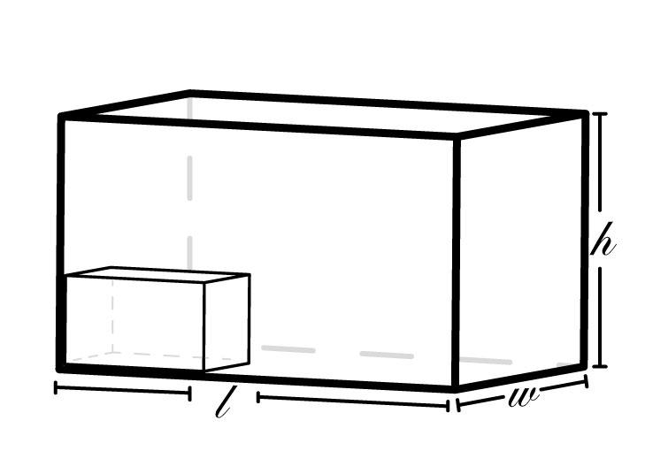
Figure 1: The lobster will require a rectangular space of 10 by 5 by 3 inches in the crate. The lobster’s ten-inch length must lie along the length of the crate.

  - Given the orientation requirements, how many lobsters can fit along the 22-inch length of the crate?

  - How much space in the crate does one lobster take?

  - Consider how you determined how many lobsters can fit along the length of the crate. How many lobsters can be packed in one crate the same way as in the diagram?
Hint: Draw on scratch paper a sketch of several lobsters (rectangles) in the crate, noting the dimensions for each lobster and the crate. This should tell you how to structure the problem.

- The crate weight limit is 25 kilograms. The contents of your crate weigh 50 pounds. Is the crate safe? Why or why not?

- To make sure the lobsters are cool but not frozen, you need to keep their temperature between 32 and 40 degrees Fahrenheit while they are being shipped. However, your driver, Igor, is from Europe, where they use Celsius instead of Fahrenheit. Please provide these temperatures in Celsius for Igor and round to the nearest degree.

