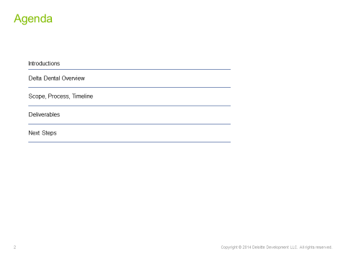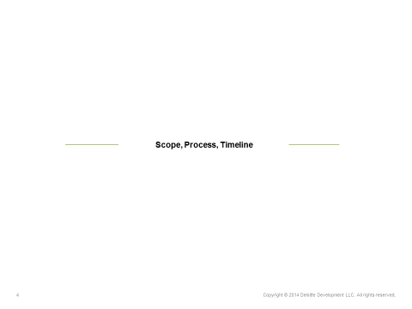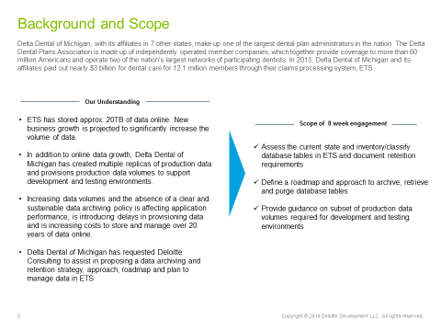
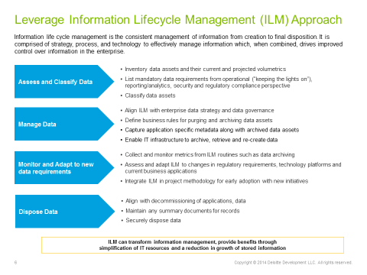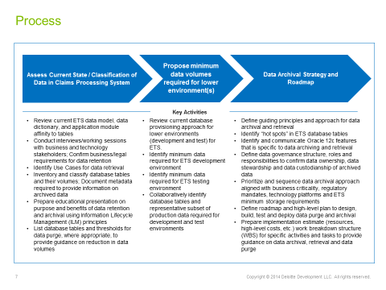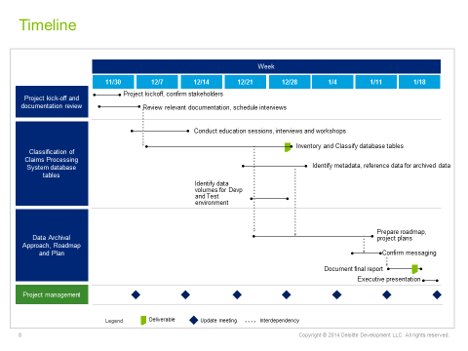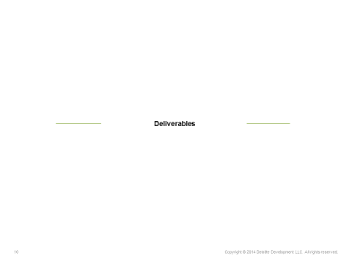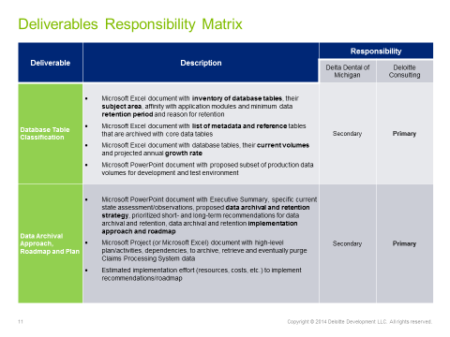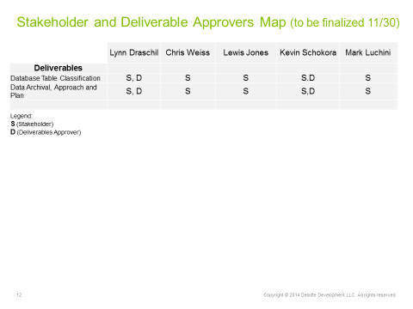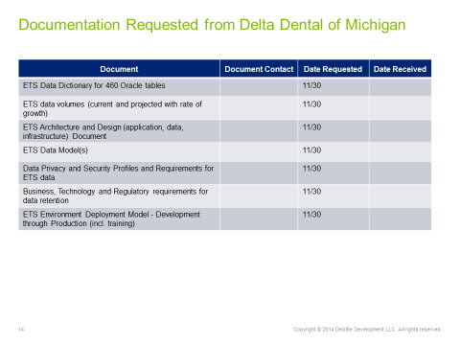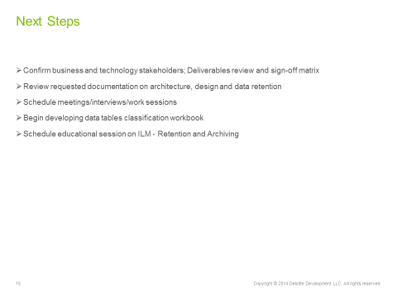
Data Arching Strategy –Database Administration Overview
Meeting Date: December 15, 2015 / 3:30 PM

Purpose / Intended Outcome
- DBA Technology Overview

- Oracle upgrade planned for 2016
- Challenges in roles
Discussion Items

  - Getting the business to agree on data management/purging has been a challenge
    - Looked at a partitioning strategy, but the project died
      - Had a strategy – didn’t like the archival aspect when talking about production
      - Concern of testing
      - Technically constraints – HP hardware (8 years old); changes would take a long time
o ESI is operating 8 times faster after hardware refresh
  - Consumption of disk space and management
    - Not worried about performance if data footprint increases
      - Left unchecked, performance issue will happened again though
  - DBAs have had to be reactionary versus on the front end of the design process
- Not really spending time rebuilding indexes – not best practices
  - Don’t do a lot of deleting, mostly inserts, so don’t have fragmentation
- Partitioning
  - Claim and line item tables – by date was obvious in 2008-2009
    - Didn’t know how things would be growing or where needs would be
  - There wasn’t a project to put it together
    - Need to work together with how to partition data
  - Want to get rid of dead data – don’t want to partition things not used by the business
- Databases
  - 90% of information on Solaris, Spark
  - Handful of stuff on HP UX – Federal mostly
  - Number of production databases – 15
    - Bulk of ETS is in one database
    - Separation with provider and Renaissance
    - Closer to 21 DB in UAT, 15 DB in Test, 4 DB in Dev
- Quarterly patches – done about twice a year
Page 1 of 2

o Don’t have a regular patching strategy
- Application code migration
  - Dev -> Test -> UAT -> production
- Stored procedures, schemas, Code value updates
  - ETS – DDL and store procedures done on build weekend; manual process
- How do DBAs share data internally between applications
  - Application code lives in Java
  - Java code will request data from DW
- Additional opportunities
  - Reporting database (CDC) is currently manual and will be automated next year
  - Shrinking the database size – Claim PR2 has growth by 5 TB in the last 5 months
    - Added 100 TB with hardware refresh
    - Add 100MM records a month
  - File and table organization
    - Use all small files now
    - Tables will need to be reorganize when data is purged
    - Talking about the physical storage
  - Backup and recovery strategy
    - Don’t have a great place for full image copies
  - Multi-tendency

Page 2 of 2

