Prove that the divergence of a tensor 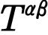 is given by

