- Evaluate the integral shown below (try substitution)
$$\int{\frac{x dx}{{\left(7x^{2}+3\right)}^{5}}}$$

- Evaluate the integral shown below (apply a property of logarithms first.)
$$\int{\frac{In x^{6}}{x}}dx$$

- Use the Fundamental Theorem of Calculus to find the derivative shown below.

$$\frac{d}{dx} \int_{0}^{x^{5}}{\sin{t dt}}$$

- For the function below, sketch a graph of the function, and then find the smallest possible value and the largest possible value for a Riemann sum of the function on the given interval as instructed.
$f\left(x\right)=x^{2};between x=3 and x=7 with four rectangles of equal width$

- Use I’Hopitals rule to find the limit below.

$$\lim_{x→∞}{{\frac{5x+9}{6x^{2}+3x-9}}^{}}$$

- Use I’Hopitals rule to find the limit below. (The indeterminate form is f(x)g(x).)

$$\lim_{x→∞}{{\left(1+\frac{2}{x^{3}}\right)}^{x}}$$

- The 9 ft wall shown here stands 30 feet from the building. Find the length of the shortest straight beam that will reach to the side of the building from the ground outside the wall.

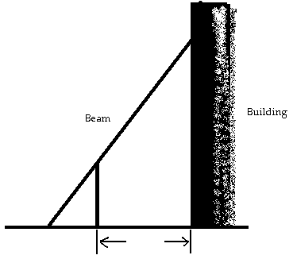

Use similar triangles and the Pythagorean Theorem to express the length of the beam "L".

- For the function shown below, identify the coordinates of all local and absolute extreme values.
$f\left(x\right)=-x^{3}-9x^{2}-24x+3$ Defined for all reall numbers “x”

- Find a value for "c" that satisfies the equation $\frac{f\left(b\right)-f(a)}{b-a}=f'(c)$ in the conclusion of the Mean Value Theorem for the function and interval shown below.
$f\left(x\right)=x+\frac{75}{x},$ on the interval [3,25]

- Find the equation of the tangent line to the curve whose function is shown below at the given point.
$x^{5}y^{5}=32,$ tangent at (2,1)

