- Let B(x) represent the area bounded by the graph and the horizontal axis and vertical
lines at t=0 and t=x for the graph below. Evaluate B(x) for x = 1, 2, 3, 4, and 5.

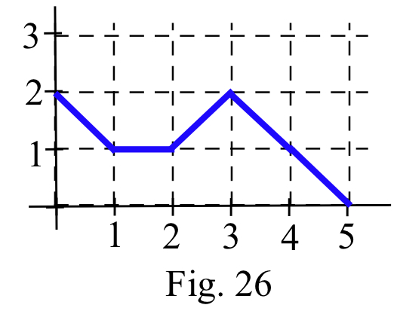
- $f\left(x\right)=x^{2}, g\left(x\right)=3x, and h\left(x\right)=2/x$. Evaluate each sum.

$$\sum_{i=0}^{3}{f(1+i)}$$

- sketch the function and find the smallest possible value and the largest possible value for a Riemann sum of the given function and partition.

$$f\left(x\right)=x^{2}-2x+3$$
P={0, 1, 2,3}

- For f(x)=3+x, partition the interval [0, 2] into n equally wide subintervals of length Δx = 2/n. Write the lower sum for this function and partition, and calculate the limit of the lower sum as n⟶∞ (b) Write the upper sum for this function and partition and find the limit of the upper sum as n⟶∞.

- Use the graph to determine the values of the definite integrals. $\int_{3}^{5}{f\left(x\right)dx}$

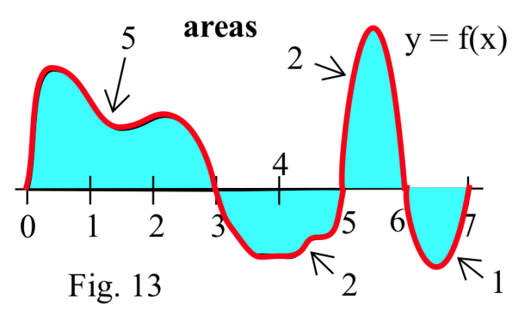

- Same instructions and graph as above. $\int_{3}^{5}{|f\left(x\right)|dx}$
- sketch the graph of the integrand function and use it to help evaluate the integral.
$$\int_{0}^{2}{\left|x\right|-1dx}$$

- use the Antiderivatives and Definite Integrals Theorem to evaluate the integrals.
$$\int_{0}^{2}{4x^{3}dx. \int_{0}^{1}{4x^{3}dx. \int_{1}^{2}{4x^{3}dx.}}}$$

- The velocity of a car after t seconds is $3t^{2}$ feet per second. (a) How far does the car travel during its first 10 seconds? (b) How many seconds does it take the car to travel half the distance in part (a)?

- Find the exact area under half of one arch of the sine curve:$\int_{0}^{π/2}{\sin\left(x\right)dx}$. (Note: D( –cos(x) ) = sin(x) )

