MATH 141 Homework Due Dec 2 Name :

- Solve the following linear programming problem using a graphical method

A company makes two puddings, vanilla and chocolate. Each serving of vanilla pudding requires 2 teaspoons of sugar and 25 fluid ounces of water, and each serving of chocolate requires 3 teaspoons of sugar and 15 fluid ounces of water. The company has available each day 3,600 teaspoons of sugar and 22,500 fluid ounces of water. The company makes no more than 600 servings of vanilla pudding because it is all that it can sell each day. If the company makes a profit of 10 cents on each serving of vanilla pudding and 7 cents on each serving of chocolate pudding, how many servings of each pudding should it make to maximize its profit ?

Step I : Set up your objective function and constraint inequalities
Maximize: P = 10x + 7y
Subject to 2x + 3y $≤$ 3600
5x + 3y $≤$ 4500
x $≤$ 600
$x_{1}$$≥0$ $y_{1}≥0$
Step II : Shade the feasible region, Find corner points and evaluate profit at each corner point.
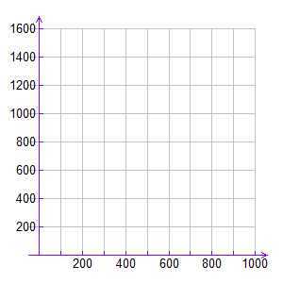 | Please complete the table below.  Point
The maximum Profit is ___________.
It occurs when the number of vanilla puddings is ___________
and the number of chocolate puddings is ___________
- Now solve the same linear programming problem in question #1 above using the SIMPLEX
method. Clearly state the row operations used. For each tableau used, complete the leftmost column by providing the appropriate basic variables.

Step I : Set up your objective function and constraint inequalities
Maximize: P = +
Subject to: = $≤$
= $≤$
$X_{1}$
$X_{2}$

Step II : Introduce slack variables
Step III : Set up the initial Simplex tableau.
 |  | 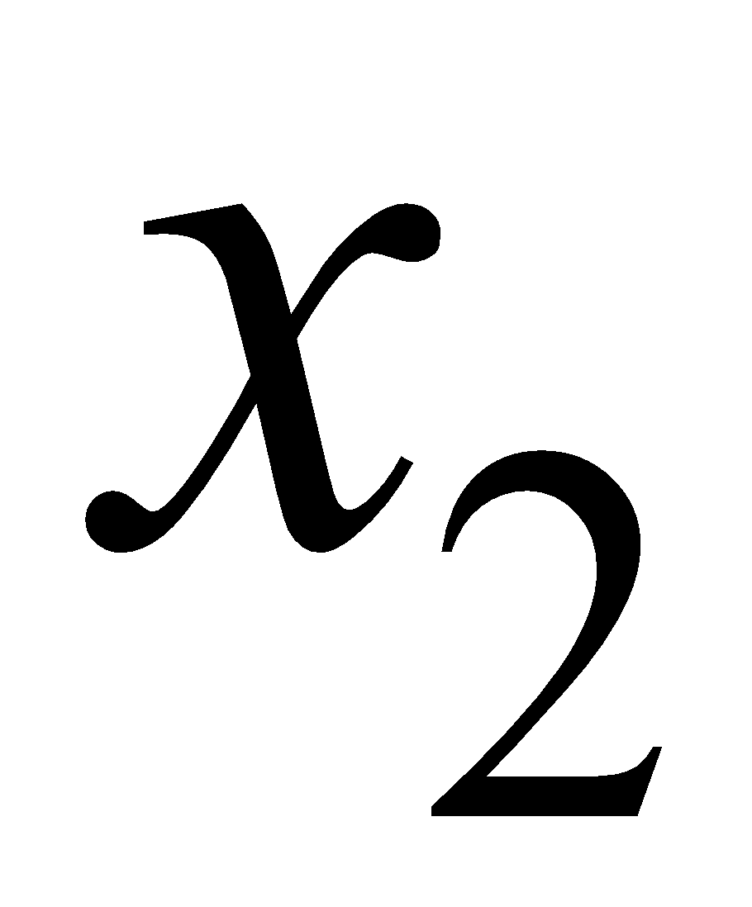 |  | 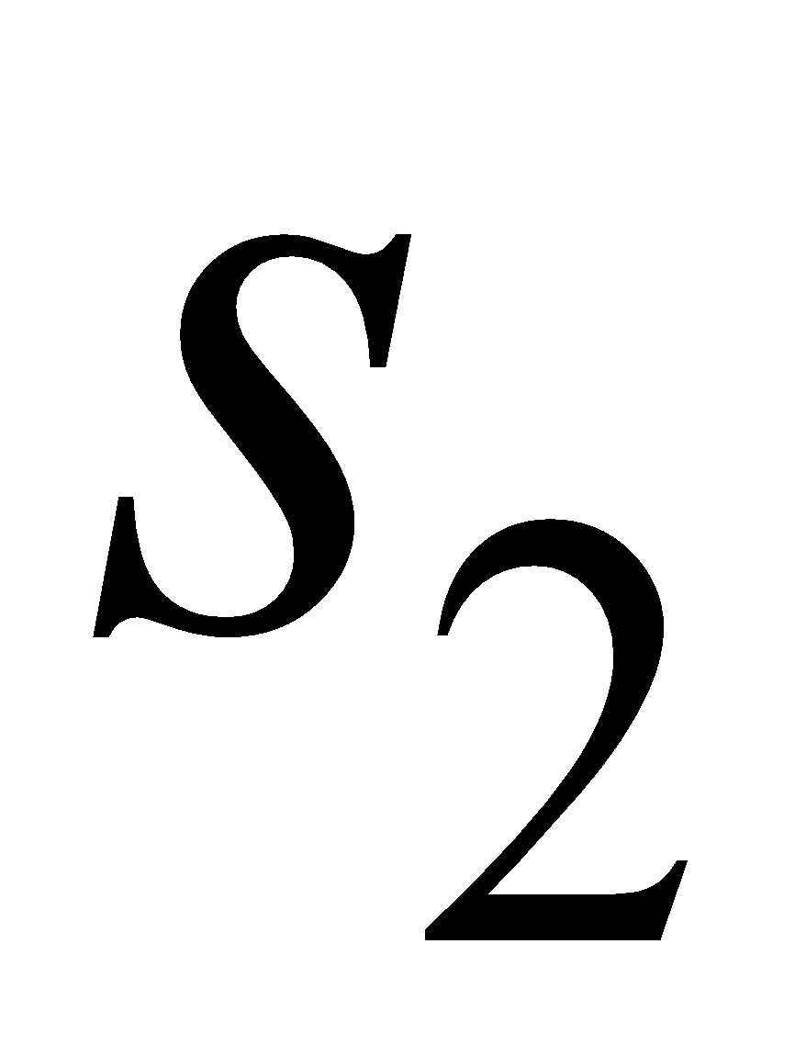
 | 1 | 0 | 1 | 0 | 0 | 0 | 600
 | 2 | 3 | 0 | 1 | 0 | 0 | 3600
 | 5 | 3 | 0 | 0 | 1 | 0 | 4500
 | -10 | -7 | 0 | 0 | 0 | 1 | 0
$R_{2}-2R_{1}$ $→R2$
$R_{3}-5R_{1}$ $→R3$
$R_{4}+10R_{1}$ $→R4$
Now carry out successive pivoting operations to obtain an optimum solution to the linear programming problem. In each case clearly state the row operations used. For each tableau used, complete the leftmost column by providing the appropriate basic variables. You must show all work leading to the final tableau. Use the tables in the next page. At the end of your work please answer the questions below.

The maximum Profit is __$100__.
It occurs when the number of vanilla puddings is 300 servings and the number of chocolate puddings is 1000 servings
Does this result agree with your solution from question #1?

Show your work in the following tables. You may need less than the six tables provided for you.

 | 1 | 0 | 1 | 0 | 0 | 0 | 600
 | 0 | 3 | -2 | 1 | 0 | 0 | 2400
 | 0 | 3 | -5 | 0 | 1 | 0 | 1500
 | 0 | -7 | 10 | 0 | 0 | 1 | 6000
$R_{2}-R_{3}$ $→R2$
$3R_{4}+7R_{3}$$→R4$
S1 | 1 | 0 | 1 | 0 | 0 | 0 | 600
_{S2} | 0 | 0 | 3 | 1 | -1 | 0 | 900
S3 | 0 | 3 | -5 | 0 | 1 | 0 | 1500
P | 0 | 0 | -5 | 0 | 7 | 3 | 28500
S1 | 3 | 0 | 0 | -1 | 1 | 0 | 900
_{S2} | 0 | 0 | 3 | 1 | -1 | 0 | 900
S3 | 0 | 9 | 0 | 5 | -2 | 0 | 9000
P | 0 | 0 | 0 | 5 | 16 | 9 | 90000
$3R_{1}-R_{2}$ $→R1$
$3R_{3}+5R_{2}$ $→R3$
$3R_{4}+5R_{2}$$→R4$

3.
Verik Engineering Company manufactures three different types of
Calculators and classifies them as Scientific, Business and Graphing
according to their computing capabilities. The production requirements
are as follows
Each Scientific calculator requires five circuit components, one
assembly hour and one case.
Each Business calculator requires seven circuit components, three
assembly hours and one case.
Each Graphing calculator requires ten circuit components, four
assembly hours and one case.
The company has a monthly limit of 90,000 circuit components,
30,000 labor hours and 9,000 cases. The unit profits on Scientific,
Business, and Graphing calculators are $6, $13 and $20 respectively.
How many of each should be produced to yield the maximum profit?
What is the maximum profit?

a. Complete the production table below

 | Scientific | Business | Graphing
Circuit components
Assembly Time (hours)
Cases

b. Construct the mathematical model for the linear programming problem.
Include the objective equation and the constraints in standard form.
_{Let}
 | = the number of Scientific calculators
 | = the number of Business calculators
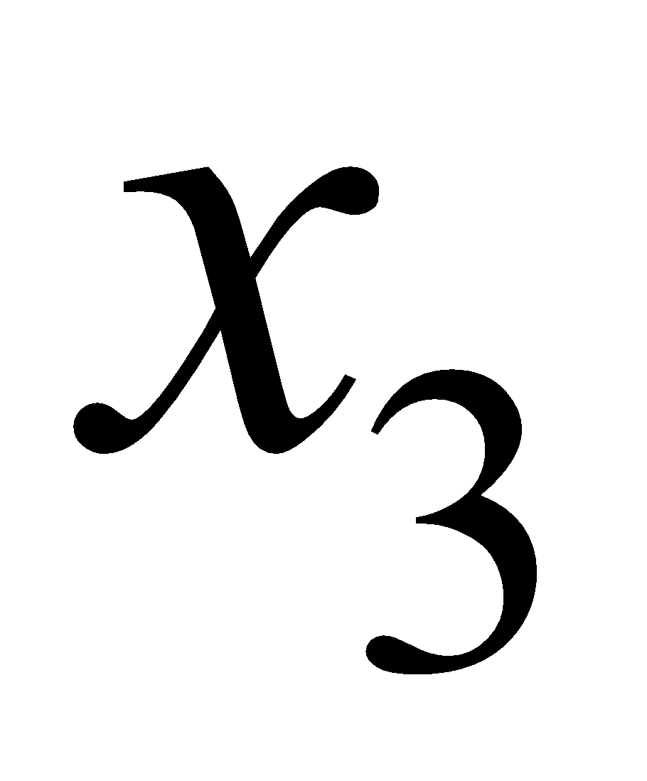 | = the number of Graphing calculators
_{P} | = Profit

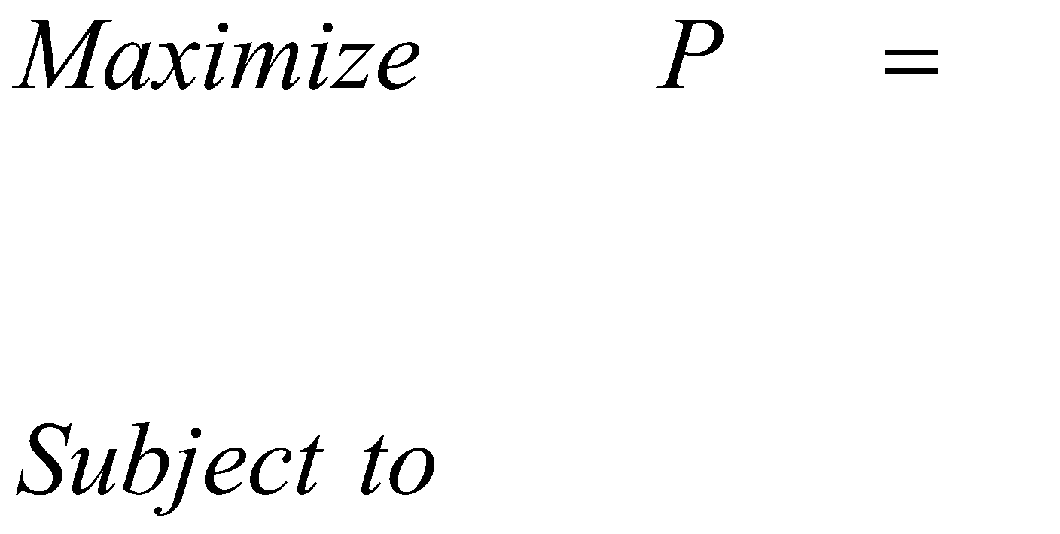

c. Introduce slack variables to obtain the initial system.

In order to answer questions d and e below you must first complete
questions f, g and h below,

d. How many of each calculator should Columbia Engineering Company
produce each month to maximize profit.

Scientific = ______ Business = ______ Graphing = ______

e. What is the maximum profit?
Maximum Profit = ______

f. Are there any unused circuit components, hours, or cases?
If there are, what are they and how many.

g. Set up the initial simplex tableau. Circle the pivot element.

h.
Now carry out successive pivoting operations to obtain an optimum solution to
the linear programming problem. In each case clearly state the row operations
used. For each tableau used, complete the leftmost column by providing
the appropriate basic variables.
You must show all work leading to the final tableau.
Show your work in the following tables. You may need less than the seven tables provided for you.

The initial simplex tableau for this problem is :

