- You have been asked to determine the least expensive route for a telephone cable that connects
Andersonville with Beantown (see figure below)
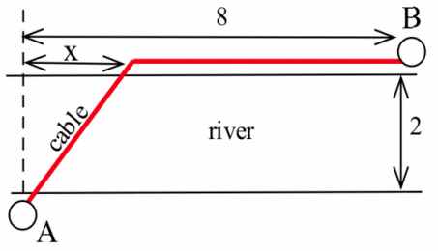
If it costs $5000 per mile to lay the cable on land and $8000 per mile to lay the cable across the river (with the cost of the cable included), find the least expensive route.

- Find the shortest distance from the point (2, 0) to the curve:
- Y=3x-1
- $y=x^{2}$
- $x^{2}+y^{2}=1$
- Y=sin(x)

- Find the dimensions of the rectangle with the greatest area that can be built so the base of the rectangle is on the x-axis between 0 and 1 and one corner of the rectangle is on the curve
$y=x^{3}$. What is the area of this rectangle?

- calculate the limit of each expression as "x→ ∞."
$$\frac{7x+12}{3x-2}$$

- same instructions as #4
$$\frac{x+sin⁡(x)}{x-\sin\left(x\right)}$$

