Kmart Team Marketing Plan
Review the different ways to segment the market and which one we should use.
Methods of segmentation
Market segmentation is a technique used to segment the market while advertising and selling products and services. The following are the four ways to segment a market, based on different customer and region-related aspects:
- Geographic market segmentation: The market can be segmented based on the geographical criteria, including states, countries, regions, cities and nations.
- Psychographic market segmentation: This segmentation type is based on examining the opinions, interests and activities of the customers in order to gain information regarding the external factors influencing them (Debelak, 2000).
- Demographic Segmentation: This market segment is undertaken according to the demographical aspect, such as income, gender, age, education and occupation.
- Behavioral segmentation: This segmentation type segregates the customers based on the awareness and knowledge regarding the product-related information, such as readiness stage, loyalty, response, knowledge and the usage rate.
Recommended Method
We recommend using Demographic segmentation, specifically income level. Demographic segmentation is easily measurable and provides clearly defined segments. The demographic segment that should be used for this marketing plan is income level because that is a factor that has a large affect on consumer buying behavior. According to the website "The Consumer Factor", income level "affects what [the consumer] can afford, his perspective on money and the level of importance of price in his purchasing decisions. But it also plays a role in the kind of retailers where he goes or the kind of brands he buys" (Perreau, F., 2014).
The K-mart team chose to segment the market based on the demographic segment descriptor of income level due to their corporate and strategic goals. This segmentation objective highlights their strategy that reflects that of a low-cost defender with future aspirations to defend their market share based on differentiation. Differentiation is the hallmark of competitive advantage, through its’ value creating traits such as customer satisfaction, low cost factors and unique features exhibited in their products and service as per Mahlburg (2004). The relationship between consumer behavior and market segmentation, specifically your target market, resides in the principle of satisfying the under-served segment, according to Boykin (2015). Kmart income level break down segments based on High Income, Upper-Middle Income, Middle Income and Low Income.

Market Segment | Buying Behavior
High Income | High income buying behavior considers consumers that have large amounts of disposable income and purchase more consumer and luxury goods such as expensive cars, homes and jewelry. These consumers are the upper three percent of society that shop at exclusive retailers demanding higher quality and complementary services at the expense of pricing; their buying decision is based on quality and the atmosphere surrounding the purchase.
Upper Middle Income | Upper-Middle income consumers are future oriented and economically sound people. These consumers are looking to enhance their quality of life because their disposable income is in excess of discretionary spending. They are drawn to higher status brands and are less sensitive to price as opposed to convenience.
Middle Income | Middle-income consumers are the average blue and white-collar workers who attempt to buy products to keep up with current trends. They aspire to raise their status level into the upper-middle class segment through promotions, overtime and budgeting concepts. The middle-income consumers are also price sensitive, and thus consider value saving options such as loyalty programs, product pricing between competitive brands, they draw self-esteem from being the bargain hunter.
Lower Income | Lower Income consumers look for products at low prices, convenience of one-stop shopping, use sales and coupons. Not concerned with brand names or shopping experience. Lower-income consumers also focus on necessities and hence purchase generics. They strive for advancement through employment and attaining better skill levels. They are normally hourly paid workers that seek out assistance from government agencies to supplement their income level. They utilize coupons and spend time on bargain pricing as opposed to speed and convenience.

List all the segments and the buying behaviors for each segment (do not include the marketing mix).

Using a Market Segmentation Map, we can obtain a visual representation of the buying behaviors of these consumers when choosing between price vs. brand names, and quality vs. convenience:
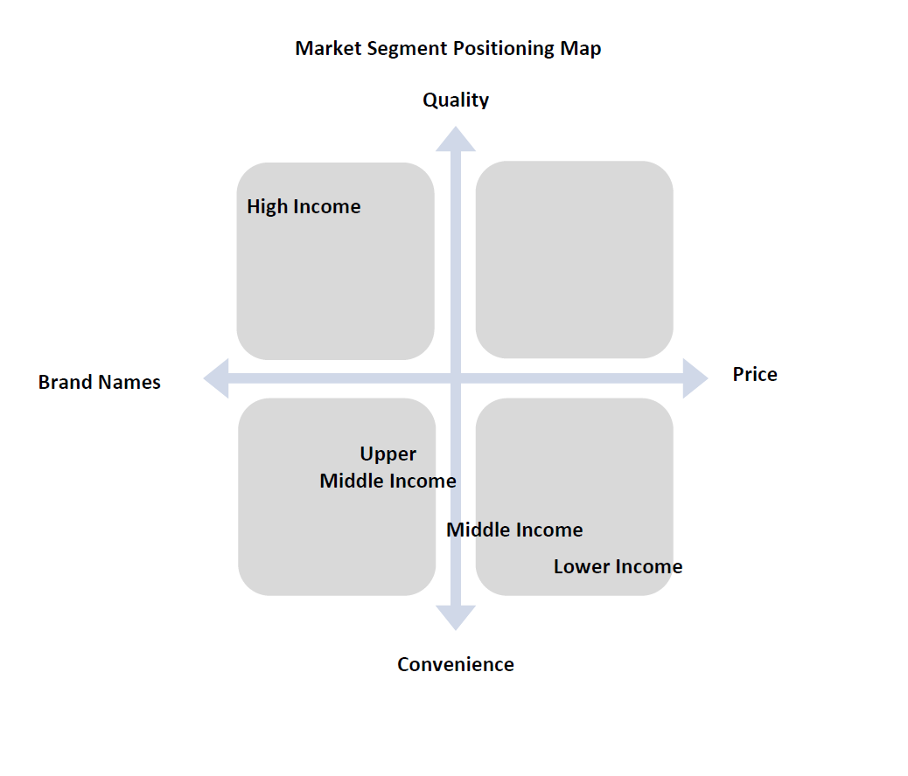
Which segment will we target?
Kmart and Kmart Corporation is focused on providing the customer with affordable products and convenience. According to the 2014 Annual Report, the major competition for Kmart stores consists of: Walmart, Target, Kohl's, and J.C. Penney (Sears Holding Corp, 2014). The following Competitive Positioning Map illustrates how Kmart aligns with the varied needs of the consumer as compared to the competition. You can see that Kohl's focuses on offering high quality, brand name products. JCPenney also offers many brand names, but is more concerned with convenience over quality. Walmart is very similar in product offerings to Kmart, offering convenience and low prices to their customers.
By comparing this positioning map to the Market Segment Positioning Map in the previous section, it can be determined which market segment best aligns Kmart's offerings. Based on the market segments that were defined earlier, and comparing the preferences of each segment to the existing strengths of Kmart, we recommend targeting the lower income group. They are the segment that directly aligns with Kmart’s strengths and can provide market growth without a major strategy shift within the organization. The low -income consumer looks for products that are offered at a low price, they want to be able to get all of their shopping done at one time so the one-stop-shopping experience that Kmart provides meets the needs of the customer. Also Low-income consumers want to be able to take advantage of sales and coupons and Kmart provides that as well. The low-medium income consumer is looking for name brand items at low cost but higher quality. These consumers also enjoy the one-stop-shopping experience. The medium-high income consumers are not as concerned with the cost and are looking for high quality name brand products. Knowing what features their target market desires, and knowing that these desires align with their current strategy, Kmart can focus on enhancing their strengths and continue to offer even lower prices and more convenience to their customers to further differentiate themselves and their products from the competition.
.
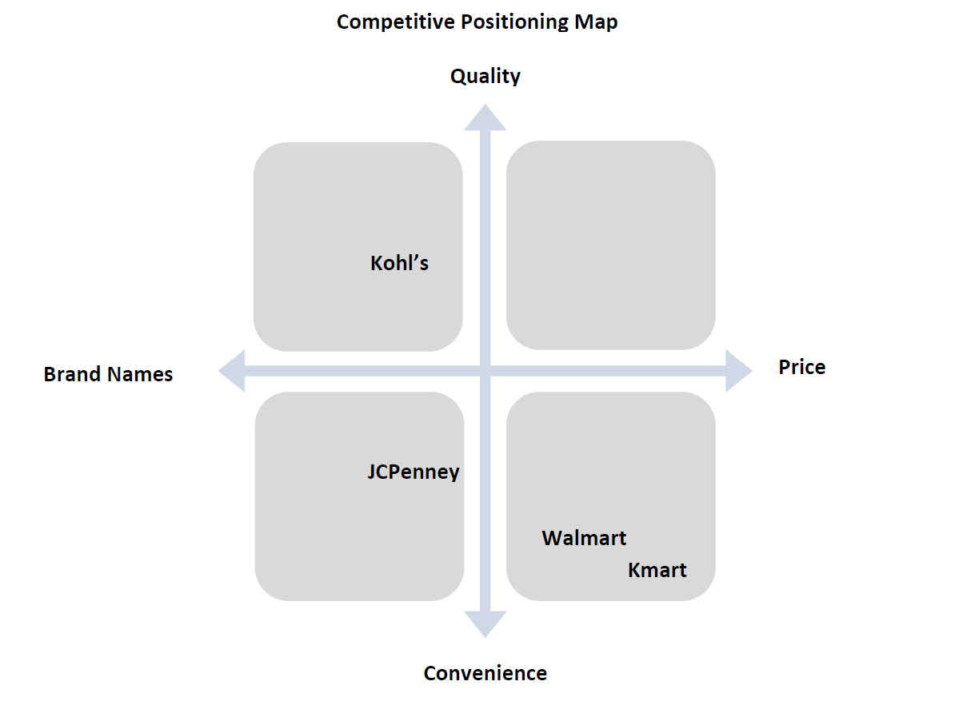
Which marketing strategy will we use (market development, product development, market penetration, diversification)?
Based on much information and market research, we have decided that the best marketing strategy for Kmart moving forward would be through market penetration. Market penetration strategies are best for increasing market share using current products in a current markets. Kmart has many products that will appeal to our target market segment that are already developed (store brand clothing, blue-light specials, in-store services), and this is the current segment that is already targeted by Kmart stores. We want to increase market share, increase product usage, and introduce new applications (new services, grocery shopping, etc). (Mullins & Walker, 2013, pg. 50, Exhibit 2.9). Due to the availability of existing products and target market, the method of market penetration that we will specifically focus on includes increasing the market share or sales volume through an existing customer base (Lehmann & Winer, p. 261). In choosing this path we are going to focus on low-income consumers and how we can attract new low-income consumer or create situations where regular low-income consumers are able to spend more money. The specific tactics to be used to attract these consumers include:
- Coupons
- Shop Your Way Rewards (SYW)
- Layaway
- Leasing
- Sears Store/Credit Card
Coupons:
Most low-income consumers may not be concerned with brand name products and most coupons are distributed by brand name companies, so at first it may not seem like a good strategy. If comparing prices based on what is on the shelf alone and no other discounts taken into consideration it would seem like generics would win every time. However, adding a coupon to a brand name item may actually make the brand name item cost less than a generic item. In this way consumers can actually save money during a shopping trip and receive better products. By pushing coupons we can give the image that consumers are saving money which could lead to them spending more money in the long run. We will also be able to stock products in larger quantities and sizes if we know that there are coupons available for those products. Kmart also has a policy of doubling manufacturing coupons up to $1.00, which is another incentive to use coupons. At checkout Kmart also prints out CRTs (Cash Register Tape) and catalina coupons. These coupons are determined per shopper, and this is done by having a customer sign up for a Kmart Shop Your Way card. The register and catalina coupon printer prints out coupons based on consumers past purchase in hope that it will influence future purchases. In essence, there are many different ways in which consumers can obtain and use coupons to influence purchasing behavior. Part of this strategy will also include promoting grocery shopping. Many customers in the low-income market may use government assistance for grocery spending. Kmart is not generally seen as a place to go grocery shopping, but with the various ways to use coupons we are looking to attract the low-income consumers into Kmart for all of their grocery shopping needs for a one stop shopping experience. (Kmart Coupon Policy, 2015).
Shop Your Way (SYW) Rewards:
Shop Your Way (SYW) Rewards is another way in which Kmart should target low-income consumers. People go shopping regularly simply for the necessity of it, so why not provide an incentive for consumers to choose your store to shop at? The SYW incentive program gives the consumer 1% back of the total price paid at checkout in store credit. The program also provides occasional surprise SYW points to spend during a specific time frame or by spending a certain amount of money in a certain area of the store. Becoming a SYW member is free and it provides many different incentives to come shopping at the Kmart. Customers can combine earned SYW points and coupons for additional savings. (Shop Your Way, 2015)
Layaway:
Kmart is one of the few stores that provide Layaway services to customers year round. Since low-income consumers generally live pay check to pay check it is important to have an option to attract these customers for bigger ticket items and larger purchase orders on nonperishable items such as toys, clothing, and sporting goods to name a few items. The general layaway guidelines allows for either an 8-week or 12-week time frame based on the total price of the purchase and payments are to be made bi-weekly until the layaway is paid in full. There are layaway service fees of $5/$10 respectively and layaway cancellation fees of $10/$20 respectively. During the holiday season layaway service charges may even be waved. Increasing the number of layaways will increase sales and bring in extra income through servicing fees. The layaway program is a great option for those who do not qualify for other programs such as leasing or store credit card, both programs which are described below. (Kmart Layaway, 2015)
Leasing:
Kmart should also start pushing leasing options to low-income consumers. The difference between leasing and layaway is that the consumer will get to take the item home the day that first payment is made with the opportunity to make payments over a certain timeframe. In some instances consumers may not be able to wait (he or she needs a new refrigerator immediately) or have no intention of waiting for a layaway to be paid off to take an item home to use (for example a flat screen television or new gaming system). There is a percentage added to the price of the item for the term of the lease, and this can sometimes be determined by the length of time it takes to pay off the items. One set back is that a credit check is required and not all individuals may be approved for the leasing option, which could in turn help Kmart push for the layaway program. (Leasing, 2015)
Sears Store/Credit Card:
Sales by credit will be another option to attract low-income consumers. Credit cards may be limited to certain customers based on a credit check and approval, but often times if a customer is approved it is a way to attract extra revenues through credit card purchases and interest collected from the unpaid credit card balances. To attract consumers to the credit option we may also create incentives to apply and then to use the card. These incentives could include a percentage of the first initial sale or SYW rewards incentives. Most low-income consumers are unable to pay off full balances so interest revenue is almost guaranteed. A potential downfall to the use of this tactic is if a customer defaults on payments as Kmart will be out the products and the money from the credit card payments. (Sears Credit Card Offer 2015)

References:
Boykin, George, (2015). Relationship between consumer behavior and target markets. Chron. Retrieved from: http://smallbusiness.chron.com/relationship-between-consumer-behavior-target-markets-71260.html
Debelak, D. (2000). Streetwise Marketing Plan: Winning Strategies for Every Small Business. Adams Media.
Kmart’s Coupon Policy 2015. (2010, June 16). Retrieved November 5, 2015. http://www.cuckooforcoupondeals.com/questions/coupon-policies/kmarts-coupon-policy/
Kmart Layaway. (2015). Retrieved November 5, 2015.
http://www.kmart.com/en_us/dap/layaway.html
Leasing. (2015). Retrieved November 5, 2015.
http://www.kmart.com/en_us/dap/leasing.html
Lehmann, D., & Winer, R. (2008). Analysis for marketing planning (7th ed.). Boston: McGraw-Hill Irwin.
Mahlburg, Chris, (2004). Value Creation: Differentiation pays off. Industry Week. Retrieved from: http://www.industryweek.com/planning-amp-forecasting/value-creation-differentiation-pays?page=1
Perreau, F. (2014, November 28). The 4 Factors Influencing Consumer Behavior. The Consumer Factor: Consumer Insights, market research, consumer behavior, and neuromarketing. Retrieved on 10/29/15 from: http://theconsumerfactor.com/en/4-factors-influencing-consumer-behavior/
Sears Credit Card Offers. (2015). Retrieved November 5, 2015. http://www.kmart.com/en_us/dap/sears-credit-card-offers.html?adcell=footersearscreditcard
Sears Holding Corp. (2014) Sears Holding Corp. Form 10-K. United States Securities and Exchange Commission: Washington D.C. Retrieved on 10/10/15 from: http://searsholdings.com/docs/investor/SHC_2014_Form_10-K.pdf
Shop Your Way. (2015). Retrieved November 5, 2015.
http://www.kmart.com/en_us/dap/shop-your-way.html
Stauble, V. R. (2000). Marketing Strategy: A Global Perspective. Dryden Press.

