Plan-Do-Check-Act (PDCA) Cycle
Looking for more on the PDCA model?
Try Plan-Do-Study-Act (PDSA) Plus QTools™ Training:
- Plan-Do-Study-Act
- Plan-Do-Study-Act plus QToolsTM
Also called: PDCA, plan–do–study–act (PDSA) cycle, Deming cycle, Shewhart cycle
The plan–do–check–act cycle (Figure 1) is a four–step model for carrying out change. Just as a circle has no end, the PDCA cycle should be repeated again and again for continuous improvement.
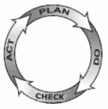
Figure 1: Plan-do-check-act cycle

When to Use Plan–Do–Check–Act
- As a model for continuous improvement.
- When starting a new improvement project.
- When developing a new or improved design of a process, product or service.
- When defining a repetitive work process.
- When planning data collection and analysis in order to verify and prioritize problems or root causes.
- When implementing any change.

Plan–Do–Check–Act Procedure
- Plan. Recognize an opportunity and plan a change.
- Do. Test the change. Carry out a small-scale study.
- Check. Review the test, analyze the results and identify what you’ve learned.
- Act. Take action based on what you learned in the study step: If the change did not work, go through the cycle again with a different plan. If you were successful, incorporate what you learned from the test into wider changes. Use what you learned to plan new improvements, beginning the cycle again.

Plan–Do–Check–Act Example
The Pearl River, NY School District, a 2001 recipient of the Malcolm Baldrige National Quality Award, uses the PDCA cycle as a model for defining most of their work processes, from the boardroom to the classroom.
PDCA is the basic structure for the district’s overall strategic planning, needs–analysis, curriculum design and delivery, staff goal-setting and evaluation, provision of student services and support services, and classroom instruction.
Figure 2 shows their “A+ Approach to Classroom Success.” This is a continuous cycle of designing curriculum and delivering classroom instruction. Improvement is not a separate activity: It is built into the work process.
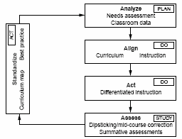
Figure 2: Plan–do–check–act example
Plan. The A+ Approach begins with a “plan” step called “analyze.” In this step, students’ needs are analyzed by examining a range of data available in Pearl River’s electronic data “warehouse,” from grades to performance on standardized tests. Data can be analyzed for individual students or stratified by grade, gender or any other subgroup. Because PDCA does not specify how to analyze data, a separate data analysis process (Figure 3) is used here as well as in other processes throughout the organization.
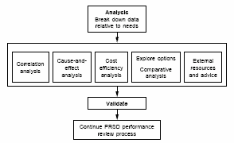
Figure 3: Pearl River: analysis process
Do. The A+ Approach continues with two “do” steps:
- “Align” asks what national and state standards require and how they will be assessed. Teaching staff also plans curriculum by looking at what is taught at earlier and later grade levels and in other disciplines to assure a clear continuity of instruction throughout the student’s schooling. Teachers develop individual goals to improve their instruction where the “analyze” step showed any gaps.
- The second “do” step is, in this example, called “act.” This is where instruction is actually provided, following the curriculum and teaching goals. Within set parameters, teachers vary the delivery of instruction based on each student’s learning rates and styles and varying teaching methods.
Check. The “check” step is called “assess” in this example. Formal and informal assessments take place continually, from daily teacher “dipstick” assessments to every-six-weeks progress reports to annual standardized tests. Teachers also can access comparative data on the electronic database to identify trends. High-need students are monitored by a special child study team.
Throughout the school year, if assessments show students are not learning as expected, mid-course corrections are made such as re-instruction, changing teaching methods and more direct teacher mentoring. Assessment data become input for the next step in the cycle.
Act. In this example the “act” step is called “standardize.” When goals are met, the curriculum design and teaching methods are considered standardized. Teachers share best practices in formal and informal settings. Results from this cycle become input for the “analyze” phase of the next A+ cycle.
Excerpted from Nancy R. Tague’s The Quality Toolbox, Second Edition, ASQ Quality Press, 2004, pages 390-392.

