- A circle of radius 3 inches is inside a square with 12-inch sides (see figure below). How fast is the area between the circle and square changing if the radius is increasing at 4 inches per minute and the sides are increasing at 2 inches per minute?

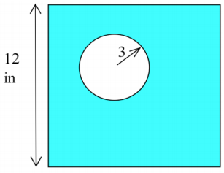

- Find $\frac{dy}{dx}$ in two way (a) by differentiating implicitly and (b) by explicitly solving for y and then differentiating. Then find the value of $\frac{dx}{dy}$ at the given point using your results from both the
implicit and the explicit differentiation.

$x^{2}+5y^{2}=45$, point: (5, 2)

- Find $\frac{dy}{dx}$ using implicit differentiation and then find the slope of the line tangent to the graph of the equation at the given point.
$y^{2}-5xy+x^{2}+21=0$point: (2, 5)

- Find $\frac{dy}{dx}$ in two ways: (a) by using the “usual” differentiation patterns and (b) by using logarithmic differentiation.
$y=\cos^{7}{(2x+5)}$

- use logarithmic differentiation to Find $\frac{dy}{dx}$
$y={\left(\cos\left(x\right)\right)}^{x}$

