solve
- If f(x) =7x + 11 and g(x) =5x- 1, find f(g(x)). What is f(g(2))?

- Find the average rate of change of the function shown below over the given interval. y=-$3x^{2}$ - x, [5, 6]

- Find the limit, if it exists. $\lim_{x→4} \frac{x^{2}+4x-32}{x^{2}-16}{{}^{}}$

- Find an equation for the tangent to the curve at the given point. y=$x^{2}$- x, (-4,20)

- Calculate the derivative of the function. Then find the value of the derivative as specified. f(x)= $x^{2}$+ 7x- 2; f (0)

- Solve. Find the point where the graph of the function has a horizontal tangent. f(x)=$4x^{2}$+ 5x+ 2

- Find all points "x" where the function whose graph is shown below is discontinuous.

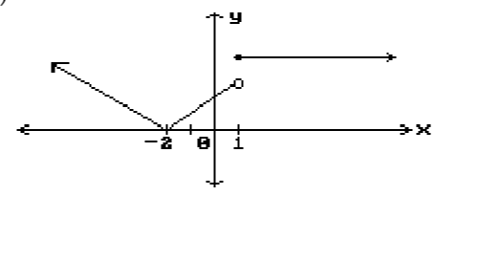

- A function f(x), a point c, the limit of f(x) as x approaches c, and a positive number ɛ is given. Find a number δ> 0 such that for all x,0<|x – c|<δ ⟶ |f(x)- L| <ɛ.
f(x)=5x+ 9, L=29, c=4, and ɛ= 0.01

- Use the graph of the function f(x) to evaluate the limit, or state that the limit does not exist.
$$\lim_{x→0} f(x){{}^{}}$$
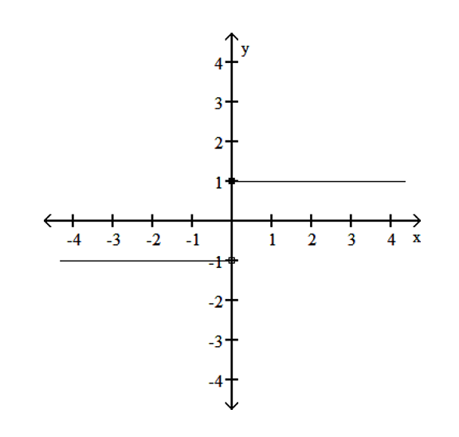

- Find an equation of the line passing through the given point and parallel to the graph of the function shown. Write the equation using function notation. 10) Through (7,3); parallel to f(x)=4x- 6

