New Competencia Demographic Data
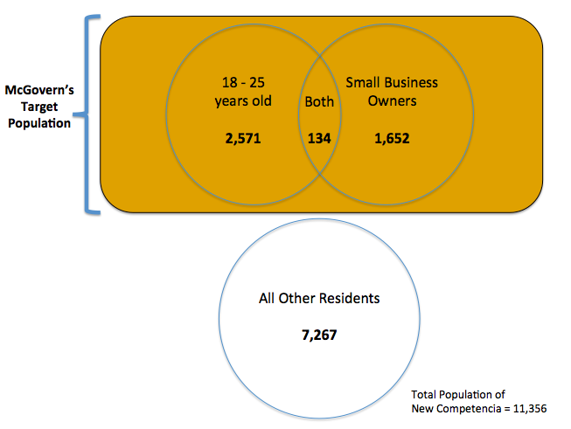

1. Assuming no calls have been made to New Competencia residents yet, what is the probability that the first phone call will be to someone in McGovern’s target population?

2. A few hours into your visit, the polling center has called 37 small business owners, 63 residents between ages 18-25, 12 residents who fell into both categories, and 133 non-target residences. What is the probability that the next phone call will be to a resident who is between ages 18-25 or a small business owner?

3. Your visit is wrapping up and the polling center is preparing to close in 10 minutes. The polling staff have called 787 residents throughout the day; 212 of those residents are part of McGovern’s target population. What is the probability that the last two calls of the day will be to residents in McGovern’s target population?

4. As you thank one of the polling staffers for your visit she tells you that of the 862 people called that day, the center reached 256 residents in McGovern's target population. She says, "I appreciate what great attention you have paid to our work. Given the information you gathered today, can you tell us what the likelihood will be that the first call we make tomorrow will be to someone in McGovern's target population? We are really under pressure!" What is the likelihood and how would you explain to the staffer how you came to that conclusion?

