B.1 Solve the following linear programming problem
graphically:
Maximize profit = 4X + 6Y
Subject to: X + 2Y … 8
5X + 4Y … 20
X, Y U 0

B.5 Solve the following LP problem graphically:
Minimize cost = 24X + 15Y
Subject to: 7X + 11Y U 77
16X + 4Y U 80
X, Y U 0

B.7 The Attaran Corporation manufactures two electrical
products: portable air conditioners and portable heaters. The
assembly process for each is similar in that both require a certain
amount of wiring and drilling. Each air conditioner takes 3 hours
of wiring and 2 hours of drilling. Each heater must go through
2 hours of wiring and 1 hour of drilling. During the next production
period, 240 hours of wiring time are available and up to
140 hours of drilling time may be used. Each air conditioner sold
yields a profit of $25. Each heater assembled may be sold for a
$15 profit.
Formulate and solve this LP production-mix situation, and
find the best combination of air conditioners and heaters that
yields the highest profit

B.11 The Sweet Smell Fertilizer Company markets bags
of manure labeled “not less than 60 lb dry weight.” The packaged
manure is a combination of compost and sewage wastes. To
provide good-quality fertilizer, each bag should contain at least
30 lb of compost but no more than 40 lb of sewage. Each pound
of compost costs Sweet Smell 5¢ and each pound of sewage costs
4¢. Use a graphical LP method to determine the least-cost blend
of compost and sewage in each bag.

B.21. Par, Inc., produces a standard golf bag and a deluxe
golf bag on a weekly basis. Each golf bag requires time for cutting
and dyeing and time for sewing and finishing, as shown in the following
table:
HOURS
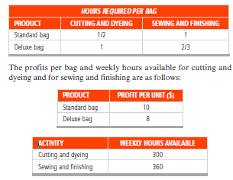REQUIRED PER BAG
PRODUCT CUTTING AND DYEING SEWING AND FINISHING
Par, Inc., will sell whatever quantities it produces of these two
products.
a) Find the mix of standard and deluxe golf bags to produce per
week that maximizes weekly profit from these activities.
b) What is the value of the profit?

