1. Complete the square in order to put the equation into standard form. Identify the center and the radius or explain why the equation does not represent a circle.

2. Find the standard equation of the circle with endpoints of a diameter
$(-3, 7)$ and $(1, 5)$.

3. Find an equation of a parabola satisfying the given: Focus $(0, 3)$, Vertex $(0, 0)$

4. Find the vertex, the focus, and the directrix of the parabola. Then sketch the parabola. Computer generated graph will not be accepted.
$${x=-\frac{1}{2}y}^{2}$$

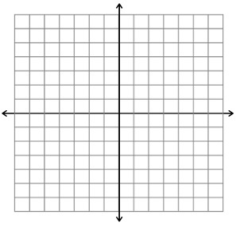
5. Find the vertices and the foci of the ellipse with the equation. Then sketch the ellipse. Computer generated graph will not be accepted.

$$4x^{2}+9y^{2}=36$$

6. Find an equation of the ellipse satisfying the conditions
Vertices: $\left(0, 9\right),(0,-9)$, Foci: $\left(0,-5\right),(0, 5)$

7. Find an equation of the hyperbola with vertices $\left(-2, 0\right), (2, 0)$ and foci $\left(-5, 0\right), (5, 0)$. Then find the asymptotes.

8. Find the center, the vertices, the foci, and the asymptotes of the hyperbola. Then sketch the hyperbola and the asymptotes. Computer generated graph will not be accepted.
$$16y^{2}-9x^{2}=144$$

