- FIGURE 1 shows the block diagram of a superhetrodyne radio receiver. In a test a 20 μV signal was fed from the aerial into the first stage of the receiver, a radio frequency amplifier. This signal is then passed through several stages of the receiver to eventually appear at the input to the AM detector. For the AM detector to work satisfactory it requires a minimum signal level of –3dB(mW). Calculate the required minimum gain of the fifth intermediate amplifier given the data in TABLE 1.

Stage | Gain
RF amplifier | +10 dB
Mixer | –7 dB
BPF | –1 dB
IF1 | +15 dB
IF2 | +15 dB
IF3 | +20 dB
IF4 | +10 dB

TABLE 1

20 μV
–3 dB (mW)
Amplifier
Mixer
Band pass filter
Intermediate amplifier 1
Intermediate amplifier 2
Intermediate amplifier 3
Intermediate amplifier 4
Intermediate amplifier 5
AM
detector
(75 Ω)

FIG. 1

- As a rule of thumb, the perceived noise from a source falls by 6 dBA with every doubling of the distance from the source.

If a 1 MW wind turbine (FIGURE 2) produces 103 dBA of noise within one metre of its base, estimate the distance from the turbine at which the noise can be reckoned to have fallen below the background noise level of 40 dBA.

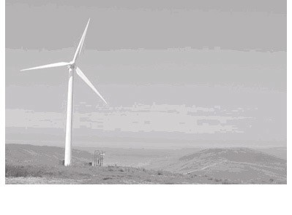Background level
Noise level/dBA

Distance

FIG. 2

- A simplified model of ADC noise refers the noise to a noisy input source resistance Rn while assuming the rest of the signal path to be noiseless.
FIGURE 3 represents a particular 18-bit ADC that has a 10 V input
voltage range. The ADC has a bandwidth of 1 MHz.

Calculate the maximum value of Rn if the resolution of the ADC is not to be adversely affected by thermal noise. Assume the ADC operates at 25°C.

[N.b. The voltage resolution of an ADC is equal to its overall voltage measurement range divided by the number of discrete values possible on its output.]

Analogue input

Rn
1

Digital output 18 lines
ADC
18

FIG. 3

- The specification for a 4-way TV antenna amplifier [FIGURE 4] is given
in TABLE 2, below.

TABLE 2

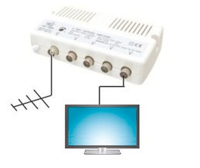
FIG. 4
Bandwidth | 40–862 MHz
Gain | 20 dB
Noise Figure | 6 dBB
Max. Output | 85 dBμV
Input Impedance | 75Ω
Output Impedance | 75Ω

  - Determine the voltage required on the input of the amplifier to give the maximum output of 85 dBμV.

  - If the signal level from the aerial is 5 dBmV and the input noise level is 20 dBμV, calculate the signal-to-noise ratio on the output of the amplifier.

- A voltage amplifier ideally should have the input-output relationship of
vo = 100vi but in practice the relationship is vo = vi(98 + 2vi).

Calculate the %age second harmonic distortion present in the amplifier’s output for a sinusoidal input of 10 mV r.m.s.

6.
You may find the following relationship helppful in answering this
question:
For a lossless line:
The characteristic impedance is given by Z
o
= L
C
and the velocity of propagation by v =
p
1
LC
where L and C are, respectively, the line's inductance and
capacitance per metre length.

A transmission line is formed by two identical parallel tracks in a printed circuit board, as depicted in FIGURE 5. The line has a length of 50 mm and all line terminations are of 70 Ω. The line can be assumed to be lossless.

  - Use equations (4) and (5) from the lesson to calculate the magnitude of the NEXT and FEXT voltages generated in the victim conductor when the source voltage, Vin, in the aggressor conductor is a voltage step of 2 V with a rise time of 100 ps.

[Note that the Vs voltage at the input to the aggressor conductor is
R

V = V
in .]

s in R + Z
in o

  - Sketch the NEXT and FEXT waveforms.

The relevant parameters for the line are listed in TABLE 3.

Aggressor
70 Ω
70 Ω

Victim

Ground plane
PCB

70 Ω
Rin

Vin

FIG. 5

Parameter | Value
Line inductance | 400 nH per m
Line capacitance | 80 pF per m
Mutual inductance | 80 nH per m
Mutual capacitance | 10 pF per m

TABLE 3

