# Question 3:

A dynamical system is governed by two equations

*x*  4  *y*  2*x*,

*y*  *y* 8  *y*  12*x*.

1. Show that the critical points of this system are *P*(0, 0) and *Q*(1, 2).
2. Using linearation of the system in the neighbourhood of each critical point, determine the nature of the critical points.
3. Draw qualitatively and reasonably careful these critical points and corresponding trajectory diagrams.

# Question 4:

Minimise the functional

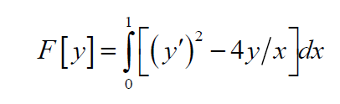

such that *y*(0) = *y*(1) = 0 .