Review the Critical Thinking Activity called Which Approach is Best? Select a health care entity to focus on, this could be a clinic or hospital of your choosing. Review the debate that is discussed between Sandra and Juan and answer the following questions:
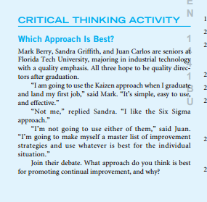

If you were the supervisor of Sandra and Juan, how would you guide their discussion in determining the best improvement strategy?

As CEO of the health care entity of your choosing, what strategy would you choose to reduce the turn- around time for test results? Reduce patient complaints?

As CEO of the health care entity of your choosing, how would you explain the rationale for continual improvement to your management team, nurses, clinicians, doctors, etc? Why is it important for all levels of the organization strive for continual improvement?

Explain why total quality can be implemented in any business environment? How can it be utilized in health care?

