Lesson - Week Five Part 1

Week 5

Economic Policy
This week we are tackling economic and health care policy. These are two hot policy areas right now. We are going to look at economic priorities and policy strategies, budgeting, taxation, and the current debt and federal budget crisis. We are also going to look at health care policy, Medicare, Medicaid, state CHIP programs, and look critically at recent policy developments in this arena.

To start, let’s take a look at a couple of videos discussing economic policy.

CNBC interviews 2013 laureate in economics sciences, Lars Peter Hansen, on Squak Box.
http://video.cnbc.com/gallery/?video=3000286677#.

Jacob Hacker, Yale University, discusses the US economic policy in hindsight at a conference held by the Brookings Institute.
https://www.youtube.com/watch?v=nxEZ4Ak7sxw&feature=youtu.be

Fox News Panel on whether the 2011 economic policies were ‘protectionist’
http://video.foxbusiness.com/v/3890059/us-economic-policies-protectionist/?#sp=show-clips

Goals of Economic Policy:
- Economic growth
- Low levels of unemployment
- Low levels of inflation
- Positive balance of trade
- Limiting/managing deficits and debt
As our text points out, we cannot consider one economic goal without considering how it is interrelated to another goal. Kraft points out three specific relationships:
- Inflation and full employment
- Economic growth and inflation
- Federal deficits (debt), economic growth and unemployment
“Governments have a variety of policy tools to help them achieve their goals and deal with economic issues.” (Kraft, 2013, p. 238) These include:
- Fiscal policy
- Monetary policy
- Regulation
- Incentives, subsidies and support
- Tax policy
The budget process ties several economic tools together to effect economic policy. In terms of the federal budget process, Kraft lays out 6 specific steps:

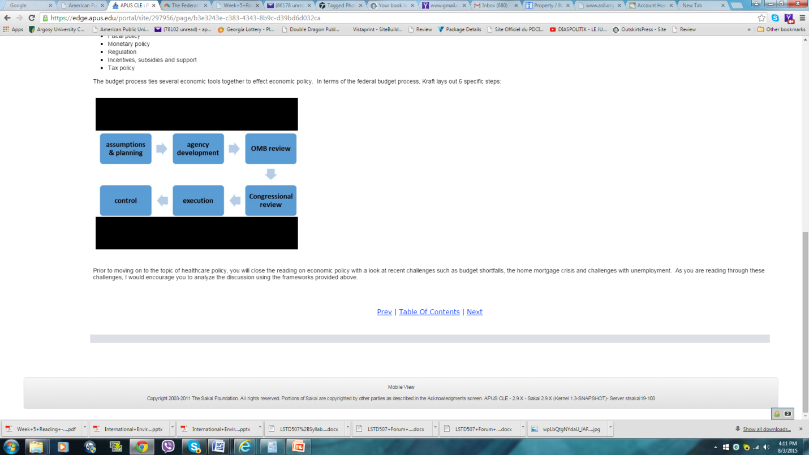

Prior to moving on to the topic of healthcare policy, you will close the reading on economic policy with a look at recent challenges such as budget shortfalls, the home mortgage crisis and challenges with unemployment. As you are reading through these challenges, I would encourage you to analyze the discussion using the frameworks provided above.

