Purpose of Assignment

The purpose of this assignment is for you to analyze how an event will influence the market equilibrium.
Background: Suppose the weather in Florida was extremely cold one winter. This event would affect the market for coffee in Florida, causing the demand curve to shift to the right. Remember an event that changes the demand for a product shifts the demand curve to the right. Likewise, a decrease in the supply of a product shifts the supply curve to the left. Review the Figures 10-12 on pp. 79, 80, & 82 for illustrations of these different shifts.

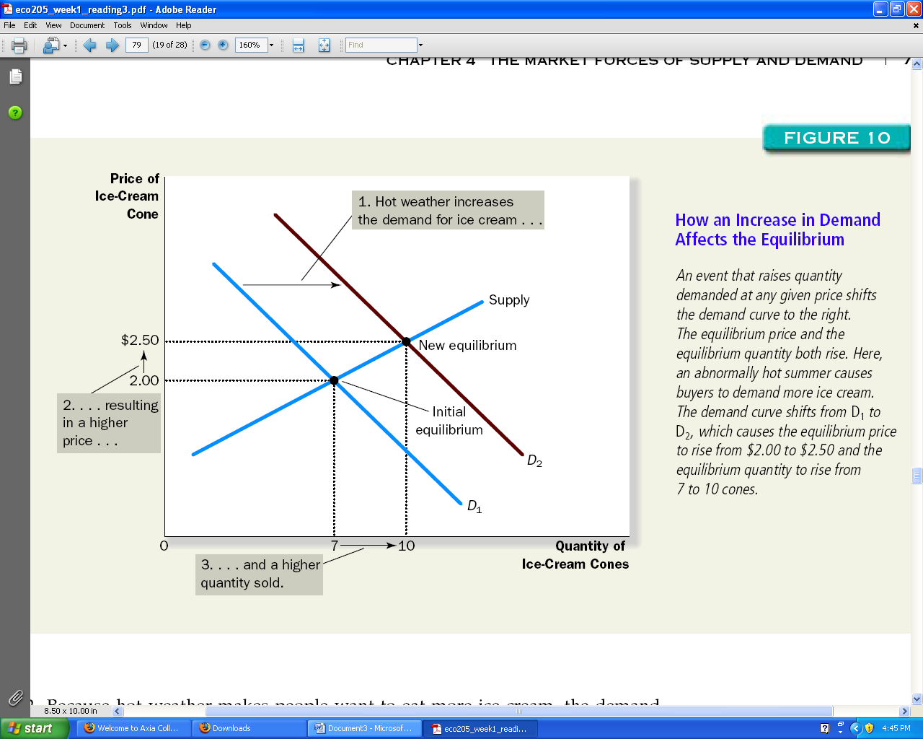

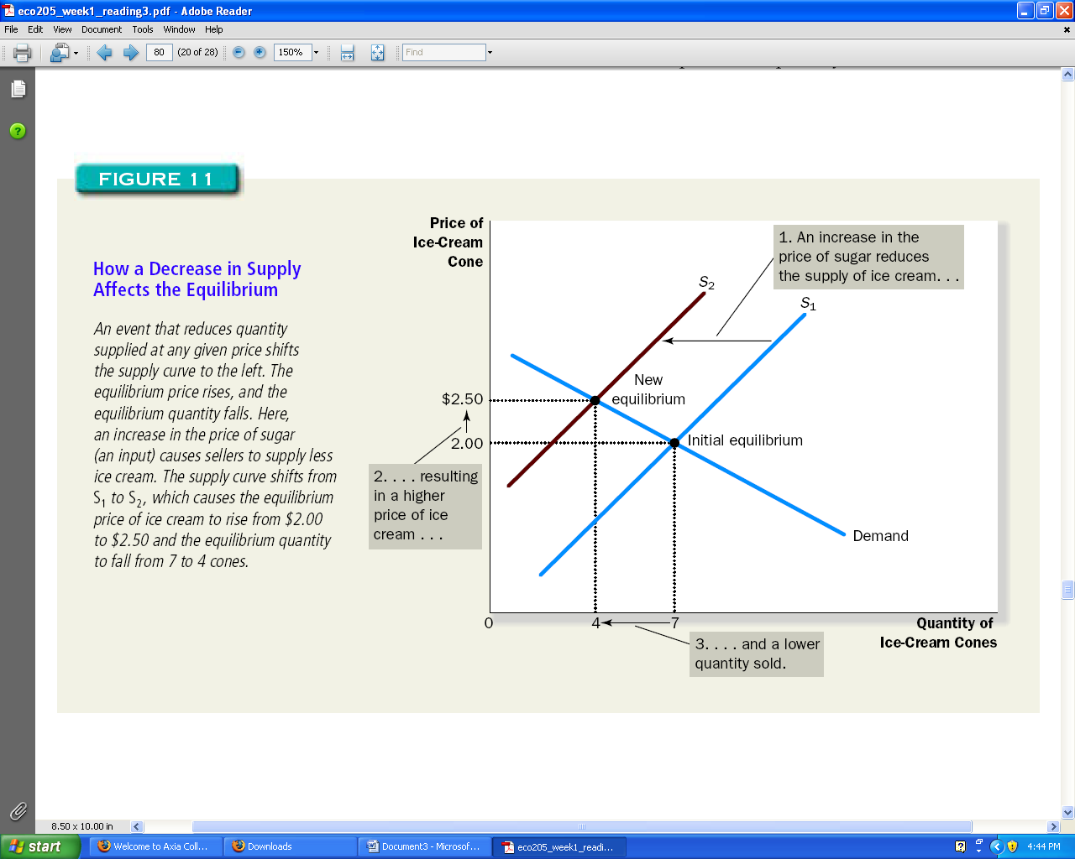

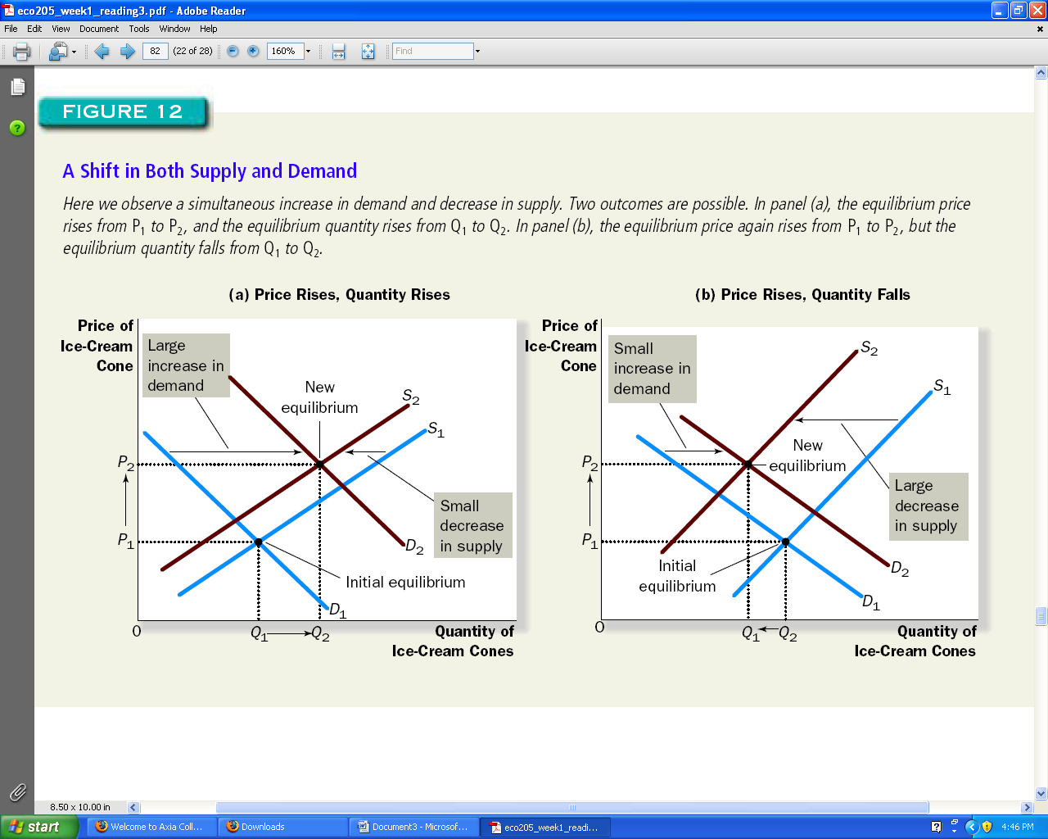

Assignment: Supply and Demand

Purpose of Assignment

This assignment assesses student understanding of supply and demand. After completing the assigned reading and viewing the three-part interactive tutorial, Appendix C can be completed and submitted. The assignment addresses the relationship between price and quantity on the supply and demand curves. Students will explore factors that shift the supply and demand curves and how the equilibrium price is affected.

Resources Required

This is an awesome link. If you want to do well on the written assignment, study the material at this link.

Interactive Activity: Supply and Demand http://www.bized.co.uk/learn/economics/markets/mechanism/interactive/part1.htm

Answer the following questions.

- If the price of a good increases, what happens to demand?
- If the price of a good decreases, what happens to supply?
- Does a change in price create curve shifts? Explain.
Complete the following matrix. An example is provided.
Event | Market affected by event | Shift in supply, demand, or both. Explain your answer. | Change in equilibrium
Frozen orange crops in California | Orange juice | Supply (left)—Not as many available oranges to offer consumers. | Price will increase and quantity will decrease.
Hurricanes in the Gulf Coast | Gulf Coast tourism
Price of hot dogs increases | Hamburger
Price of sugar increases | Candy
New auto company opens in Detroit | Automobile
War in Middle East | Gasoline
Movie theaters increase admission prices | Video rentals
Very trendy designer handbag manufacturer enters the market | Hand bags
Cost of cotton decreases | Textiles
Tennis racquets decrease in price | Tennis balls
Technology improves efficiency in pasta manufacturing | Pasta

