Select the graph that matches the numbered manufacturing cost data. Indicate by letter which graph
Best fits the situation or item described. (· (Click to view the graphs.)
The vertical axes of the graphs represent total cost, and the horizontal axes represent units produced
during a calendar year. In each case, the zero point of dollars and production is at the intersection of the two axes. The graphs may be used more than once.

1. Annual depreciation of equipment, where the amount of depreciation charged is computed by the machine-hours method.
- Electricity bill - a flat fixed charge, plus a variable cost after a certain number of kilowatt-hours are L
in which the quantity of kilowatt-hours used varies proportionately with quantity of units produced.
- City water bill, which is computed as follows:
First 1,000,000 gallons or less $1,000 flat fee

Next 10,000 gallons
Next 10,000 gallons
Next 10,000 gallons and so on
$0.003 per gallon used
$0.006 per gallon used
$0.009 per gallon used and so on

The gallons of water used vary proportionately with the quantity of production output.
4. Cost of direct materials, where direct material cost per unit decreases with each pound of material u: example, if 1 pound is used, the cost is $10; if 2 pounds are used, the cost is $19.98; if 3 pounds are the cost is $29.94), with a minimum cost per unit of $9.20.
5. Annual depreciation of equipment, where the amount is computed by the straight-line method. Whe depreciation schedule was prepared, it was anticipated that the obsolescence factor would be great1 the wear-and-tear factor.
6. Rent on a manufacturing plant donated by the city, where the agreement calls for a fixed-fee payme
unless 200,000 labor-hours are worked, in which case no rent is paid.
- Salaries of repair personnel, where one person is needed for every 1,000 machine-hours or less (th to 1,000 hours requires one person, 1,001 to 2,000 hours requires two people, and so on.)
- Cost of direct materials used (assume no quantity discounts.)
- Rent on a manufacturing plant donated by the county, where the agreement calls for rent of $100,0C reduced by $1 for each direct manufacturing labor-hour worked in excess of 200,000 hours, but a IT rental fee of $20,000 must be paid.

Graph/Chart

1
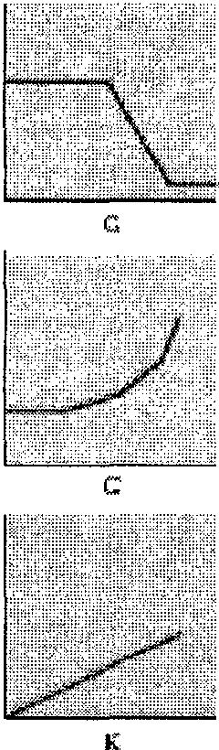(cont.)

D

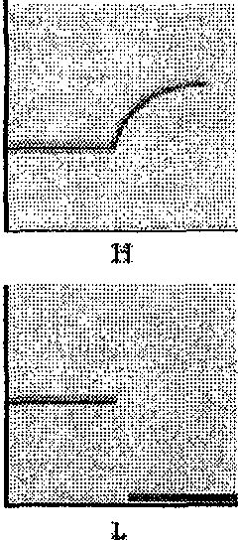

2.
Given here are a number of graphs.

(Click to view the graphs.)
The horizontal axis represents the units produced over the year and the vertical axis represents total cost or revenues. Indicate by number which graph best fits the situation or item described. Some graphs may be used more than once; some may not apply to any of the situations.

  - Direct material costs
  - Supervisors' salaries for one shift and two shifts
  - A cost-volume-profit graph
  - Mixed costs-for example, car rental fixed charge plus a rate per mile driven
  - Depreciation of plant, computed on a straight-line basis
  - Data supporting the use of a variable-cost rate, such as manufacturing labor cost of $14 per unit pr
  - Incentive bonus plan that pays managers $0.1O for every unit produced above some level of produc
  - Interest expense on $2million borrowed at a fixed rate of interest Graph/Chart

1 l :l

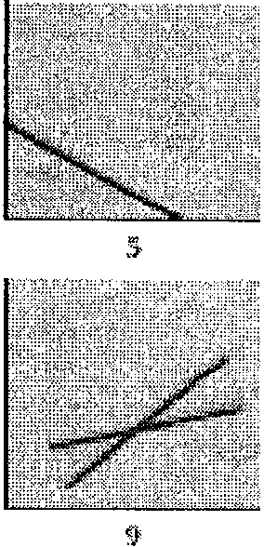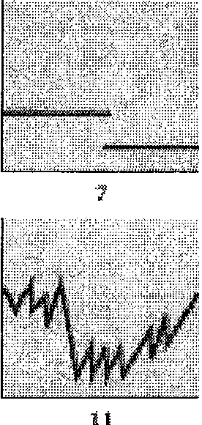

3 Raburt Travel offers helicopter service from suburban towns to John F. Kennedy International Airport in New York City. Each of its 6 helicopters makes between 900 and 1,800 round-trips per year. The records indicate that a helicopter that has made 900 round-trips in the year incurs an average operating cost of $385 per round-trip, and one that has made 1,800 round-trips in the year incurs an average operating cost of $250 per round-trip.

Requirements
1. Using the high-low method, estimate the linear relationship y = a + bX, where y is the total annual operating cost of a helicopter and X is the number of round-trips it makes to JFK airport during the year.
2. Give examples of costs that would be included in a and in b.
3. If Rabuet Travel expects each helicopter to make, on average, 1,300 round-trips in the coming year, what should its estimated operating budget for the helicopter fleet be?

Requirement 1. Using the high-low method, estimate the linear relationship y = a + bX, where y is the total annual operating cost of a helicopter and X is the number of round-trips it makes to JFK airport during the year.

=
+
Requirement 2. Give examples of costs that would be included in a and in b.

Begin by selecting which type of costs "a" and "b" represent, then select the costs that correlate with that cost type, use each cost only once.

"a" = I
"b" =

Requirement 3. If Rabuet Travel expects each helicopter to make, on average, 1,300 round-trips in the coming year, what should its estimated operating budget for the helicopter fleet be?
Rabuet Travel's estimated operating budget for all 6 helicopters in the fleet combined should be $.

- Gonzalez Corporation manufactures a children’s bicycle, model CT8. Gonzalez currently manufactures ti 2012, Gonzalez made 35,000 frames at a total cost of $945,000. Ryan Corporation has offered to supply Gonzalez wants at a cost of $25.50 per frame. Gonzalez anticipates needing 38,000 frames each year fc

Requirements
  - a. What is the average cost of manufacturing a bicycle frame in 2012? How does it compare to Ryan':
b. Can Gonzalez use the answer in requirement 1a to determine the cost of manufacturing 38,000 bic
  - Gonzalez's cost analyst uses annual data from past years to estimate the following regression equati1 costs of the bicycle frame as the dependent variable and bicycle frames produced as the independen
y = $433,000 + $14X
During the years used to estimate the regression equation, the production of bicycle frames varied frc this equation, estimate how much it would cost Gonzalez to manufacture 38,000 bicycle frames. How it to manufacture the frames rather than to acquire them from Ryan?

Requirement 1a. What is the average cost of manufacturing a bicycle frame in 2012? How does it compare to Ryan's offer?

Calculate the average cost of manufacturing a bicycle frame in 2012. How does it compare to Ryan's offer?

less greater

The average cost of $0 per frame is
than Ryan's offer.

Requirement 1b. Can Gonzalez use the answer in requirement 1a to determine the cost of manufacturing 38,000 bicycle frames? Explain.

Determine if Gonzalez can use the answer in requirement 1a to determine the cost of manufacturing 38,000 bicycle frames.

can cannot

Gonzalez
take the average manufacturing cost in 2012 to determine the total cost of

manufacturing 38,000 bicycle frames. The reason is that

all of the total costs are fixed costs
all of the total costs are variable costs
some of the total costs are fixed costs and some are variable costi

Requirement 2. Gonzalez's cost analyst uses annual data from past years to estimate the following
regression equation with total manufacturing costs of the bicycle frame as the dependent variable and bicycle frames produced as the independent variable: y = $433,000 + $14X. During the years used t?
estimate the regression equation, the production of bicycle frames varied from 34,000 to 38,000. Using
this equation, estimate how much it would cost Gonzalez to manufacture 38,000 bicycle frames. How much more or less costly is it to manufacture the frames rather than to acquire them from Ryan?

Estimate how much it would cost Gonzalez to manufacture 38,000 bicycle frames, then calculate the cost to purchase the frames.

4 (cont.)
Estimated cost to make the frames $
Cost to purchase the frames $

It will cost $ more to purchase 1ha frames rather than manufacture them- in-house.
less

-'· Brickman Apparel produces equipment for the extreme-sport market. It has four peak periods, each lasting two months, for manufacturing the merchandise suited for spring, summer, fall, and winter. In the off-peak periods, Brickman schedules equipment maintenance. Brickman's controller, Sascha Green, wants to understand the drivers of equipment maintenance costs. The data collected is shown in the table as follows:
(Click the icon to view the data.)

A regression analysis of one year of monthly data yields the following relationships: Maintenance costs = $18,552 - ($2.683 x Number of machine-hours)
Upon examining the results, Green comments, "So, all I have to do to reduce maintenance costs is run my machines longer?! This is hard to believe, but numbers don't lie! I would have guessed just the opposite."
Read the requirements.

Requirement 1. Explain why Green made this comment. What is wrong with her analysis?

Sascha Green is commenting about some surprising and
 |  |  | economically-implausi ble economically-plausible
In the regression, the coefficient on |  | machine-hours has a negative sign.  machine-hours has a positive sign. maintenance costs has a negative sign. maintenance costs has a positive sign. |  |  | This su
extra machine hour increases maintenance costs by $2.683. extra machine hour reduces maintenance costs by $2.683.  extra $18,552 in maintenance costs increases machine hours by 1 hour extra $18,552 in maintenance costs reduces machine hours by 1 hour. |  |  |  | This estim
is economically plausible.
is not economically plausible.

regression results.

ggests that each

ated relationship

Requirement 2. Upon further reflection, Sascha Green reanalyzes the data, this time comparing quarterly machine-hours with quarterly maintenance expenditures. This time, the results are very different. The regression yields the following formula:
Maintenance costs = $2,622.80 + ($1.175 x Number of machine - hours). What caused the formula to
change, in light of the fact that the data was the same?

To correctly understand the relationship between machine-hours and maintenance costs, Brickman

