Student Name:

Please answer the following questions. Submit as a Microsoft Word® document to the Dropbox when completed.
- Analyze what would happen to equilibrium price and quantity in the market for Pepsi if the following occurred (be sure to indicate WHY it happens as well):

  - The price of Coke decreases.

  - Average household income falls from $50,000 to $43,000

  - There are improvements in soft-drink bottling technology.

  - The price of sugar increases and the Pepsi launches an extremely successful advertising campaign.

  - Analyze the following demand and supply equations. What is market equilibrium price? What is market equilibrium quantity?

Demand: Qd = 100 – 4P
Supply: Qs = 10 + 6P

  - Assume the government places a price ceiling at $7 in the market. What is quantity demanded? What is quantity supplied? Is there a shortage or a surplus?

- Using the diagram below, answer the following questions:

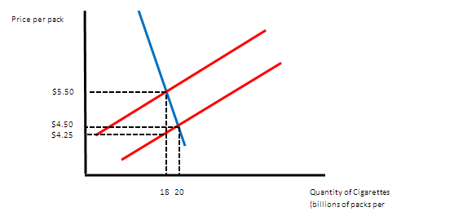
  - How much is the per-unit tax on cigarettes?

  - What price do consumers pay after the tax?

  - How much tax revenue is collected?

  - What is the amount of deadweight loss?

