RATIO | FORMULA | CALCULATION | RATIO | INDUSTRY AVERAGE | COMMENT
Liquidity | 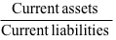 | 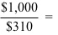 | 3.2 | 4.2 | Poor
Quick | 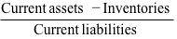 | 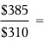 | 1.2 | 2.1 | Poor
Asset Management
Inventory turnover | 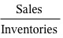 | 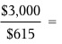 | 4.9 | 9.0 | Poor
Days sales outstanding (DSO) | 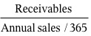 | 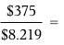 | 45.6 | 36.0 | Poor
Fixed assets turnover | 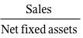 | 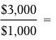 | 3.0 | 3.0 | OK
Total assets turnover | 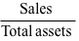 | 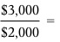 | 1.5 | 1.8 | Poor
Debt Management
Debt ratio | 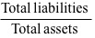 | 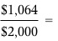 | 53.2% | 40.0% | High (risky)
Times-interest-earned (TIE) | 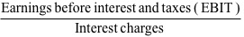 | 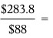 | 3.2 | 6.0 | Low (risky)
EBITDA coverage | 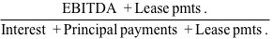 | 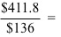 | 3.0 | 4.3 | Low (risky)
Profitability
Profit margin on sales | 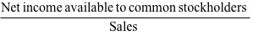 | 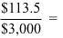 | 3.8% | 5.0% | Poor
Basic earning power (BEP) | 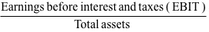 | 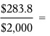 | 14.2% | 17.2% | Poor
Return on total assets (ROA) | 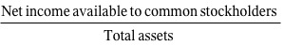 | 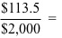 | 5.7% | 9.0% | Poor
Return on common equity (ROE) | 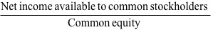 | 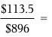 | 12.7% | 15.0% | Poor
Market Value
Price/earnings (P/E) | 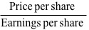 | 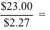 | 10.1 | 12.5 | Low
Price/cash flow | 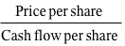 | 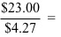 | 5.4 | 6.8 | Low
Market/book (M/B) | 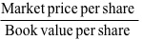 | 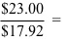 | 1.3 | 1.7 | Low

