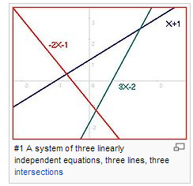
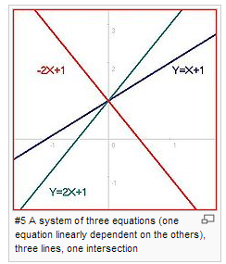
But I don’t get that one of these equations are dependent?:

I want proof that explains why three lines that intersect at only one point is not independent. And is there a way of proving that only one of them is dependent?
Illustrations are taken from
http://en.wikipedia.org/wiki/Overdetermined_system

