Industry Analysis and Financial Framework for Eat Right Healthy Shop

Market Analysis for Eat Right Healthy Shop
The market analysis decides how appealing a market is and to comprehend its progressive favorable circumstances (opportunities) and unfavorable prospects (threats) in relation to the firm’s strengths and weaknesses. For example, Eat right Healthy Shop could be divided into markets for (1) individuals and (2) families.
There will be a decision made from if families make up the greatest number of consumers for lunch time of the restaurant’s business or if individuals make up the greater part of dinner time of the restaurant business or vice versa will be made.
Eat Right Healthy Shop will be running its business among the fast-casual niche of the restaurant industries in the Orlando, Florida area. It will be contending with other division inside the industry (e.g., fast food, fine restaurants and Happy hour restaurants, etc.). Orlando, FL is a city that attracts tourists from all over the world and visitors from other states. Eat Right Healthy Shop will be located at a high traffic flow area (mention two or three that you know) of the city, attract consumers and higher degree of chances of high sales of its products.
The State of the Macroeconomics Industry in the Last Five Years
For observation purposes (to see how sales and customer service are conducted), I often visit all the restaurants for the past five years and found it interesting to see they are always full, especially in the evening hours (between 6:00 pm and midnight). Therefore, it is expected for the restaurant industry to be profitable as long as each business owners use prudent marketing intelligence to keep customers coming to patronize the business.
Based on restaurant performance index in Figure 1.1, there is prospect for (Eat Right Healthy Shop to earn a good market share in its busy Orlando, FL location
Figure 1.1 (Retrieved from Restaurant, 2015)
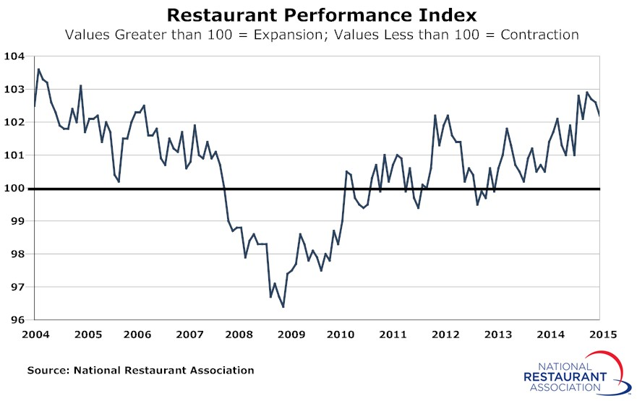
Establishing the Financial Statement Structure to Identify Details Required for the Financial Analysis.
Knowledge of financial statements is fundamental to the success of a business as they help in depicting the right pathway and help in avoiding costly mistakes. The fundamental parts of financial statements are:
(1) Balance Sheet: Account of financial standing at specific point in time. Formula: Assets = Liabilities + Equity (Quick MBA, 2015),
(2) Income Statement: Shows the outcome of a business activities at a specific point in time. Formula: Net Income = Revenue - Expenses (Quick MBA, 2015).
(3) Statement of Owner’s Equity: Illustrates changes in retained earnings which is retrieved from the income statement. Formula: Ending Equity = Beginning Equity + Investments - Withdrawals + Income (Quick MBA, 2015).
(4) Statement of Cash Flows: Shows a clearer view of a company’s cash inflow, cash outflow, and changes in cash balance. It indicates if a company has enough cash handy to continue its normal operations. The data for statement of cash flows can be obtained from the opening and ending balance sheet for the specific point in time and income statement for that specific point in time (Quick MBA, 2015).

References
Franchise Direct Canada. (2008). Trends and Facts about Restaurant Franchises. Retrieved from
http://www.franchisedirectcanada.com/restaurant-franchises-0550/trendsand factsabout
restaurantfranchises/550/203.
Quick MBA. (2015). The Four Financial Statements. Retrieved from
http://www.quickmba.com/accounting/fin/statements.
Restaurant. (2015). Restaurant Performance Index. Retrieved from
http://www.restaurant.org/Restaurant/media/Restaurant/SiteImages/News%20and%20Re
search/RPI/Restaurant-Performance-Index-March2015.jpg

