Include answers for Problems and include MATLAB coding along with any output plots that support solutions

- The input-output equation characterizing an amplifier that saturates once the input reaches certain values is:

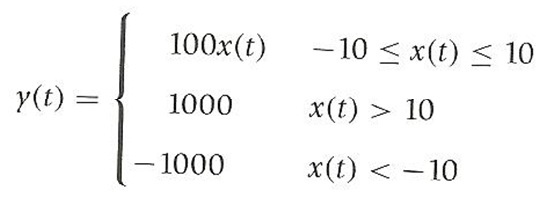
Where x(t) is the input and y(t) the output.

- Plot the relation between the input x(t) and the output y(t). Is this a linear system? For what range of input values is the system linear, if any?

- Suppose the input is a sinusoid x(t) = 20 cos(2πt)u(t), carefully plot x(t) and y(t) for t = -2 to 4.

- The following op-amp circuit is used to measure the changes of temperature in a system. The output voltage is given by:
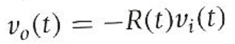
Suppose that the temperature in the system changes cyclically after t = 0, so that:
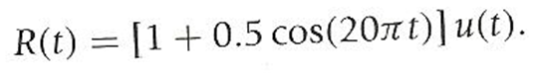
Let the input be V_{i}(t) = 1 volt.

- If the switch closes at t₀ = 0 msec., plot the output voltage V₀₁(t) for 0≤t≤0.2 sec. in time-intervals of 0.01 sec.

- If the switch closes at t₀ = 50 msec., plot the output voltage V₀₁(t) for 0≤t≤0.2 sec. in time-intervals of 0.01 sec.

- A zener diode is such that the output corresponding to an input V_{s}(t) = cos(πt) is a “clipped” sinusoid

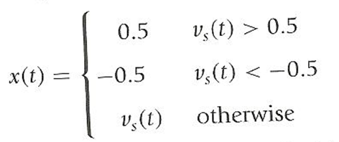
Use MATLAB to generate the input and output signals and plot them in the same plot for 0≤t≤4 at time intervals of 0.001.

- Is this system linear? Compare the output obtained from V_{s}(t) with that obtained from 0.3 V_{s}(t).

