The importance of the legal context of talent management.

Bases for Employment Lawsuits
a-What the difference between disparate treatment and adverse impact
b- Strategic Exercise. Using each of the three statistical examples (stock, flow, and concentration), discuss whether or not there is evidence of adverse impact
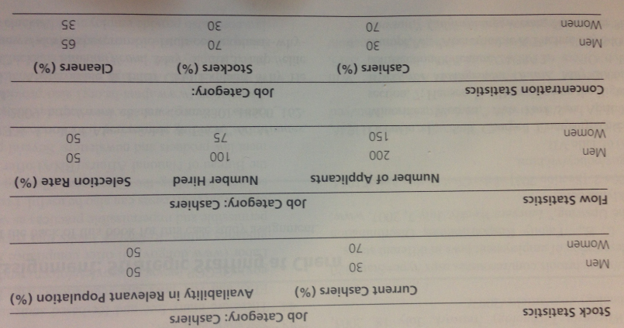
c- Try to identify what might be happening.

