Problem 1
Long-term investment decision, payback method Bill Williams has the opportunity
to invest in project A that costs $9,000 today and promises to pay annual end-ofyear
payments of $2,200, $2,500, $2,500, $2,000, and $1,800 over the next 5 years.
Or, Bill can invest $9,000 in project B that promises to pay annual end-of-year payments
of $1,500, $1,500, $1,500, $3,500, and $4,000 over the next 5 years.
a. How long will it take for Bill to recoup his initial investment in project A?
b. How long will it take for Bill to recoup his initial investment in project B?
c. Using the payback period, which project should Bill choose?
d. Do you see any problems with his choice?

Problem 2
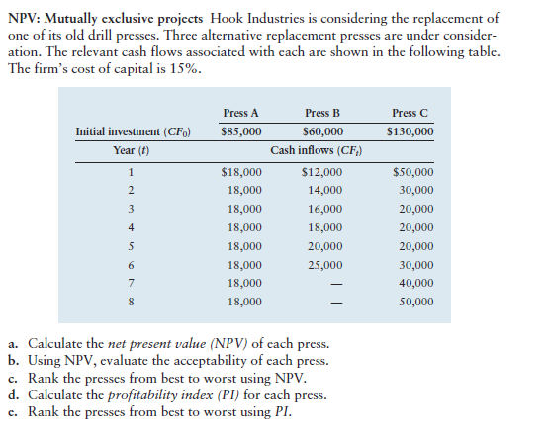

Problem 3
Long-term investment decision, NPV method Jenny Jenks has researched the financial
pros and cons of entering into a 1-year MBA program at her state university. The
tuition and books for the master’s program will have an up-front cost of $50,000. If
she enrolls in an MBA program, Jenny will quit her current job, which pays $50,000
per year after taxes (for simplicity, treat any lost earnings as part of the up-front
cost). On average, a person with an MBA degree earns an extra $20,000 per year (after
taxes) over a business career of 40 years. Jenny believes that her opportunity cost
of capital is 6%. Given her estimates, find the net present value (NPV) of entering
this MBA program. Are the benefits of further education worth the associated costs?

Problem 4
Internal rate of return Peace of Mind, Inc. (PMI), sells extended warranties for durable
consumer goods such as washing machines and refrigerators. When PMI sells an extended
warranty, it receives cash up front from the customer, but later PMI must cover any repair
costs that arise. An analyst working for PMI is considering a warranty for a new line
of big-screen TVs. A consumer who purchases the 2-year warranty will pay PMI $200.
On average, the repair costs that PMI must cover will average $106 for each of the warranty’s
2 years. If PMI has a cost of capital of 7%, should it offer this warranty for sale?

Problem 5
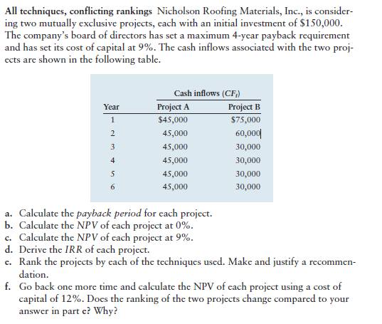

Problem 6
