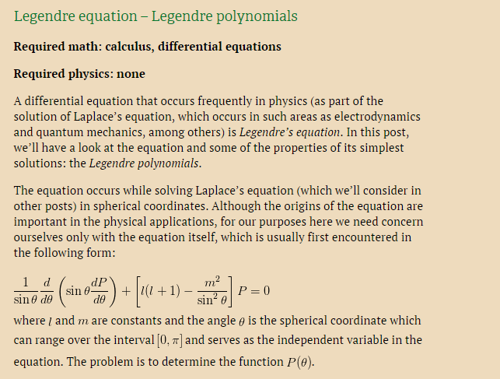
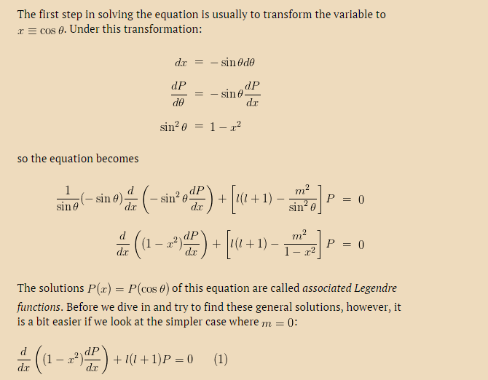
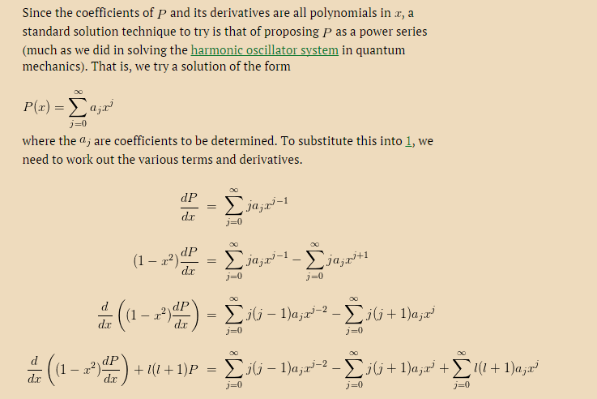
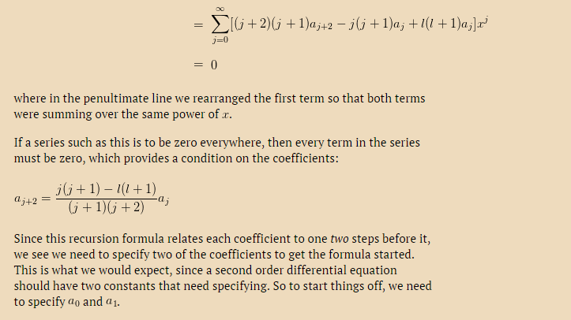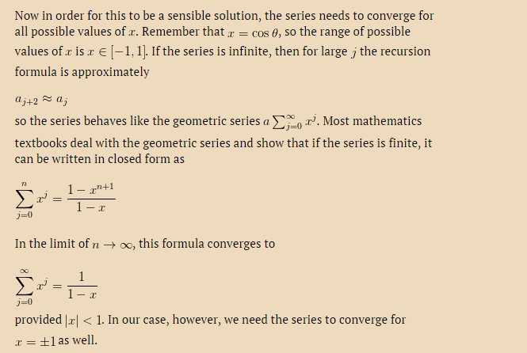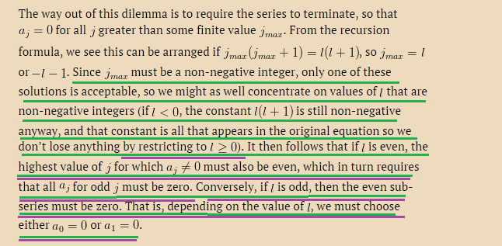
In the derivation above I don’t get the underlined part that I have underliened in the end here. Can you help with this? Thank you
It is taken from this site
http://physicspages.com/2011/03/08/legendre-equation-legendre-polynomials/
My question would be:
For the underlined parts in green and purple could you please explain it by showing the problem with equations and equality signs and why the equalities make the relations hold? Thank you. I need to be shown this with equations in order to understand it I am afraid. Thank you!

