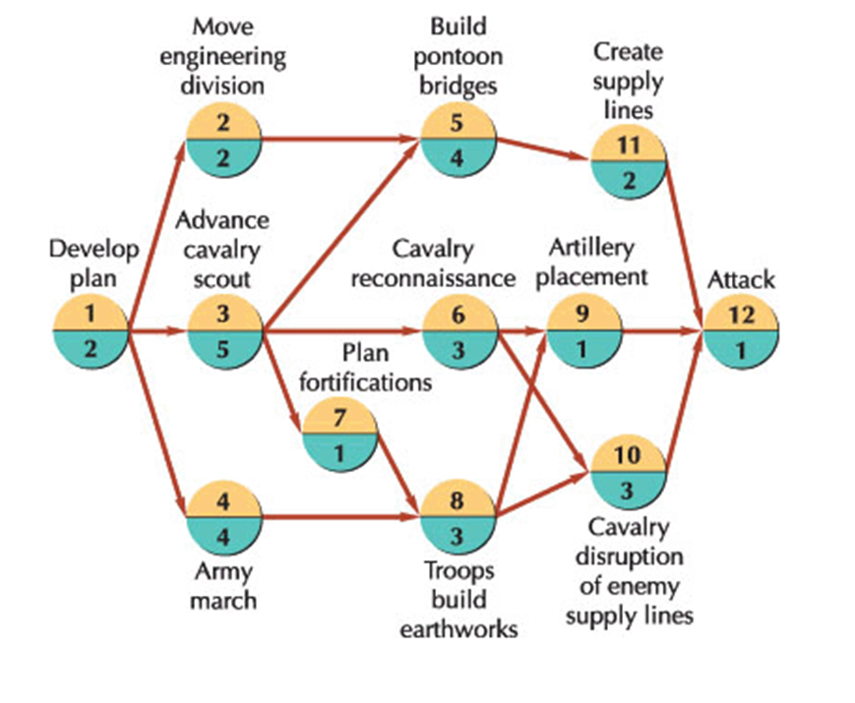
The following probabilistic activity time estimates are for a CPM/PERT network.
 | Time Estimates (days) |  |  |  | Time Estimates (days)
Activity | a | m | b | Activity | a | m | b
1 | 1 | 2 | 6 | 7 | 1 | 1.5 | 2
2 | 1 | 3 | 5 | 8 | 1 | 3 | 5
3 | 3 | 5 | 10 | 9 | 1 | 1 | 5
4 | 3 | 6 | 14 | 10 | 2 | 4 | 9
5 | 2 | 4 | 9 | 11 | 1 | 2 | 3
6 | 2 | 3 | 7 | 12 | 1 | 1 | 1

Determine the following:
- Expected activity times
- Earliest start and finish times
- Latest start and finish times
- Activity Slack
- Critical Path
Expected Project duration and standard deviation.

