TASK 1
The following table, based on Figure 4.2 Customer-Product Profitability Analysis in your textbook, shows an example of a Customer-Product Profitability Analysis filled in for a small sewing alterations company that specializes in formal wear.
As you can see, there are six different types of customers for this company. This small business should focus on the "high profit" customers, but sometimes may want to keep in touch with the "mixed-bag" customers since word-of-mouth is the best advertisement for this small company with little repeat business. Within a few years, teens can become brides who are looking for wedding gown fittings.
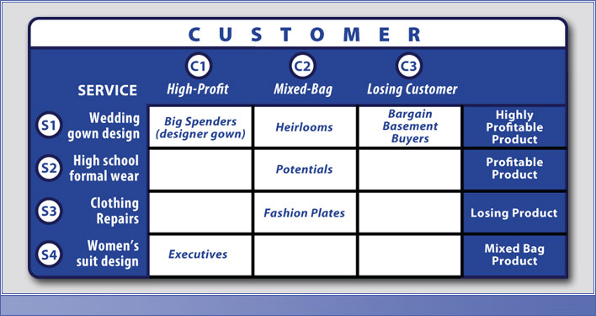
Instructions:
- Re-create the table above and use it to segment the customer base at your company.
- Make any assumptions or simplifications you need to create the table.
- You can make up a name for each segment.
- After you have segmented the customers in your company, put together a value proposition for each of these customers.

Guidelines:
- There are two components to this assignment:
  - a table showing customer segments at your company
  - a written explanation of the value proposition for each segment and what can be done to change the value proposition in order to build customer loyalty

Task 2
Instructions:
- Customer acquisition and retention are the major activities for firms. It is generally believed that it costs 5-7 times more to acquire a customer than it does to retain one. Do you agree with this? Provide your opinion and justification.
- Discuss with examples market share and customer share.
- Firms talk about life time value when they discuss customer loyalty and benefits of retaining customers. Use yourself as an example of a customer and estimate your life time value for the grocery store you visit (Assume: you live in the area for 10 years). State the assumptions.

Guidelines:
  - Looking at the problem from a strategic point of view.

