E15-5 Nordstrom, Inc. operates department stores in numerous states. Selected financial statement
data for the year ending January 31, 2002, are as follows.

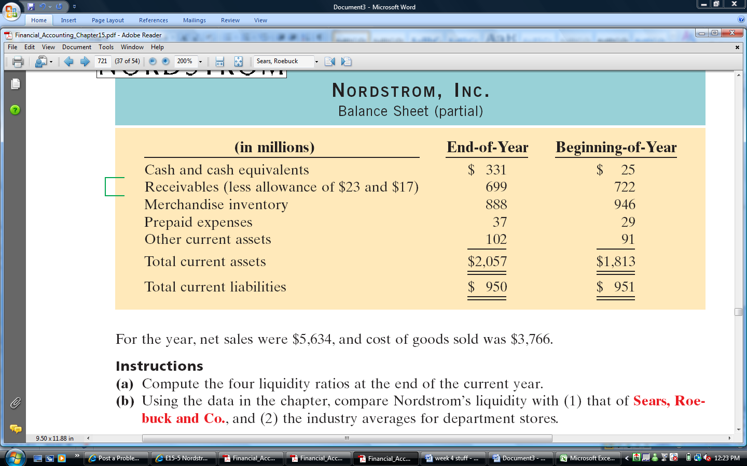
Financial Accounting, 5th edition
P. Kimmel, J. Weygandt, and D. Kieso
Wiley, 2005
Hoboken, NJ

