http://ramanujan.math.trinity.edu/wtrench/texts/TRENCH_LAGRANGE_MULTIPLIERS.PDF
the extrema subject to two constraints is on page 11 in the link above

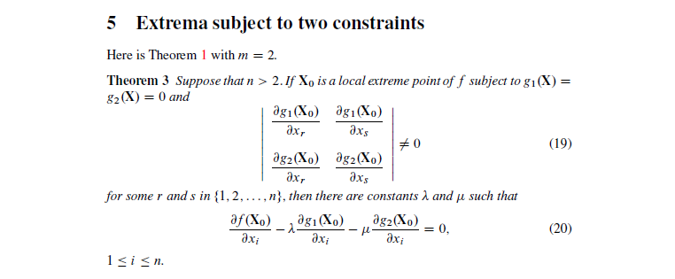
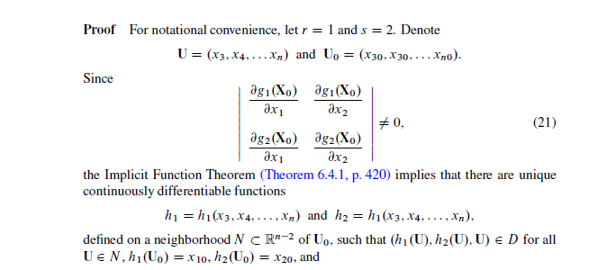
I don’t get how they can take the derivative of $g_{1}$ and $g_{2}$ with respect to $x_{1} and x_{2}$ when they are defined as
$$h_{1}=h_{1}\left(x_{3},x_{4},…,x_{n}\right)=x_{1} and h_{2}=h_{2}\left(x_{3},x_{4},…,x_{n}\right)=x_{2}$$
I need a mathematical justification for how this can be written simply as (21) when $x_{1} and x_{2}$ are defined as functions from other variables: $x_{3},x_{4},…,x_{n}$
Is it by using the chain rule or something else? Please og through the detailed steps for how this can be a normal quadratic matrix as defined in the implicit function theorem and by that showing why this is an appliable form of the implicit function theorem nonsingular matrix in (21):

Note:
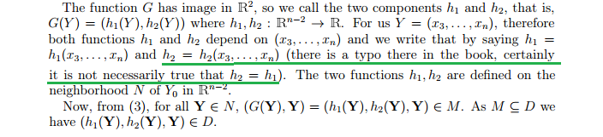

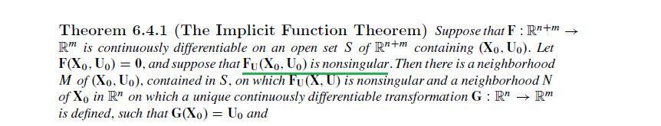
Search for the theorem in this link if you want to see more from the implicit function theorem. It is on page 420
http://ramanujan.math.trinity.edu/wtrench/texts/TRENCH_REAL_ANALYSIS.PDF

