http://ramanujan.math.trinity.edu/wtrench/texts/TRENCH_LAGRANGE_MULTIPLIERS.PDF
the extrema subject to two constraints is on page 11 in the link above
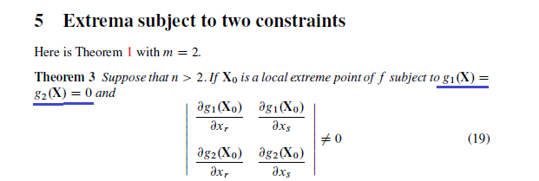
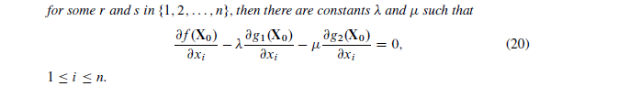
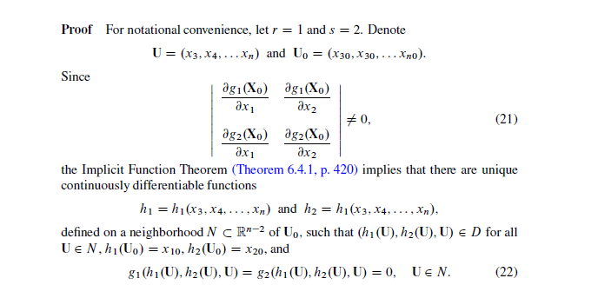
I need to prove that
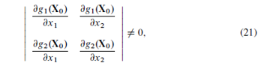
Has the shape of
Can you show first how the determinant of
Is. I have a problem since it is the derivative with respecot of U. And afterwards show why (21) is the same as this?
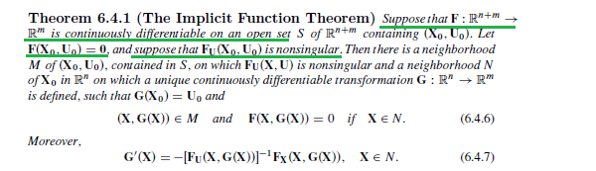
Search for the theorem in this link if you want to see more from the implicit function theorem. It is on page 420
http://ramanujan.math.trinity.edu/wtrench/texts/TRENCH_REAL_ANALYSIS.PDF

