IT MAY SOUND ASTONISHING that a fast-food chain selling fried chicken could conquer a country with a diverse culinary culture rooted in thousands of years of tradition, but the Chinese division of Yum! Brands did just that. Yum! Brands was created in 1997 as a result of PepsiCo spinning off its fast-food operations worldwide, a group that included KFC, Pizza Hut, and Taco Bell. Not only did Yum! China become the biggest restaurant chain in the country, accounting for 4 out of 10 fast-food restaurants; it also now provides half of Yum!'s total revenue and 42 percent of its profits (Exhibit MC15.1). No wonder David Novak, CEO of Yum! Brands, considers China to be “the best restaurant growth opportunity of the 21st century.”¹

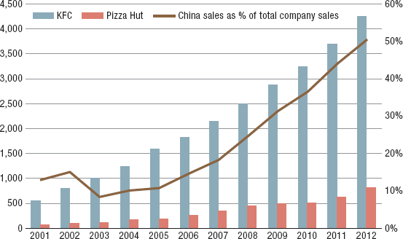
EXHIBIT MC15.1 Yum! China's Restaurant Numbers
SOURCE: Authors' depiction of data from Yum Brands Annual Reports, 2000–2012.
When Yum! Brands (then a subsidiary of PepsiCo) opened its first KFC restaurant in Beijing in 1987, there was no other Western-style fast-food chain in China. Being greeted by smiling staff and then dining in an air-conditioned, clean, and brightly lit environment was a novelty to local Chinese, as was a bite of KFC's crispy chicken. Compared to other American fast foods, KFC also has a natural advantage: Chicken is the second most common meat staple in China, just after pork. Based on an understanding and appreciation of the Chinese taste for tradition and variety, KFC introduced dishes that mimicked local cuisines, such as Chinese porridge and dough fritters for breakfast. Its menu in China included more items than on menus in the U.S., and was updated more frequently. In addition, the level of spiciness of the food was adjusted according to regional preferences within China. As a result, a KFC restaurant in China has a much bigger kitchen and employs twice as many people as its U.S. counterpart (although Chinese labor costs are much lower, see Exhibit MC15.2). Given all its efforts in pleasing Chinese diners, KFC no longer positions itself in China as a cheap place for take-outs. Instead, it is seen as a more upscale quick-service restaurant for gatherings of family and friends.
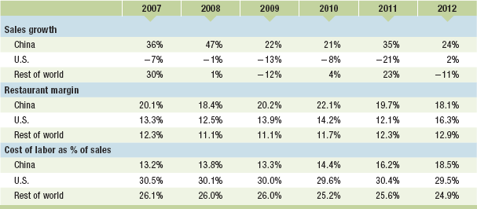
EXHIBIT MC15.2 Yum! Brands Selected Financials
SOURCE: Yum! Brands Annual Reports, 2006–2012.
D
KFC's sister chain, Pizza Hut, also underwent a similar makeover in China. Unlike its image in the West as a cheap, fast-food outlet, Pizza Hut in China has presented itself as a trendy casual dining restaurant since its opening in 1990. Diners at a Pizza Hut restaurant in China are waited on while soothing background music plays, and the menu offers many other Western-style dishes than just pizza.
Yum! China's localization strategy was made possible because Pepsi was busy competing with Coca-Cola in the United States and took a hands-off approach toward managing its overseas restaurant business. When Yum! Brands was spun off from its parent in 1997, Yum! China had already opened 200 restaurants in major cities. But Yum! China's growth strategy is about more than simply adding restaurants. From the very beginning, the company has focused on “building a perfect system which governs every step of the way—from purchasing, to making, to delivering the food and to the quick service.”² Because a reliable network of distributors in China was nonexistent at the time, Yum! China set up its own distribution arm with company-owned warehouses and a fleet of trucks to cover every province in China. To make sure each new restaurant is properly staffed and offers excellent customer service, Yum! China runs an extensive training program where teams of new employees work side by side with experienced ones in established restaurants. Once trained, these new employees rotate to new restaurants.
The emphasis in the early years on building an efficient operations network nationwide laid a solid foundation for Yum! China's rapid expansion. From 1997 to 2012, Yum! China opened more than 4,000 KFC and 800 Pizza Hut restaurants in 850 Chinese cities. Most of the time, Yum! China was the first fast-food chain (let alone international chain) to establish a presence in a city. This enabled Yum! to gain a first-mover advantage by selecting the best locations with strong customer traffic, high visibility, and an attractive rental rate. Sometimes, being the first also generated free publicity from local officials since the opening of a world-famous fast-food restaurant meant that their city was becoming more cosmopolitan. Also, benefiting from China's lower labor costs, Yum! China has become the only division within Yum! Brands to consistently deliver double-digit sales growth and the highest restaurant margin (see Exhibit MC15.2).
Page 442
With thousands of stores and a vast distribution network in densely populated areas, Yum! China is vulnerable to many external and internal threats, such as outbreaks of bird flu (a repeat occurrence in China) and food safety scandals. In 2003, the avian flu outbreak caused a 40 percent decline in Yum! China's sales. Two years later, the discovery of a questionable ingredient used in the chicken feeds by one of Yum! China's suppliers brought sales growth down to “only” 11 percent. Although Yum! China recovered quickly from these setbacks, last December Yum! China was again attacked by China's national news service for sourcing from suppliers that use excessive antibiotics in their chicken feeds. Worse yet, just as Yum! China was rebuilding its bond of trust with Chinese customers, another potential outbreak of avian flu scared more eaters away. Yum! China's same-store sales dropped by 20 percent for the first quarter of 2013, its first quarterly decline in three years (Exhibit MC15.3). But with only two Yum! restaurants per million people in China currently (compared to 58 in the U.S.), Yum! China has no intention of modifying its growth strategy or losing its number-one spot in China's fast-food industry any time soon.
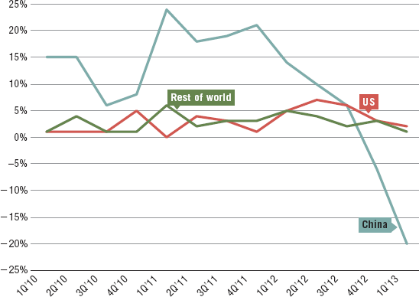
EXHIBIT MC15.3 Yum! Brands Quarterly Same-Store Sales Growth by Region
SOURCE: Authors' depiction of data from Yum! Brands quarterly earnings releases, Q1 2010–Q1 2013.
DISCUSSION QUESTIONS
Review Chapter 9: Corporate Strategy: Mergers and Acquisitions, Strategic Alliances.
- Yum! Brands is the result of a spin-off by PepsiCo, where it sold its fast-food chains KFC, Taco Bell, and Pizza Hut. Do you consider this spin-off successful? Why or why not? Explain.
- Why is Yum! Brands so much more successful in China than in the U.S., its home country?
- Why was Yum! Brands KFC so successful in China, while other U.S. fast-food companies—such as Pizza Hut (also owned by Yum!), McDonald's, and Burger King—were much less successful?
- Page 443 Given Yum! Brands recent challenges in China, do you consider this to be a temporary problem or a harbinger of losing its competitive advantage?
- What recommendations would you give David Novak, Yum! Brands' CEO, to overcome the company's current challenges in China?
ENDNOTES
1. Yum! Brands 2012 Annual Report.
2. “Competition gearing up in China's fast food industry,” China Daily, June 30, 2008.
Frank T. Rothaermel and Carrie Yang (GT MBA, MSc.) prepared this MiniCase from public sources. It is developed for the purpose of class discussion. It is not intended to be used for any kind of endorsement, source of data, or depiction of efficient or inefficient management. All opinions expressed, and all errors and omissions, are entirely the authors'. © Rothaermel and Yang, 2014.
Sources: This MiniCase is based on Yum! Brands Annual Reports, 2000–2012; “Competition gearing up in China's fast food industry,” China Daily, June 30, 2008; “Fast food in China: Yucky Kentucky,” The Economist, February 9, 2013; and Bell, D. E., and Shelman, M. L. (2011), “KFC's radical approach to China,” Harvard Business Review, November.

