1/.
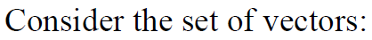

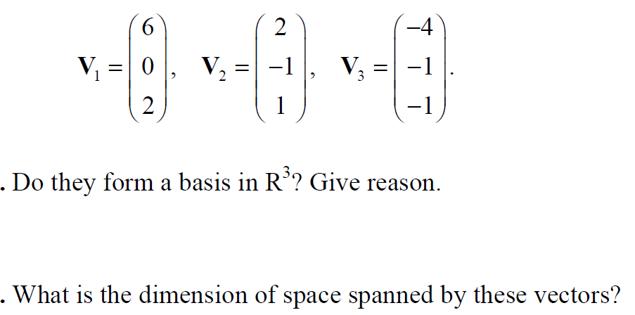
2/.

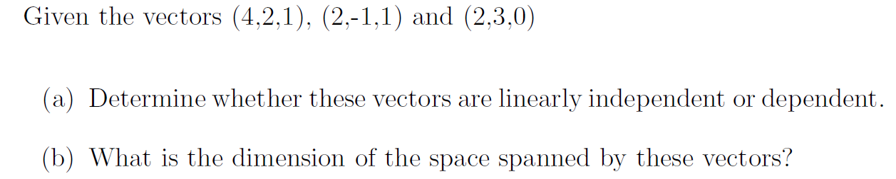
3/.

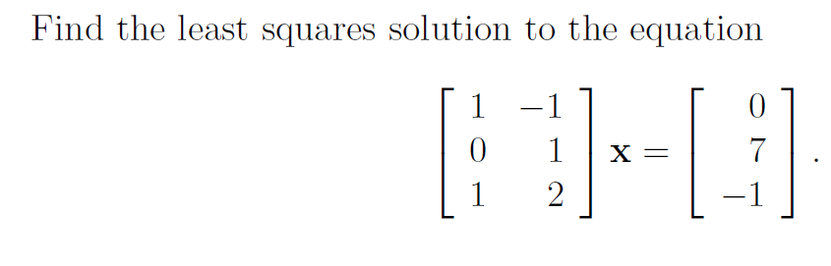
4/.

