1/. Could you please plot this function?

This was previously solved by you, however the plot was not provided.

Thus, solution will be



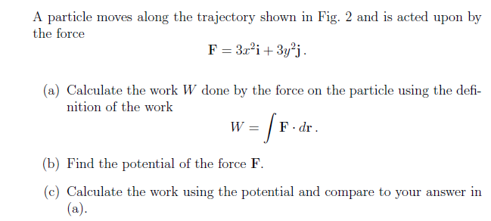

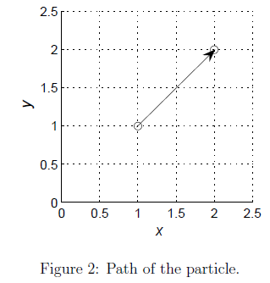2/.