Question 3:

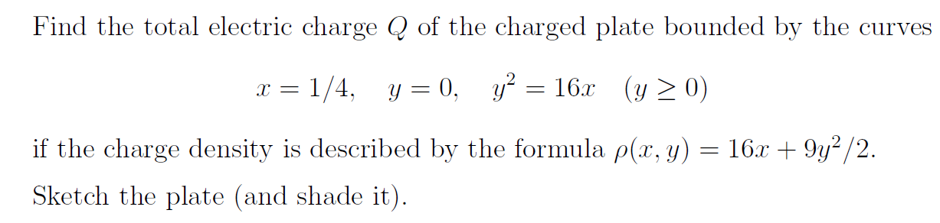

Solution:



Answer: 4