http://aerostudents.com/files/materialsAndStructures/MaterialsScienceBookSolutions/CH12.pdf

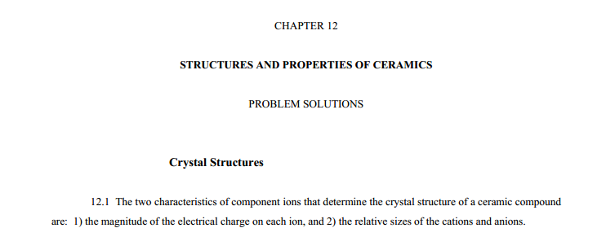
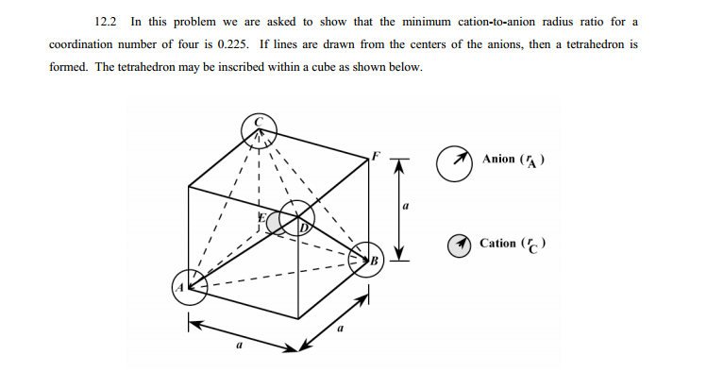

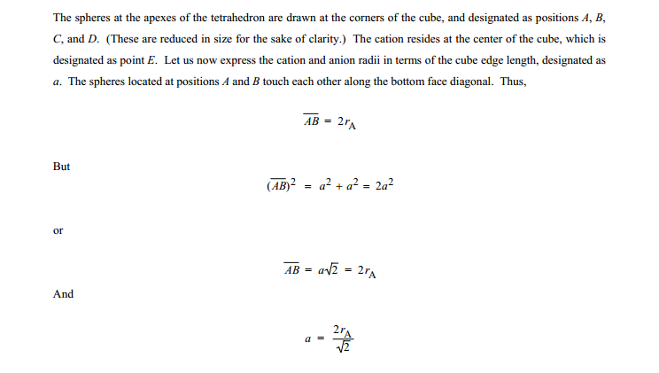
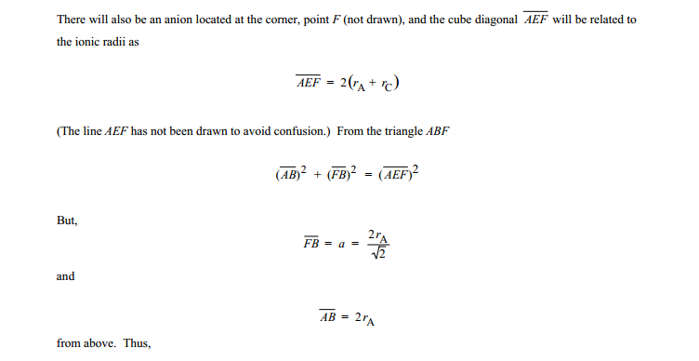
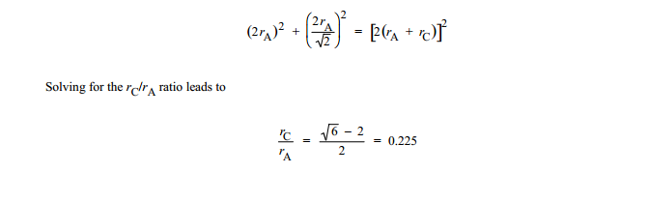
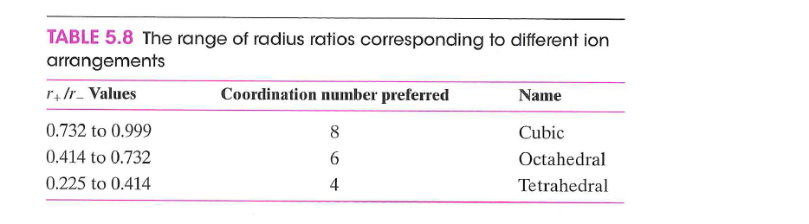
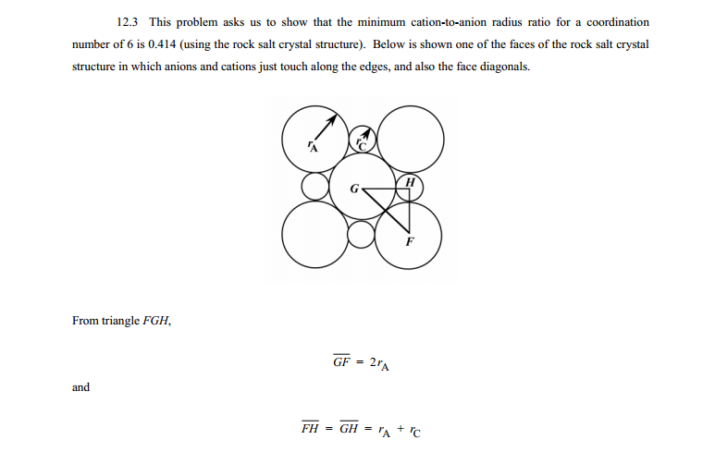
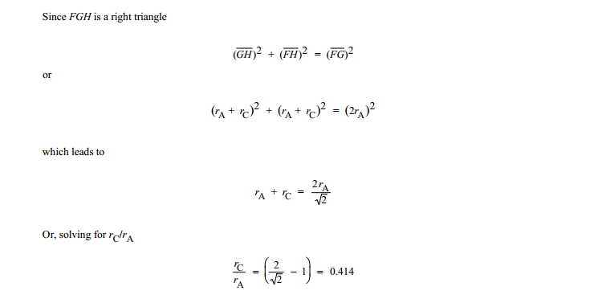
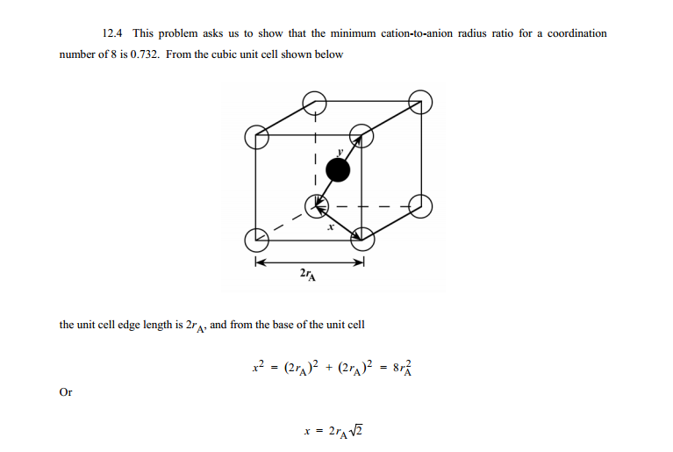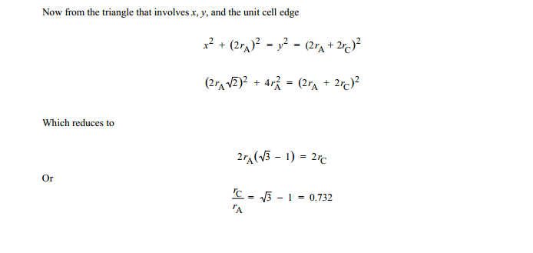
Why does all theese problems say that we have found the minimum value for the cation anion ratio?
Table 5.8 below says that the cation anion ratio can have an interval of values.
From what I get it seems that if all the anions are in touch with eachother then the values 0,225, 0,414 and 0,732 have to be the only possible cation anion ratios for the given arrangments? Can you show a mathematical relation to the derivation that shows why the ratio can have an interal of values and not only the nmbers calculated in the proofs. And show mathematically why theese values are mathematically constrained to the values in 5.8?

