SEPTEMBER 4, 2014

Views of Job Market Tick Up, No Rise in Economic Optimism
56% Say They Are ‘Falling Behind’ Financially
In advance of Friday’s jobs report, the public’s assessment of job availability in their local communities has improved modestly. But that has done nothing to boost overall economic optimism.
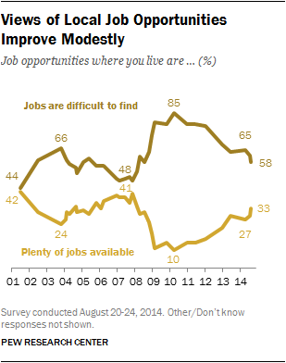For Americans, jobs are only part of the economic picture: 56% say their family’s incomes are falling behind the cost of living. That is about as many as said their incomes were falling behind in October 2008 (57%), during the Wall Street financial crisis.
And 45% say they have experienced one or more serious financial hardships – such as a job layoff, an inability to pay for health care or trouble with a collection agency – over the past year. Among those with low family incomes (less than $30,000 a year), fully 66% have confronted at least one serious financial problem.
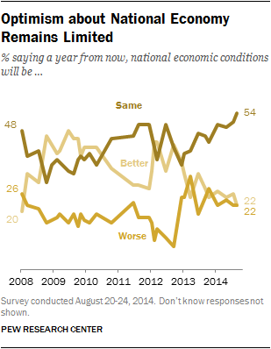The new national survey by the Pew Research Center, conducted August 20-24 among 1,501 adults finds that 33% say there are plenty of jobs available where they live, while 58% say that jobs are difficult to find. The share saying jobs are available has ticked up from 29% in July and 27% in April. Nearly two years ago, in December 2012, just 22% said there were plenty of jobs locally.
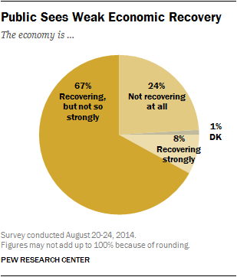But the public’s views of the national economy – both current and future – remain bleak. Just 21% rate economic conditions as excellent or good, while 79% say they are only fair or poor. That is up modestly from earlier this year; in January, 16% expressed a positive view of economic conditions.
About one-in-five (22%) expect that economic conditions will be better a year from now than they are today, while the same percentage says things will be worse; 54% expect conditions to be about the same. The share expecting the economy to improve has remained fairly stable for more than a year.
Moreover, there is broad agreement among the public that the economic recovery remains weak. Two-thirds (67%) say “the economy is recovering, but not so strongly.” Just 8% say the economy is recovering strongly, while three times as many (24%) say it is not recovering at all. These opinions are virtually unchanged from April.

Most Feel Like They’re ‘Falling Behind’
As is typically the case, people rate their own financial situation more positively than national conditions. Overall, 42% say they are in excellent or good shape financially, compared with 36% who say they are in only fair shape and 21% who say they are in poor shape.
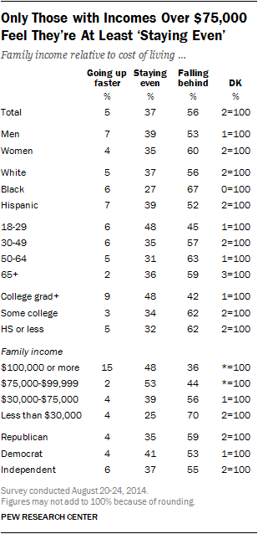People also continue to express more optimism about their personal finances than about the national economy: 56% expect their financial situation will improve “some” over the next year, while 10% expect it will improve “a lot.” The share saying they expect their finances to show at least some improvement has risen seven points since April and now is at the same point as it was two years ago.
While most think their own financial situation will improve at least some over the next year, there is widespread concern about keeping up with the cost of living. A 56% majority says that their family’s income is falling behind the cost of living, while 37% say their income is staying about even; just 5% say their income is rising faster than the cost of living.
There are stark income differences in views of whether incomes are keeping up with living costs: Among those with family incomes of $75,000 or more, most say they are at least keeping pace with the cost of living; among those with the highest incomes ($100,000 or more), 15% say their incomes are going up faster than living costs and 48% are staying even.
But majorities of those in the lowest two income categories say they are falling behind: 56% of those with family incomes between $30,000 and $75,000 say they are falling behind; just 39% say they are staying even while 4% say their incomes are rising faster than living costs. Among those with incomes below $30,000, 70% say they are falling behind. (According to Census data, in 2012 the median household income was $51,017, below the pre-recession 2007 level of $55, 627).

Many Face Financial Problems
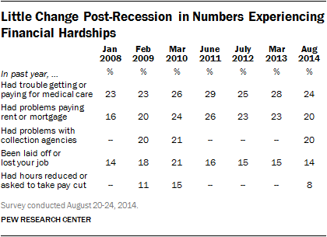Overall, about a quarter (24%) of the public says they have had trouble getting or paying for medical care in the past year. Nearly as many say they’ve had trouble paying their rent or mortgage (20%) or had problems with collection or credit agencies (20%).
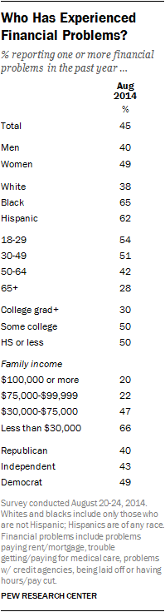Somewhat fewer say they have been laid off or lost their job in the past year (14%); another 8% say they have had their hours reduced or been asked to take a cut in pay.
Across these measures of financial stress, there have generally been only modest declines from levels measured during, or shortly after, the depths of the recession. For example, the 20% having trouble paying their rent or mortgage is down just six points from June 2011, when 26% said this had happened to them in the past year.
While no more than a quarter of the public has experiencedany of the individual financial problems tested in the survey, fully 45% of Americans report having experienced at least one in the past year. Two-thirds (66%) of those with family incomes of less than $30,000 say that they have experienced at least one financial problem in the past year. This compares with 47% of those with incomes between $30,000 and $75,000, and only about 20% of those with higher incomes.
Across racial and ethnic groups, blacks (65%) and Hispanics (62%) are far more likely than whites (38%) to say they have faced a severe financial problem in the past year.
Among those ages 18-29, 54% have experienced at least one of the five financial problems tested in the survey. By comparison, just 28% of those 65 and older have had one of these problems.

Views of the Job Situation
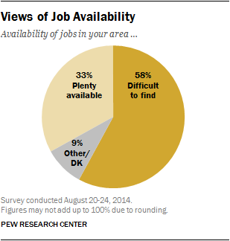Overall, 33% say there are plenty of jobs available where they live, compared with 58% who say that jobs are difficult to find. The percentage saying that jobs are readily available is up six points since April and has steadily increased since reaching 10% in the spring of 2010.
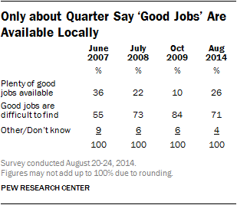Half the sample was asked about the availability of jobs generally, and the other half was about the availability of “good jobs.” About a quarter (26%) say there are plenty of good jobs available where they live; 71% say good jobs are hard to find in their area.
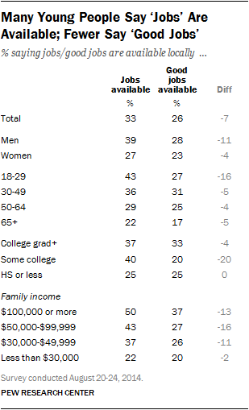The percentage saying there are plenty of good jobs in their area has increased 16 points since the question was last asked in October 2009. Impressions of the availability of good jobs remain more negative than in June 2007, before the start of the recession; at that time, 36% said there were plenty of good jobs available in their area.
About four-in-ten of those younger than 30 (43%) say there are plenty of jobs in their local communities, but just 27% say good jobs are plentiful. Among older age groups, there is less of a disparity in views of the availability of jobs generally and good jobs.
And while comparable shares of college graduates think both jobs in general (37%) – and good jobs (33%) – are available, there is a larger gap in the perceptions of those who have not completed a bachelor’s degree. Four-in-ten (40%) of those with some college experience say jobs are in ample supply locally, but only half as many (20%) say good jobs are plentiful.

National Economic Ratings
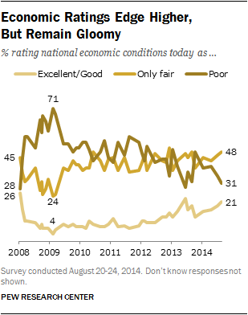Current ratings of the national economy are dim: 48% say the economy is in only fair shape, while 31% say it is in poor shape; just 21% say the economy is in excellent or good shape.
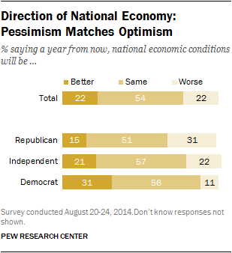While negative, economic ratings have improved modestly since January. The share rating the economy as poor has declined eight points (from 39%), while the percentage saying the economy is excellent or good is up five points (from 16%).
However, the public is not optimistic about the direction of the national economy over the next year. As many say that economic conditions will be worse in a year (22%) as say they will be better (22%); 54% say the economy will be about the same a year from now.
Republicans and Democrats differ significantly in their economic expectations. More Democrats expect the economy to be better in a year (31%) than worse (11%); 56% say conditions will be the same. Among Republicans, 31% say the economy will be worse in a year compared with 15% who think it will be better; 51% say it will be about the same.

Views of Job Market Tick Up, No Rise in Economic Optimism
56% Say They Are ‘Falling Behind’ Financially

About the Survey
The analysis in this report is based on telephone interviews conducted August 20-24, 2014 among a national sample of 1,501 adults, 18 years of age or older, living in all 50 U.S. states and the District of Columbia (600 respondents were interviewed on a landline telephone, and 901 were interviewed on a cell phone, including 487 who had no landline telephone). The survey was conducted under the direction of Abt SRBI. A combination of landline and cell phone random digit dial samples were used; both samples were provided by Survey Sampling International. Interviews were conducted in English and Spanish. Respondents in the landline sample were selected by randomly asking for the youngest adult male or female who is now at home. Interviews in the cell sample were conducted with the person who answered the phone, if that person was an adult 18 years of age or older. For detailed information about our survey methodology, see http://people-press.org/methodology/
The combined landline and cell phone sample are weighted using an iterative technique that matches gender, age, education, race, Hispanic origin and nativity and region to parameters from the 2012 Census Bureau’s American Community Survey and population density to parameters from the Decennial Census. The sample also is weighted to match current patterns of telephone status (landline only, cell phone only, or both landline and cell phone), based on extrapolations from the 2013 National Health Interview Survey. The weighting procedure also accounts for the fact that respondents with both landline and cell phones have a greater probability of being included in the combined sample and adjusts for household size among respondents with a landline phone. Sampling errors and statistical tests of significance take into account the effect of weighting.
The following table shows the unweighted sample sizes and the error attributable to sampling that would be expected at the 95% level of confidence for different groups in the survey:
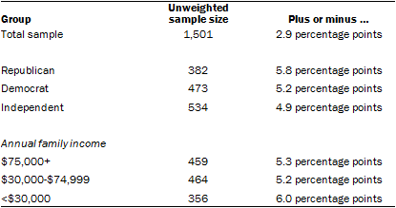
Sample sizes and sampling errors for other subgroups are available upon request.
In addition to sampling error, one should bear in mind that question wording and practical difficulties in conducting surveys can introduce error or bias into the findings of opinion polls.

