Question 1.

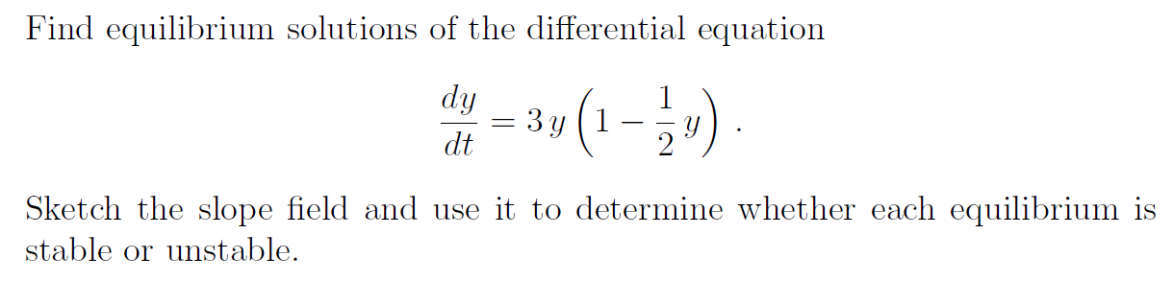

Question 2.

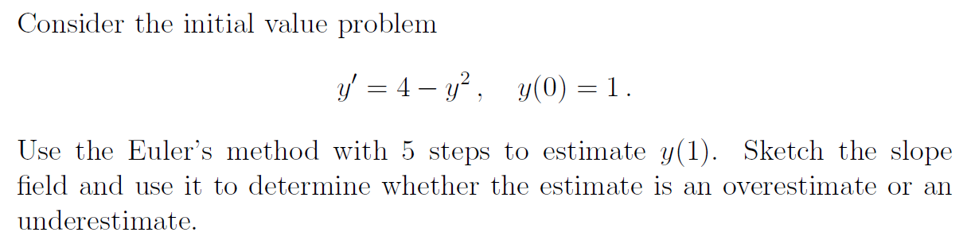

Question 3.

