1. The diagram of FIGURE 1 represents a meter shunted by a parallel resistance RS.

(a) Determine the required value of the shunt resistance if the maximum value of the current I is 200 A. The meter can read a maximum of 1 mA and has a
resistance of 0.1 Ω.

Meter

IM R I
M

IS RS

Shunt

FIG. 1

(b) If the shunt is made of copper and has a cross-sectional area of
25 cm2 calculate its required length.

(For copper take ρ as 1.7 × 10–8 Ωm.)

2. The circuit of FIGURE 2 shows a 10 kΩ potentiometer with a 5 k Ω load. Determine the position of the slider on the
‘pot’ when the voltage across points ‘XX'
is 3 V.

9 V 10 kΩ

5 kΩ

FIG. 2

3. (a) Calculate the value of the current through the 12 V battery shown in
FIGURE 3.

(b) Calculate the power dissipated in R1, R2 and R.

I1 I2

13 V

R = 3 Ω

14 V

R1 = 1 Ω

12 V
R2 = 2 Ω

FIG. 3

4. If the magnetic flux linking all the turns of a 50 turn coil changes from
10 mWb to 20 mWb and induces an e.m.f. of 62.5 V in the coil, calculate the time over which the flux changes.

5. A 500 mm conductor inside an electric motor has a force of 1.5 newtons exerted on it. If it is at right angles to a magnetic field of flux density
0.6 T, calculate the current flowing in the conductor.

6. FIGURE 4 show the construction of a multi-plate variable capacitor having 4 pairs of plates. The plates, when closed, are separated in air by
0.01 mm and a capacitance range of 10 to 400 pF is required. (a) Estimate the required radius, R, of each plate.
(b) The capacitor is set to the maximum 400 pF and is charged to 10 V

through a 50 kΩ resistor. Determine:

(i) the initial value of current flowing. (ii) the time constant for the circuit.

(c) Having fully charged, the capacitor is then discharged through the

50 kΩ resistor. Determine:

(i) the current flowing when the capacitor has been discharging for

5 µs

(ii) the voltage drop across the resistor when the capacitor has been discharging for 10 µs.

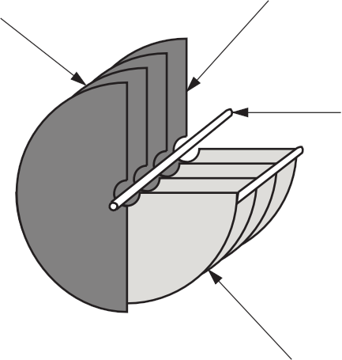
Rotating
Moveable plates mounted on a spindle

Spindle

Fixed

FIG. 4

7. An inductor of negligible resistance and an inductance of 0.2 H is connected in series with a 330 Ω resistor to a 12V d.c. supply. Determine:

(a) the time constant of the circuit

(b) the voltage drop across the inductor after two time constants

(c) the voltage drop across the resistor after three time constants

(d) the resistance of a 0.2 H coil used to replace the inductor if the circuit’s time constant falls to 0.55ms.

