Six steps of hypothesis testing are:

Identify populations, comparison distribution, and assumption; state null and research hypothesis; determine characteristics of the comparisons distribution; determine critical values, or cutoffs; calculate test statistic; and make a decision.

Question 7.18: Calculate the following percentages for a z- score using z table: -0.08
(-0.08 = 93.62 (46.81+ 46.81) (above) 6.38 (3.19 + 3.19) (below), 0.08 (at least as extreme as this z score).

Question 7.20: Rewrite percentages as probabilities, or p levels: a. 5% (0.05) b. 83% (0.83) c. 51% (0.51).

Question 7.22: If the critical values for a hypothesis test occur where 2.5% of the distribution is in each tail, what are the cutoffs for z?

Question 7.28: If cutoffs for a z test are -2.58 and 2.58, determine whether you would reject or fail to reject the null hypothesis in each of the following cases: a. z = -0.94 b. z = 2.12

Question 7.32: z distribution and height. 15 year old girl is 58 inches tall, average height for girls is at this age is 63.80 inches, with a standard deviation of 2.66 inches; a. Calculate her z score, b. What percentage of girls are taller than her? c. What percentage of girls are shorter? d. How much would she have to grow to be perfectly average?

Question 7.34: The z statistic and height. An average class of thirty three 15 yr. old girls with an average height of 62.6 inches. Remember, u = 63.8 inches and σ = 2.66 inches; a. Calculate z score, b. How does this sample of girls compare to the distribution of sample means?

Question 7.39: Directional versus no directional hypotheses; for each example, identify whether the research has expressed a directional or a no directional hypotheses; a. A researcher is interested in studying the relation between the use of antibacterial products and the dryness of people’s skin. He thinks these products might alter the moisture in skin compared to other products that are not antibacterial; b. A student wonders if grades in a class are in any way related to where a student sits in the classroom. In particular, do students who sit in the front row get better grades, on average, than the general population of students?
- Fill in the blank with the best word or words.
  - Values of a test statistic beyond which you reject the null hypothesis are called critical values.
  - Critical region is the area in the tails in which the null can be rejected.
  - If your data differ from what you would expect if chance were the only thing operating, you would call your finding statistically significant.
  - A hypothesis test in which the research hypothesis is directional is a (n) one- tailed test.
  - A hypothesis test in which the research hypothesis specifies that there will be a difference but does not specify the direction of that difference is a (n) two- tailed test.
  - If your z-statistic exceeds the critical cutoff, you can reject the null hypothesis.
The police department of a major city has found that the average height of their 1,250 officers is 71 inches (μ = 71 in.) with σ = 2.3 inches.
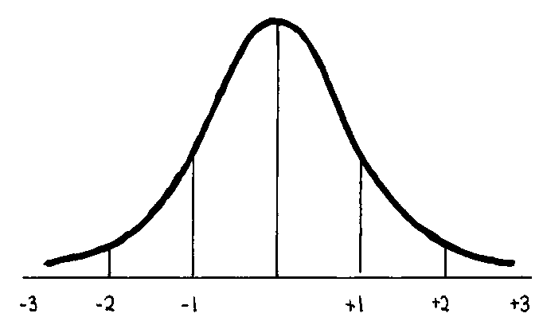
- How many officers are at least 75 inches tall? 513 (1250 – 71/2.3).
- What percent of officers are between 65 and 72 inches tall? 5.2% and 5.76%
- The top 10% of the officers in terms of height also make higher salaries than the shorter officers. How tall does an officer have to be to get in that top 10% group? (I.e. what is the height marking off the top 10 percent?) 6 ft. tall.

- The verbal part of the Graduate Record Exam (GRE) has a μ of 500 and σ = 100. Use the normal distribution to answer the following questions:
  - If you wanted to select only students at or above the 90th percentile, what verbal GRE score would you use as a cutoff score?
  - What verbal GRE score corresponds to a percentile rank of 15%?
  - What’s the percentile rank of a GRE score of 628?

- The police department of a major city has found that the average height of their 1,250 officers is 71 inches (μ = 71 in.) with σ = 2.3 inches.
- How many officers are at least 75 inches tall? 513 (1250 – 71/2.3).
- What percent of officers are between 65 and 72 inches tall? 5.2% and 5.76%
- The top 10% of the officers in terms of height also make higher salaries than the shorter officers. How tall does an officer have to be to get in that top 10% group? (I.e. what is the height marking off the top 10 percent?) 6 ft. tall.

- The verbal part of the Graduate Record Exam (GRE) has a μ of 500 and σ = 100. Use the normal distribution to answer the following questions:
  - If you wanted to select only students at or above the 90th percentile, what verbal GRE score would you use as a cutoff score?
  - What verbal GRE score corresponds to a percentile rank of 15%?
  - What’s the percentile rank of a GRE score of 628?

