Complete
Self-Study Review Problem (Pg. 463)

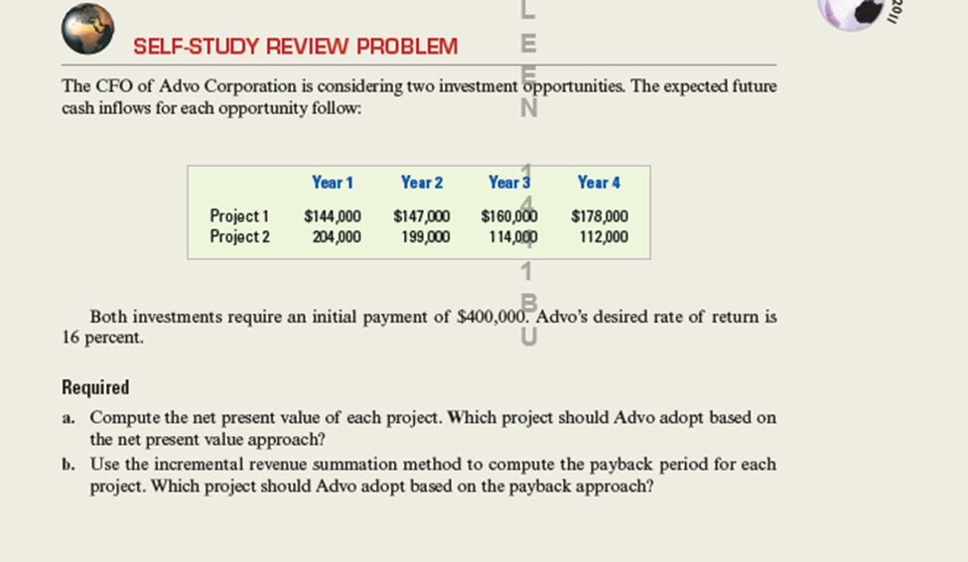

Compute the net present value of each project. Which project should Advo adopt based on the net present value approach.
Use the incremental revenue summation method to compute the payback period for each project. Which project should Advo adopt based on the payback approach?

Complete the information requested in parts (a) and (b) of the Self-Study Review Problem on pg463. Then answer the following questions related to capital investment proposals. (1) What is meant by the expression, time value of money? (2) Why should all capital investment proposals include time value of money (present value) calculations of future cash flows that are to be received from the alternative investments?

