Money Management Strategy: Financial Statements and Budgeting
Objectives
- Recognize relationships among financial documents and money management activities.
- Design a system for maintaining personal financial records.
- Develop a personal balance sheet and cash flow statement.
- Create and implement a budget.
- Relate money management and savings activities to achieve financial goals.
What will this mean for me?
The average person in the United States saves less than three cents of every dollar earned. This lack of saving results in not having adequate funds for long-term financial security. Effectively planning your spending and saving decisions provides a foundation for wise money management today and financial prosperity in the future.
My Life: Saving is the Only Path for Financial Success

“Money not going out is like money coming in!” Reducing your spending will result in lower credit card debt, more money for emergencies, and funds for long-term investing.
From a budgeting perspective, “if you only spend money on things you really need, you always have money for things you really want.” Very often in our society, people use the word need when they really mean want. As a result, overspending, increased debt, and lower saving and investing occur.
What are your money management habits? You can now start to assess your money management knowledge and skills. For each of the following statements, circle the choice that best describes your current situation.
- My money management activities are most valuable to help me
  - avoid credit problems.
  - achieve financial goals.
  - enjoy spending for daily needs.
- My system for organizing personal financial records could be described as
  - nonexistent . . . I have documents that are missing in action!
  - basic . . . I can find most stuff when I need to!
  - very efficient . . . better than the Library of Congress!
- The details of my cash flow statement are
  - simple . . . “money coming in” and “money going out.”
  - appropriate for my needs . . . enough information for me.
  - very informative . . . I know where my money goes.
- My budgeting activities could be described as
  - “I don’t have enough money to worry about where it goes.”
  - “I keep track of my spending in my checkbook.”
  - “I have a written plan for spending and paying my bills on time.”
- The status of my savings goals could be described as
  - “Good progress is being made.”
  - “If I save $100 more, I’ll have $100!”
  - “What is a savings goal?”
As you study this chapter, you will encounter “My Life” boxes with additional information and resources related to these items.

Planning for Successful Money Management
Objective 1
Recognize relationships among financial documents and money management activities.
“Each month, I have too many days and not enough money. If the month were only 20 days long, budgeting would be easy.” Most of us have heard a comment like this when it comes to budgeting and money management.
Your daily spending and saving decisions are at the center of financial planning. You must coordinate these decisions with your needs, goals, and personal situation. When people watch a baseball or football game, they usually know the score. In financial planning, knowing the score is also important.
Maintaining financial records and planning your spending are essential to successful personal financial management. The time and effort you devote to these recordkeeping activities will yield benefits. Money management refers to the day-to-day financial activities necessary to manage current personal economic resources while working toward long-term financial security.

Opportunity Cost and Money Management
Consumers can choose from more than 25,000 items in a supermarket, more than 11,000 periodicals, and 500 or more cable stations. Daily decision making is a fact of life, and trade-offs are associated with each choice made. Selecting an alternative means you give up something else. In terms of money management decisions, examples of tradeoff situations, or opportunity costs, include the following:
- Spending money on current living expenses reduces the amount you can use for saving and investing for long-term financial security.
- Saving and investing for the future reduce the amount you can spend now.
- Buying on credit results in payments later and reduces the amount of future income available for spending.
- Using savings for purchases results in lost interest earnings and an inability to use savings for other purposes.
- Comparison shopping can save you money and improve the quality of your purchases but uses up something of value you cannot replace: your time.
My Life 1
The value of money management activities.
Many online sources are available to provide money management information. Locate a blog that you consider reliable for obtaining money management assistance.
As you plan and implement various money management activities, you need to assess financial and personal costs and benefits associated with financial decisions.

Components of Money Management
As Exhibit 3-1 shows, three major money management activities are interrelated. First, personal financial records and documents are the foundation of systematic resource use. These provide written evidence of business transactions, ownership of property, and legal matters. Next, personal financial statements enable you to measure and assess your financial position and progress. Finally, your spending plan, or budget, is the basis for effective money management.
Exhibit 3-1 Money management activities

Organized financial documents are a foundation of effective money management.
© Roberts Publishing Services.
Concept Check 3-1
1 | What opportunity costs are associated with money management activities?

2 | What are the three major money management activities?
Action Application
Talk to several people regarding wise and poor money management actions they have taken in their lives.

A System for Personal Financial Records
Objective 2
Design a system for maintaining personal financial records.
Today, computers seem to be generating more paperwork than ever. Much of that paperwork relates to financial matters. Invoices, credit card statements, insurance policies, and tax records are the basis of financial recordkeeping and personal economic choices.
An organized system of financial records provides a basis for
- Handling daily business affairs, including payment of bills on time.
- Planning and measuring financial progress.
- Completing required tax reports.
- Making effective investment decisions.
- Determining available resources for current and future buying.
As Exhibit 3-2 shows, most financial records are kept in one of three places: a home file, a safe deposit box, or a home computer. A home file should be used to keep records for current needs and documents with limited value. Your home file may be a series of folders, a cabinet with several drawers, or even a cardboard box. Whatever method you use, it is most important that your home file be organized to allow quick access to required documents and information.
Exhibit 3-2 Where to keep your financial records
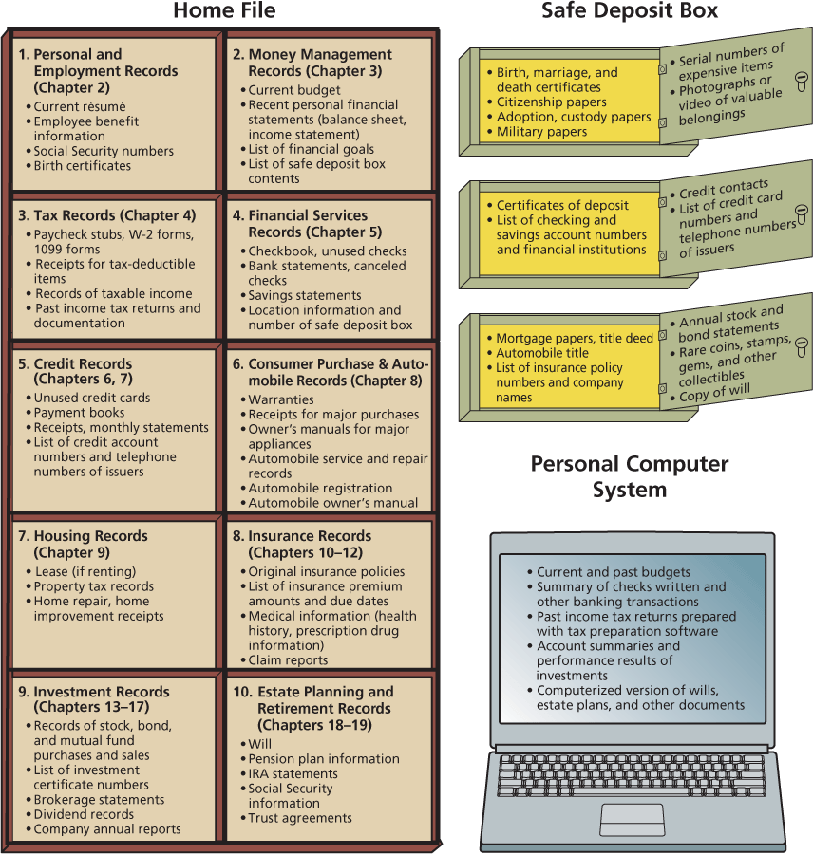
Did You Know?
In the United States, people keep various documents and valuables in 30 million safe deposit boxes in banks and other financial institutions. While these boxes are usually very safe, each year a few people lose the contents of their safe deposit boxes through theft, fire, or natural disasters. Such losses are usually, but not always, covered by the financial institution’s insurance.
Important financial records and valuable articles should be kept in a location that provides better security than a home file. A safe deposit box is a private storage area at a financial institution with maximum security for valuables and difficult-to-replace documents. Access to the contents of a safe deposit box requires two keys. One key is issued to you; the other is kept by the financial institution where the safe deposit box is located. Items commonly kept in a safe deposit box include an annual stock investment statement, contracts, a list of insurance policies, and valuables such as rare coins and stamps. These documents may also be kept in a fireproof home safe.
The number of financial records and documents may seem overwhelming; however, they can easily be organized into 10 categories (see Exhibit 3-2). These groups correspond to the major topics covered in this book. You may not need to use all of these records and documents at present. As your financial situation changes, you will add others.
How long should you keep personal finance records? The answer to this question differs for various documents. Records such as birth certificates, wills, and Social Security data should be kept permanently. Records on property and investments should be kept as long as you own these items. Federal tax laws dictate the length of time you should keep tax-related information. Copies of tax returns and supporting data should be saved for seven years. Normally, an audit will go back only three years; however, under certain circumstances, the Internal Revenue Service may request information from six years back. Financial experts also recommend keeping documents related to the purchase and sale of real estate indefinitely.
My Life 2
My system for organizing personal financial records.
Conduct a brief interview with a couple of people you know about the methods and systems they use to organize their financial documents. What filing systems do they use? How do they use computerized record-keeping systems?
Concept Check 3-2
1 | What are the benefits of an organized system of financial records and documents?

2 | What suggestions would you give for creating a system for organizing and storing financial records and documents?

3 | What influences the length of time you should keep financial records and documents?
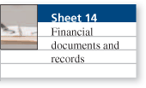
Action Application
Outline a system for filing and maintaining personal financial records. What are some of the goals of your system?

Personal Financial Statements Measure Financial Progress
Objective 3
Develop a personal balance sheet and cash flow statement.
Every journey starts somewhere. You need to know where you are before you can go somewhere else. Personal financial statements tell you the starting point of your financial journey.
Most of the financial documents we have discussed come from financial institutions, business organizations, or the government. Two documents that you create yourself, the personal balance sheet and the cash flow statement, are called personal financial statements. These reports provide information about your current financial position and present a summary of your income and spending. The main purposes of personal financial statements are to
- Report your current financial position in relation to the value of the items you own and the amounts you owe.
- Measure your progress toward your financial goals.
- Maintain information about your financial activities.
- Provide data you can use when preparing tax forms or applying for credit.

The Personal Balance Sheet: Where Are You Now?
The current financial position of an individual or a family is a common starting point for financial planning. A balance sheet, also called a net worth statement or statement of financial position, reports what you own and what you owe. You prepare a personal balance sheet to determine your current financial position using the following process:
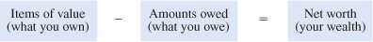
For example, if your possessions are worth $4,500 and you owe $800 to others, your net worth is $3,700.

Step 1: Listing Items of Value
Available cash and money in bank accounts combined with other items of value are the foundation of your current financial position. Assets are cash and other tangible property with a monetary value. The balance sheet for Rose and Edgar Gomez (Exhibit 3-3) lists their assets under four categories:
- Liquid assets are cash and items of value that can easily be converted to cash. Money in checking and savings accounts is liquid and is available to the Gomez family for current spending. The cash value of their life insurance may be borrowed if needed. While assets other than liquid assets can also be converted into cash, the process is not quite as easy.
- Real estate includes a home, a condominium, vacation property, or other land that a person or family owns.
- Personal possessions are a major portion of assets for most people. Included in this category are automobiles and other personal belongings. While these items have value, they may be difficult to convert to cash. You may decide to list your possessions on the balance sheet at their original cost. However, these values probably need to be revised over time, since a five-year-old television set, for example, is worth less now than when it was new. Thus, you may wish to list your possessions at their current value (also referred to as market value). This method takes into account the fact that such things as a home or rare jewelry may increase in value over time. You can estimate current value by looking at ads for the selling price of comparable automobiles, homes, or other possessions. Or you may use the services of an appraiser.
- Investment assets are funds set aside for long-term financial needs. The Gomez family will use their investments for such things as financing their children’s education, purchasing a vacation home, and planning for retirement. Since investment assets usually fluctuate in value, the amounts listed should reflect their value at the time the balance sheet is prepared.
Exhibit 3-3 Creating a personal balance sheet
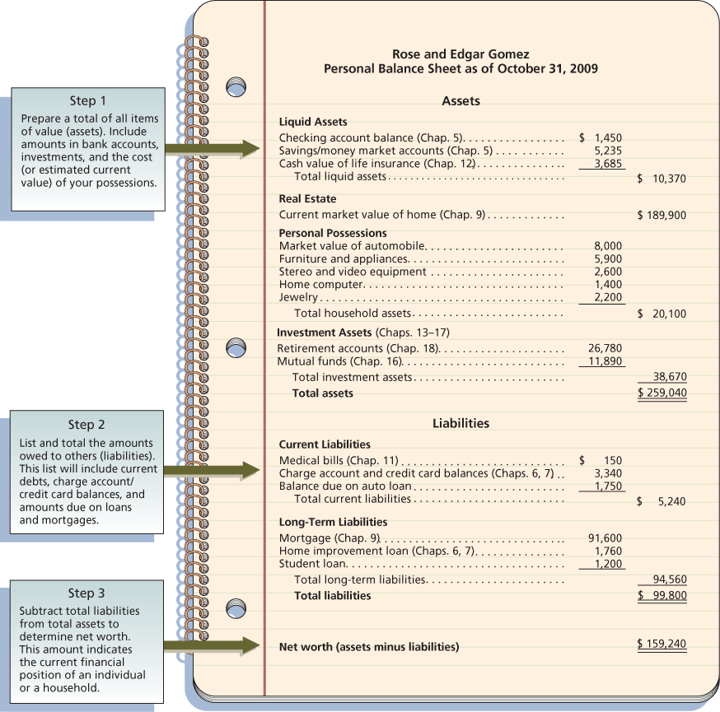
Note: Various asset and liability items are discussed in the chapters listed next to them.
Did You Know?
Poorly organized financial records can result in hidden assets such as U.S. savings bonds, old life insurance policies with a cash value, dormant savings accounts, old investments, and unused gift cards.

Step 2: Determining Amounts Owed
Looking at the total assets of the Gomez family, you might conclude that they have a strong financial position. However, their debts must also be considered. Liabilities are amounts owed to others but do not include items not yet due, such as next month’s rent. A liability is a debt you owe now, not something you may owe in the future. Liabilities fall into two categories:
- Current liabilities are debts you must pay within a short time, usually less than a year. These liabilities include such things as medical bills, tax payments, insurance premiums, cash loans, and charge accounts.
- Long-term liabilities are debts you do not have to pay in full until more than a year from now. Common long-term liabilities include auto loans, educational loans, and mortgages. A mortgage is an amount borrowed to buy a house or other real estate that will be repaid over a period of 15, 20, or 30 years. Similarly, a home improvement loan may be repaid to the lender over the next 5 to 10 years.
The debts listed in the liability section of a balance sheet represent the amount owed at the moment; they do not include future interest payments. However, each debt payment is likely to include a portion of interest. Chapters 6 and 7 discuss the cost of borrowing further.

Step 3. Computing Net Worth
Your net worth is the difference between your total assets and your total liabilities. This relationship can be stated as
Assets − Liabilities = Net worth
Net worth is the amount you would have if all assets were sold for the listed values and all debts were paid in full. Also, total assets equal total liabilities plus net worth. The balance sheet of a business is commonly expressed as
Assets = Liabilities + Net worth
As Exhibit 3-3 shows, Rose and Edgar Gomez have a net worth of $159,240. Since very few people, if any, liquidate all assets, the amount of net worth has a more practical purpose: It provides a measurement of your current financial position.
A person may have a high net worth but still have financial difficulties. Having many assets with low liquidity means not having the cash available to pay current expenses.
Insolvency is the inability to pay debts when they are due; it occurs when a person’s liabilities far exceed available assets. Bankruptcy, discussed in Chapter 7, may be an alternative for a person in this position.
You can increase your net worth in various ways, including
- Increasing your savings.
- Reducing spending.
- Increasing the value of investments and other possessions.
- Reducing the amounts you owe.
Remember, your net worth is not money available for use but an indication of your financial position on a given date.

Evaluating Your Financial Position
A personal balance sheet helps you measure progress toward financial goals. Your financial situation improves if your net worth increases each time you prepare a balance sheet. It will improve more rapidly if you are able to set aside money each month for savings and investments. As with net worth, the relationship among various balance sheet items can give an indication of your financial position.

The Cash Flow Statement: Where Did Your Money Go?
Each day, financial events can affect your net worth. When you receive a paycheck or pay living expenses, your total assets and liabilities change. Cash flow is the actual inflow and outflow of cash during a given time period. Income from employment will probably represent your most important cash inflow; however, other income, such as interest earned on a savings account, should also be considered. In contrast, payments for items such as rent, food, and loans are cash outflows.
A cash flow statement, also called a personal income and expenditure statement (Exhibit 3-4 on page 85), is a summary of cash receipts and payments for a given period, such as a month or a year. This report provides data on your income and spending patterns, which will be helpful when preparing a budget. A checking account can provide information for your cash flow statement. Deposits to the account are your inflows; checks written are your outflows. Of course, in using this system, when you do not deposit the entire amounts received, you must also note the spending of undeposited amounts in your cash flow statement.
Exhibit 3-4 Creating a cash flow statement of income and outflows
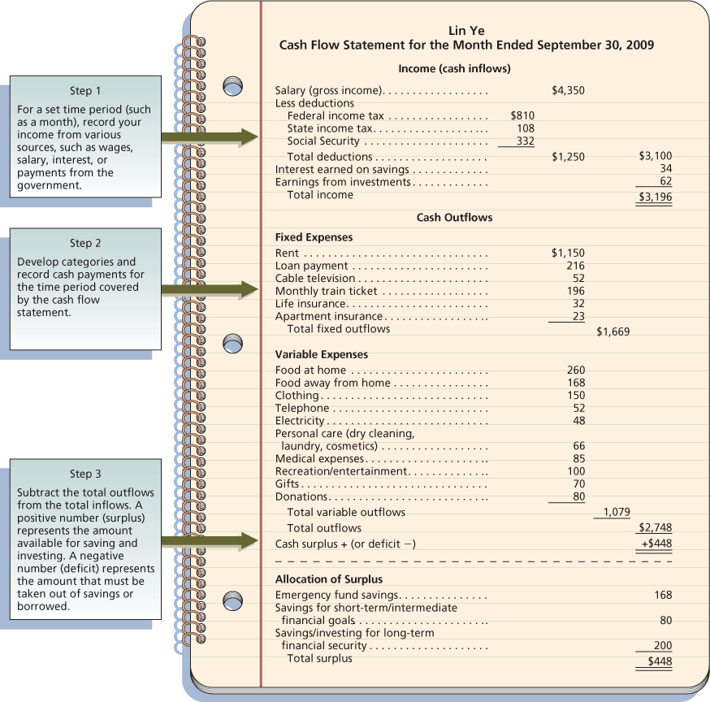
The process for preparing a cash flow statement is
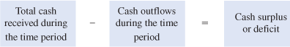

Step 1: Record Income
Creating a cash flow statement starts with identifying the cash received during the time period involved. Income is the inflows of cash for an individual or a household. For most people, the main source of income is money received from a job. Other common income sources include
- Wages, salaries, and commissions.
- Self-employment business income.
- Savings and investment income (interest, dividends, rent).
- Gifts, grants, scholarships, and educational loans.
- Government payments, such as Social Security, public assistance, and unemployment benefits.
- Amounts received from pension and retirement programs.
- Alimony and child support payments.
In Exhibit 3-4, notice that Lin Ye’s monthly salary (or gross income) of $4,350 is her main source of income. However, she does not have use of the entire amount. Take-home pay, also called net pay, is a person’s earnings after deductions for taxes and other items. Lin’s deductions for federal, state, and Social Security taxes are $1,250. Her take-home pay is $3,196. This amount, plus earnings from savings and investments, is the income she has available for use during the current month.
Take-home pay is also called disposable income, the amount a person or household has available to spend. Discretionary income is money left over after paying for housing, food, and other necessities. Studies report that discretionary income ranges from less than 5 percent for people under age 25 to more than 40 percent for older people.
Daily purchasing decisions influence cash outflows and long-term financial goals.
David Stuart//Digital Vision/Getty Images.
Financial Planning Calculations: Ratios for Evaluating Financial Progress
Financial ratios provide guidelines for measuring the changes in your financial situation. These relationships can indicate progress toward an improved financial position.
Ratio | Calculation | Example | Interpretation
Debt ratio | Liabilities divided by net worth | $25,000/$50,000 = 0.5 | Shows relationship between debt and net worth; a low debt ratio is best.
Current ratio | Liquid assets divided by current liabilities | $4,000/$2,000 = 2 | Indicates $2 in liquid assets for every $1 of current liabilities; a high current ratio is desirable to have cash available to pay bills.
Liquidity ratio | Liquid assets divided by monthly expenses | $10,000/$4,000 = 2.5 | Indicates the number of months in which living expenses can be paid if an emergency arises; a high liquidity ratio is desirable.
Debt-payments ratio | Monthly credit payments divided by take-home pay | $540/$3,600 = 0.15 | Indicates how much of a person’s earnings goes for debt payments (excluding a home mortgage); most financial advisers recommend a debt/payments ratio of less than 20 percent.
Savings ratio | Amount saved each month divided by gross income | $648/$5,400 = 0.12 | Financial experts recommend monthly savings of 5–10 percent.
Based on the following information, calculate the ratios requested:
- Liabilities $12,000
- Liquid assets $2,200
- Monthly credit payments $150
- Monthly savings $130
- Net worth $36,000
- Current liabilities $550
- Take-home pay $900
- Gross income $1,500
1. Debt ratio ____________________________________
2. Current ratio __________________________________
3. Debt-payments ratio __________________________
4. Savings ratio __________________________________
Analysis: How do these ratios compare with the guidelines mentioned in the “Interpretation” column above?

Step 2: Record Cash Outflows
Cash payments for living expenses and other items make up the second component of a cash flow statement. Lin Ye divides her cash outflows into two major categories: fixed expenses and variable expenses. While every individual and household has different cash outflows, these main categories, along with the subgroupings Lin uses, can be adapted to most situations.
- Fixed expenses are payments that do not vary from month to month. Rent or mortgage payments, installment loan payments, cable television service fees, and a monthly train ticket for commuting to work are examples of constant or fixed cash outflows.
For Lin, another type of fixed expense is the amount she sets aside each month for payments due once or twice a year. For example, Lin pays $384 every March for life insurance. Each month, she records a fixed outflow of $32 for deposit in a special savings account so that the money will be available when her insurance payment is due.
- Variable expenses are flexible payments that change from month to month. Common examples of variable cash outflows are food, clothing, utilities (such as electricity and telephone), recreation, medical expenses, gifts, and donations. The use of a checkbook or some other recordkeeping system is necessary for an accurate total of cash outflows.
My Life 3
The details of my cash flow statement.
In what ways might the “Daily Spending Diary” (at the end of each chapter) be of value when preparing a personal cash flow statement?

Step 3: Determine Net Cash Flow
The difference between income and outflows can be either a positive (surplus) or a negative (deficit) cash flow. A deficit exists if more cash goes out than comes in during a given month. This amount must be made up by withdrawals from savings or by borrowing.
When you have a cash surplus, as Lin did (Exhibit 3-4), this amount is available for saving, investing, or paying off debts. Each month, Lin sets aside money for her emergency fund in a savings account that she would use for unexpected expenses or to pay living costs if she did not receive her salary. She deposits the rest of the surplus in savings and investment plans that have two purposes. The first is the achievement of short-term and intermediate financial goals, such as a new car, a vacation, or reenrollment in school; the second is long-term financial security—her retirement.
A cash flow statement provides the foundation for preparing and implementing a spending, saving, and investment plan, discussed in the next section.
Did You Know?
When there is not enough in savings for emergencies, people most often use a home equity loan or credit cards, borrow from relatives or against a retirement account, or sell some unneeded assets.
Concept Check 3-3
1 | What are the main purposes of personal financial statements?

2 | What does a personal balance sheet tell about your financial situation?

3 | How can you use a balance sheet for personal financial planning?

4 | What information does a cash flow statement present?
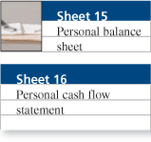
Action Application
Using a Web search or library sources, obtain information about the assets commonly held by U.S. households. How have the values of assets, liabilities, and net worth of U.S. consumers changed in recent years?

Budgeting for Skilled Money Management
Objective 4
Create and implement a budget.
A budget, or spending plan, is necessary for successful financial planning. The common financial problems of overusing credit, lacking a regular savings program, and failing to ensure future financial security can be minimized through budgeting. The main purposes of a budget are to help you
- Live within your income.
- Spend your money wisely.
- Reach your financial goals.
- Prepare for financial emergencies.
- Develop wise financial management habits.
Budgeting may be viewed in four major phases, as shown in Exhibit 3-5.
Exhibit 3-5 Creating and implementing a budget
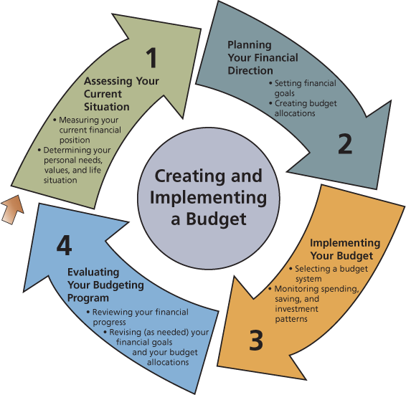

The Budgeting Process
The financial statements and documents discussed in the first sections of this chapter provide a starting point for your daily money management activities. A personal balance sheet is an effective scorecard for measuring financial progress. Increases in net worth as a result of increased assets or decreased debt are evidence of an improved financial position. A regular assessment of your financial standing using a personal balance sheet can provide a point of reference for money management decisions.

Step 1: Setting Financial Goals
Future plans are an important dimension of your financial direction. Financial goals are plans for future activities that require you to plan your spending, saving, and investing. Exhibit 3-6 gives examples of common financial goals based on life situation and time.
Exhibit 3-6 Common financial goals
Personal Situation | Short-Term Goals (less than 2 years) | Intermediate Goals (2–5 years) | Long-Term Goals (over 5 years)
Single person | - Complete college  - Pay off auto loan | - Take a vacation to Europe  - Pay off education loan  - Attend graduate school | - Buy a vacation home in the mountains  - Provide for retirement income
Married couple (no children) | - Take an annual vacation  - Buy a new car | - Remodel home  - Build a stock portfolio | - Buy a retirement home  - Provide for retirement income
Single parent (young children) | - Increase life insurance  - Increase savings | - Increase investments  - Buy a new car | - Accumulate a college fund for children  - Move to a larger home
Note: As discussed in Chapter 1, your goals should be realistic, specific, and measurable for a definite time frame.
As discussed in Chapter 1, financial goals should: (1) Be realistic; (2) be stated in specific, measurable terms; (3) have a definite time frame; and (4) imply the type of action to be taken. Your personal financial statements and budgeting allow you to achieve your financial goals with
- Your cash flow statement: telling you what you received and spent over the past month.
- Your balance sheet: reporting your current financial position—where you are now.
- Your budget: planning spending and saving to achieve financial goals.
Did You Know?
The main budgeting mistakes people make are failing to save, never creating a budget, underestimating expenses, and not planning for large costs (vacations, auto repairs).

Step 2: Estimating Income
As Exhibit 3-7 shows, you should next estimate available money for a given time period. A common budgeting period is a month, since many payments, such as rent or mortgage, utilities, and credit cards, are due each month. In determining available income, include only money that you are sure you’ll receive. Bonuses, gifts, or unexpected income should not be considered until the money is actually received.
Exhibit 3-7 The Fraziers develop and implement a monthly budget
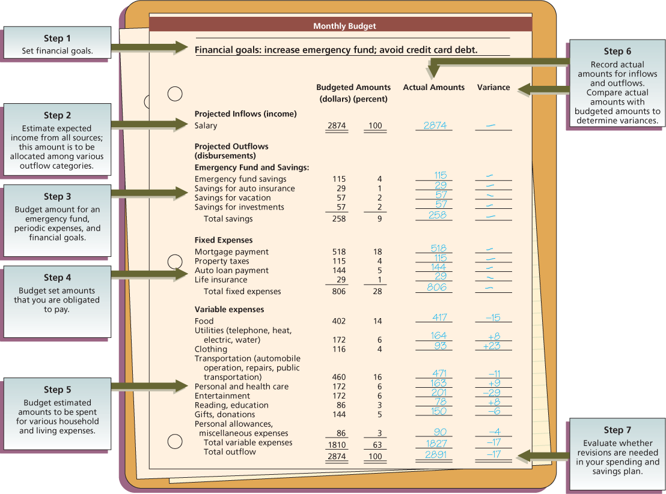
If you get paid once a month, planning is easy since you will work with a single amount. But if you get paid weekly or twice a month, you will need to plan how much of each paycheck will go for various expenses. If you get paid every two weeks, plan your spending based on the two paychecks you will receive each month. Then, during the two months each year that have three paydays, you can put additional amounts into savings, pay off some debts, or make a special purchase.
Budgeting income may be difficult if your earnings vary by season or your income is irregular, as with sales commissions. In these situations, attempt to estimate your income based on the past year and on your expectations for the current year. Estimating your income on the low side will help you avoid overspending and other financial difficulties.
Maintaining income and expense records makes the budgeting process easier.
© Digital Vision/PunchStock/DAL.

Step 3: Budgeting an Emergency Fund and Savings
To set aside money for unexpected expenses as well as future financial security, the Fraziers (see Exhibit 3-7) have budgeted several amounts for savings and investments. Financial advisers suggest that an emergency fund representing three to six months of living expenses be established for use in periods of unexpected financial difficulty. This amount will vary based on a person’s life situation and employment stability. A three-month emergency fund is probably adequate for a person with a stable income or secure employment, while a person with erratic or seasonal income may need to set aside an emergency fund sufficient for six months or more of living expenses.
Did You Know?
According to Lynnette Khalfani (www.themoneycoach.net), LIFE is the major budget buster:
L | is “Listed” expenses (housing, utilities, food, clothing) that are underestimated.
I | involves “Impulse buying,” whether in stores or online.
F | are “Forgotten” bills, such as annual insurance payments.
E | are “Emergencies,” such as unexpected auto or home repairs.
The Fraziers also set aside an amount each month for their automobile insurance payment, which is due every six months. Both this amount and the emergency fund are put into a savings account. The time value of money, discussed in Chapter 1, refers to increases in an amount of money as a result of interest earned. Savings methods for achieving financial goals are discussed later in this chapter.
A very common budgeting mistake is to save only the amount left at the end of the month. When you do that, you often have nothing left for savings. Since savings are vital to long-term financial security, advisers suggest that an amount be budgeted as a fixed expense.

Step 4: Budgeting Fixed Expenses
Definite obligations make up this portion of a budget. As Exhibit 3-7 shows, the Fraziers have fixed expenses for housing, taxes, and loan payments. They make a monthly payment of $29 for life insurance. The budgeted total for the Fraziers’ fixed expenses is $806, or 28 percent of estimated available income.
Assigning amounts to spending categories requires careful consideration. The amount you budget for various items will depend on your current needs and plans for the future. The following sources can help you plan your spending:
- Your cash flow statement.
- Consumer expenditure data from the Bureau of Labor Statistics.
- Articles in magazines such as Kiplinger’s Personal Finance Magazine and Money.
- Estimates of future income and expenses and anticipated changes in inflation rates.
My Life 4
My budgeting activities.
Your buying habits will vary depending on the number of people in your household, their ages, and your geographic location. The spending patterns for various households, reported with consumer expenditure data and the latest consumer price index, are available at www.stats.bls.gov.
Exhibit 3-8 provides suggested budget allocations for different life situations. Although this information can be of value when creating budget categories, maintaining a detailed record of your spending for several months is a better source for your personal situation. However, don’t become discouraged. Use a simple system, such as a notebook or your checkbook. This “spending diary” will help you know where your money is going. Remember, a budget is an estimate for spending and saving intended to help you make better use of your money, not to reduce your enjoyment of life.
Exhibit 3-8 Typical after-tax budget allocations for different life situations
Budget Category | Student | Working Single (no dependents) | Couple (children under 18) | Single Parent (young children) | Parents (children over 18 in college) | Couple (over 55, no dependent children)
Housing (rent or mortgage payment; utilities; furnishings and appliances) | 0–25% | 30–35% | 25–35% | 20–30% | 25–30% | 25–35%
Transportation | 5–10 | 15–20 | 15–20 | 10–18 | 12–18 | 10–18
Food (at home and away from home) | 15–20 | 15–25 | 15–25 | 13–20 | 15–20 | 18–25
Clothing | 5–12 | 5–15 | 5–10 | 5–10 | 4–8 | 4–8
Personal and health care (including child care) | 3–5 | 3–5 | 4–10 | 8–12 | 4–6 | 6–12
Entertainment and recreation | 5–10 | 5–10 | 4–8 | 4–8 | 6–10 | 5–8
Reading and education | 10–30 | 2–4 | 3–5 | 3–5 | 6–12 | 2–4
Personal insurance and pension payments | 0–5 | 4–8 | 5–9 | 5–9 | 4–7 | 6–8
Gifts, donations, and contributions | 4–6 | 5–8 | 3–5 | 3–5 | 4–8 | 3–5
Savings | 0–10 | 4–15 | 5–10 | 5–8 | 2–4 | 3–5
Sources: Bureau of Labor Statistics (stats.bls.gov); American Demographics; Money; The Wall Street Journal.

Step 5: Budgeting Variable Expenses
Planning for variable expenses is not as easy as budgeting for savings or fixed expenses. Variable expenses will fluctuate by household situation, time of year, health, economic conditions, and a variety of other factors. A major portion of the Fraziers’ planned spending—over 60 percent of their budgeted income—is for variable living costs.
The Fraziers base their estimates on their needs and desires for the items listed and on expected changes in the cost of living. The consumer price index (CPI) is a measure of the general price level of consumer goods and services in the United States. This government statistic indicates changes in the buying power of a dollar. As consumer prices increase due to inflation, people must spend more to buy the same amount. Changes in the cost of living will vary depending on where you live and what you buy.
As mentioned in Chapter 1, the rule of 72 can help you budget for price rises. At a 6 percent inflation rate, prices will double in 12 years (72/6); at an 8 percent inflation rate, prices will double in only 9 years (72/8).
Did You Know?
For ideas to cut your spending, go to www.clarkhoward.com, www.homemoneyhelp.com www.cheapskatemonthly.com, and www.thefrugalshopper.com.

Step 6: Recording Spending Amounts
After you have established your spending plan, you will need to keep records of your actual income and expenses similar to those you keep in preparing an income statement. In Exhibit 3-7, notice that the Fraziers estimated specific amounts for income and expenses. These are presented under “Budgeted Amounts.”
The family’s actual spending was not always the same as planned. A budget variance is the difference between the amount budgeted and the actual amount received or spent. The total variance for the Fraziers was a $17 deficit, since their actual spending exceeded their planned spending by this amount. The Fraziers would have had a surplus if their actual spending had been less than they had planned.
Variances for income should be viewed as the opposite of variances for expenses. Less income than expected would be a deficit, while more income than expected would be a surplus.
Spending more than planned for an item may be justified by reducing spending for another item or putting less into savings. However, it may be necessary to revise your budget and financial goals.

Step 7: Reviewing Spending and Saving Patterns
Like most decision-making activities, budgeting is a circular, ongoing process. You will need to review and perhaps revise your spending plan on a regular basis.

Reviewing Your Financial Progress
The results of your budget may be obvious: having extra cash in checking, falling behind in your bill payments, and so on. However, such obvious results may not always be present. Occasionally, you will have to sit down (with other household members, if appropriate) and review areas where spending has been more or less than expected.
As Exhibit 3-9 shows, you can prepare an annual summary to compare actual spending with budgeted amounts. This type of summary may also be prepared every three or six months. A spreadsheet computer program can be useful for this purpose. The summary will help you see areas where changes in your budget may be necessary. This review process is vital to both successful short-term money management and long-term financial security.
Exhibit 3-9 An annual budget summary
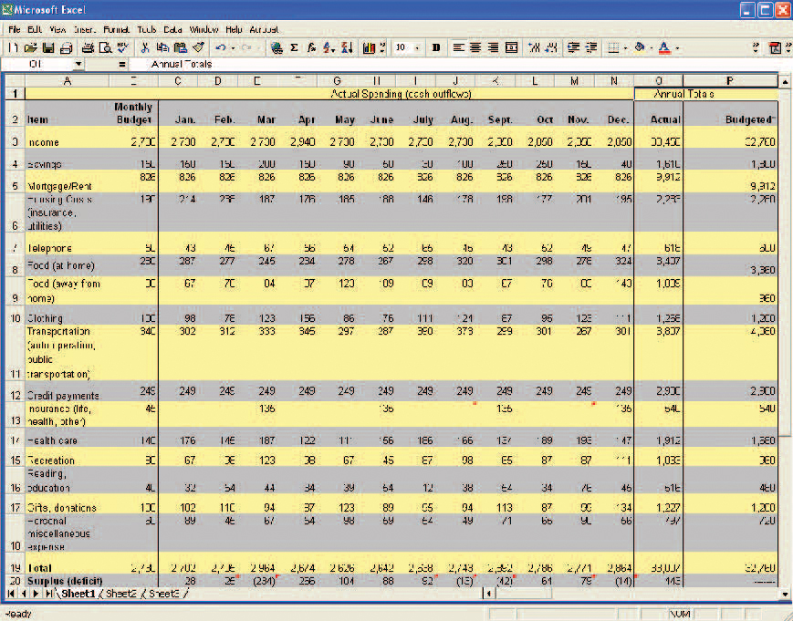
Did You Know?
A daily money manager (DMM) is a person who specializes in helping older persons with their day-to-day personal finances. These personal financial assistants may sort mail, pay bills, make bank deposits, maintain a budget, file insurance claims, and organize tax records. For further information about DMMs, go to www.aadmm.com.

Revising Your Goals and Budget Allocations
What should you cut first when a budget shortage occurs? This question doesn’t have easy answers, and the answers will vary for different household situations. The most common overspending areas are entertainment and food, especially away-from-home meals. Purchasing less expensive brand items, buying quality used products, avoiding credit card purchases, and renting rather than buying are common budget adjustment techniques. When having to cut household budgets, reduced spending most often occurs for vacations, dining out, cleaning and lawn services, cable/Internet service, and charitable donations.
At this point in the budgeting process, you may also revise your financial goals. Are you making progress toward achieving your objectives? Have changes in personal or economic conditions affected the desirability of certain goals? Have new goals surfaced that should be given a higher priority than those that have been your major concern? Addressing these issues while creating an effective saving method will help ensure accomplishment of your financial goals.

Characteristics of Successful Budgeting
Having a spending plan will not eliminate financial worries. A budget will work only if you follow it. Changes in income, expenses, and goals will require changes in your spending plan. Money management experts advise that a successful budget should be
- Well planned. A good budget takes time and effort to prepare. Planning a budget should involve everyone affected by it. Children can learn important money management lessons by helping to develop and use the family budget.
- Realistic. If you have a moderate income, don’t immediately expect to save enough money for an expensive car or a lavish vacation. A budget is designed not to prevent you from enjoying life but to help you achieve what you want most.
- Flexible. Unexpected expenses and changes in your cost of living will require a budget that you can easily revise. Also, special situations, such as two-income families or the arrival of a baby, may require an increase in certain types of expenses.
- Clearly communicated. Unless you and others involved are aware of the spending plan, it will not work. The budget should be written and available to all household members.
The budgeting process should be a cooperative effort among all household members.
Concept Check 3-4
1 | What are the main purposes of a budget?

2 | How does a person’s life situation affect goal setting and amounts allocated for various budget categories?

3 | What are the main steps in creating a budget?

4 | What are commonly recommended qualities of a successful budget?

5 | What actions might you take when evaluating your budgeting program?
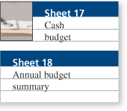
Action Application
Ask two or three friends or relatives about the budgeting system they use for their spending records. Create a visual presentation (video or slide presentation) that communicates wise budgeting techniques.

Money Management and Achieving Financial Goals
Objective 5
Relate money management and savings activities to achieving financial goals.
Your personal financial statements and budget allow you to achieve your financial goals with
- Your balance sheet: reporting your current financial position—where you are now.
- Your cash flow statement: telling you what you received and spent over the past month.
- Your budget: planning spending and saving to achieve financial goals.
People commonly prepare a balance sheet on a periodic basis, such as every three or six months. Between those points in time, your budget and cash flow statement help you plan and measure spending and saving activities. For example, you might prepare a balance sheet on January 1 and July 1. Your budget would serve to plan your spending and saving between these points in time, and your cash flow statement of income and outflows would document your actual spending and saving. This relationship may be illustrated in this way:
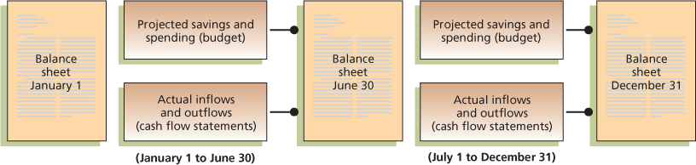
David Lok/SuperStock.
Changes in your net worth result from cash inflows and outflows. In periods when your outflows exceed your inflows, you must draw on savings or borrow (buy on credit). When this happens, lower assets (savings) or higher liabilities (due to the use of credit) result in a lower net worth. When inflows exceed outflows, putting money into savings or paying off debts will result in a higher net worth.

Identifying Saving Goals
Saving current income (as well as investing, which is discussed in Chapters 13–17) is the basis for an improved financial position and long-term financial security. Common reasons for saving include:
- To set aside money for irregular and unexpected expenses.
- To pay for the replacement of expensive items, such as appliances or an automobile, or to have money for a down payment on a house.
- To buy special items such as home video or recreational equipment or to pay for a vacation.
- To provide for long-term expenses such as the education of children or retirement.
- To earn income from the interest on savings for use in paying living expenses.

Selecting a Saving Technique
For many years, the United States has ranked lowest among industrial nations in savings rate. Low savings affect personal financial situations. Studies reveal that the majority of Americans do not have an adequate amount set aside for emergencies.
Specific savings activities contribute to achieving long-term financial goals.
© Michael Keller/CORBIS.
Since most people find saving difficult, financial advisers suggest these methods to make it easier:
- Write a check each payday and deposit it in a savings account not readily available for regular spending. Or use an automatic payment to electronically transfer an amount to your savings. This savings deposit can be a percentage of income, such as 5 or 10 percent, or a specific dollar amount.
- Payroll deduction is available through most places of employment. With this system, an amount is deducted from your salary and deposited in savings.
- Saving coins or spending less on certain items can help you save. Each day, put your change in a container. You can also increase your savings by taking a sandwich to work instead of buying lunch or refraining from buying snacks or magazines.
Financial Planning for Life’s Situations: Selecting a Budgeting System
Although your checkbook and online payment record may give you a fairly complete record of your expenses, these do not serve the purpose of planning for spending. A budget requires that you outline how you will spend available income. Four basic types of budgeting systems exist:
- A mental budget exists only in a person’s mind. This simple system may be appropriate if you have limited resources and minimal financial responsibilities. The major drawback of a mental budget is the danger of forgetting what amounts you plan to spend on various items.
- A physical budget involves the use of envelopes, folders, or containers to hold the money or slips of paper that represent amounts allocated for spending categories. This system allows you to actually see where your money goes. Envelopes would contain the amount of cash or a note listing the amount to be used for “Food,” “Rent,” “Clothing,” “Auto Payment,” “Entertainment,” and other expenses.
- Experienced financial advisers recommend a written budget. The exact system and the amount of detail will depend on the time, effort, and information that you put into the budgeting process. A written budget can be kept on notebook paper or in a specialized budgeting book available in office supply stores. A common budget format is a spreadsheet that has several monthly columns for comparing budgeted and actual amounts for various expense items.
- A computerized budgeting system is used by many people. In addition to creating a budget, money management software is capable of doing other financial recordkeeping tasks such as writing checks and projecting the future value of savings accounts. Programs such as Microsoft Money (www.microsoft.com/money) and Quicken (www.quicken.com) can assist with these tasks. While it takes time and effort to learn the software and enter data, a computerized budgeting and recordkeeping procedure can yield fast and accurate financial planning data.
How you save is far less important than making regular periodic savings deposits that will help you achieve financial goals. Small amounts of savings can grow faster than most people realize.
Did You Know?
For years, coworkers were amused by a woman who carried a brown bag lunch to her job each day. That woman later retired in financial comfort and lived her later years in beachfront property. A daily coffee and muffin can add up to over $1,300 a year.
My Life 5
The status of my saving goals.
Reaching your financial goals will depend on the savings method used and the time value of money. How do the examples shown in Exhibit 3-10, Using Savings to Achieve Financial Goals, relate to your current or future life situation?

Calculating Savings Amounts
To achieve your financial objectives, you should convert your savings goals into specific amounts. Your use of a savings or investment plan is vital to the growth of your money. As Exhibit 3-10 shows, using the time value of money calculations, introduced in Chapter 1, can help you calculate progress toward achieving your financial goals.
Exhibit 3-10 Using savings to achieve financial goals
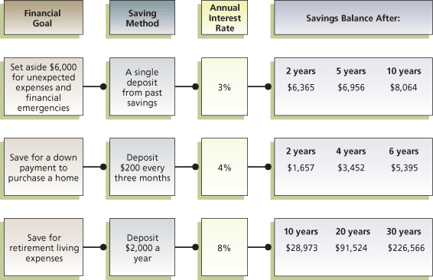
Concept Check 3-5
1 | What are some suggested methods to make saving easy?

2 | What methods are available to calculate amounts needed to reach savings goals?
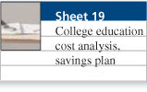
Action Application
Interview a young single person, a young couple, and a middle-aged person about their financial goals and savings habits. What actions do they take to determine and achieve various financial goals?

Summary of Objectives

My Life Objective 1

Recognize relationships among financial documents and money management activities
Successful money management requires effective coordination of personal financial records, personal financial statements, and budgeting activities.

My Life Objective 2

Design a system for maintaining personal financial records
Your system for organizing personal financial records and documents is the foundation of effective money management. This structure should provide ease of access as well as security for financial documents that may be impossible to replace.

My Life Objective 3

Develop a personal balance sheet and cash flow statement
A personal balance sheet, also known as a net worth statement, is prepared by listing all items of value (assets) and all amounts owed to others (liabilities). The difference between your total assets and your total liabilities is your net worth. A cash flow statement, also called a personal income and expenditure statement, is a summary of cash receipts and payments for a given period, such as a month or a year. This report provides data on your income and spending patterns.

My Life Objective 4

Create and implement a budget
Your budgeting activities should involve a process with four phases: (1) assessing your current personal and financial situation, (2) planning your financial direction by setting financial goals and creating budget allowances, (3) implementing your budget, and (4) evaluating your budgeting program.

My Life Objective 5

Relate money management and savings activities to achieve financial goals
Your saving goals should be based on the relationship among the personal balance sheet, cash flow statement, and budget. Saving current income provides the basis for achieving long-term financial security. Future value and present value calculations may be used to compute the increased value of savings for achieving financial goals.

Key Formulas
Page | Topic | Formula
82 | Net worth | Net worth | = Total assets – Total liabilities
 |  | Example: | = $125,000 – $53,000
 |  |  | = $72,000
84 | Debt ratio | Debt ratio | = Liabilities/Net worth
 |  | Example: | = $7,000/$21,000
 |  |  | = 0.33
84 | Current ratio | Current ratio | = Liquid assets/Current liabilities
 |  | Example: | = $8,500/$4,500
 |  |  | = 1.88
84 | Liquidity ratio | Liquidity ratio | = Liquid assets/Monthly expenses
 |  | Example: | = $8,500/$3,500
 |  |  | = 2.4
84 | Debt-payments ratio | Debt-payments ratio | = Monthly credit payments/Take-home pay
 |  | Example: | = $760/$3,800
 |  |  | = 0.20
84 | Savings ratio | Savings ratio | = Amount saved per month/Gross monthly income
 |  | Example: | = $460/$3,800
 |  |  | = 0.12
91 | Cash surplus (or deficit) | Cash surplus (or deficit) | = Total inflows – Total outflows
 |  | Example: | = $5,600 – $4,970
 |  |  | = $630 (surplus)

Key Terms
- assets 80
- balance sheet 80
- budget 86
- budget variance 91
- cash flow 83
- cash flow statement 83
- current liabilities 82
- deficit 91
- discretionary income 83
- income 83
- insolvency 82
- liabilities 82
- liquid assets 80
- long-term liabilities 82
- money management 76
- net worth 82
- safe deposit box 79
- surplus 91
- take-home pay 83

Financial Planning Problems
1. | Creating Personal Financial Statements. Based on the procedures presented in the chapter, prepare your current personal balance sheet and a cash flow statement for the next month. (Obj. 3)

2. | Calculating Balance Sheet Amounts. Based on the following data, compute the total assets, total liabilities, and net worth. (Obj. 3)  - Liquid assets, $3,670  - Investment assets, $8,340  - Current liabilities, $2,670  - Household assets, $89,890  - Long-term liabilities, $76,230

3. | Preparing a Personal Balance Sheet. Use the following items to prepare a balance sheet and a cash flow statement. Determine the total assets, total liabilities, net worth, total cash inflows, and total cash outflows. (Obj. 3)  - Rent for the month, $650  - Monthly take-home salary, $1,950  - Cash in checking account, $450  - Savings account balance, $1,890  - Spending for food, $345  - Balance of educational loan, $2,160  - Current value of automobile, $7,800  - Telephone bill paid for month, $65  - Credit card balance, $235  - Loan payment, $80  - Auto insurance, $230  - Household possessions, $3,400  - Stereo equipment, $2,350  - Payment for electricity, $90  - Lunches/parking at work, $180  - Donations, $70  - Home computer, $1,500  - Value of stock investment, $860  - Clothing purchase, $110  - Restaurant spending, $130

4. | Computing Balance Sheet Amounts. For each of the following situations, compute the missing amount. (Obj. 3)  - Assets $45,000; liabilities $16,000; net worth $_______  - Assets $76,500; liabilities $________; net worth $18,700.  - Assets $34,280; liabilities $12,965; net worth $________  - Assets $________; liabilities $38,345; net worth $52,654.

5. | Calculating Financial Ratios. The Fram family has liabilities of $128,000 and a net worth of $340,000. What is their debt ratio? How would you assess this? (Obj. 3)

6. | Determining Financial Progress. Carl Lester has liquid assets of $2,680 and current liabilities of $2,436. What is his current ratio? What comments do you have about this financial position? (Obj. 3)

7. | Determining Budget Variances. Fran Bowen created the following budget:  - Food, $350  - Transportation, $320  - Housing, $950  - Clothing, $100  - Personal expenses and recreation, $275  She actually spent $298 for food, $337 for transportation, $982 for housing, $134 for clothing, and $231 for personal expenses and recreation. Calculate the variance for each of these categories, and indicate whether it was a deficit or a surplus. (Obj. 4)

8. | Calculating the Effect of Inflation. Bill and Sally Kaplan have an annual spending plan that amounts to $36,000. If inflation is 5 percent a year for the next three years, what amount will the Kaplans need for their living expenses three years from now? (Obj. 4)

9. | Computing the Time Value of Money for Savings. Use future value and present value calculations (see tables in the Chapter 1 appendix) to determine the following. (Obj. 5)  - The future value of a $500 savings deposit after eight years at an annual interest rate of 3 percent.  - The future value of saving $1,500 a year for five years at an annual interest rate of 4 percent.  - The present value of a $2,000 savings account that will earn 3 percent interest for four years.

10. | Calculating Present Value of a Savings Fund. Hal Thomas wants to establish a savings fund from which a community organization could draw $800 a year for 20 years. If the account earns 3 percent, what amount would he have to deposit now to achieve this goal? (Obj. 5)

11. | Future Value of Reduced Spending. Brenda plans to reduce her spending by $50 a month. Calculate the future value of this increase in saving over the next 10 years. (Assume an annual deposit to her savings account, and an annual interest rate of 5 percent.) (Obj. 5)

12. | Future Value of Savings. Kara George received a $10,000 gift for graduation from her uncle. If she deposits the entire amount in an account paying 4 percent, what will be the value of this gift in

