http://ramanujan.math.trinity.edu/wtrench/texts/TRENCH_REAL_ANALYSIS.PDF
The lemma is from page 327 in the link. I am not sure about the dimensions . I believe that X is a vector. 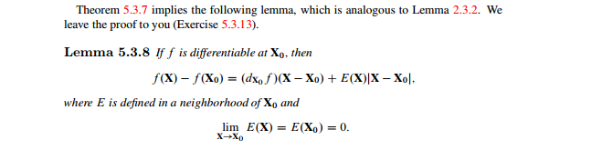
I need a proof for this lemma 5.3.8. And in addition to the proof I need you to define
1: What is E(x)
2: what does the notation $\left(d_{x_{0}}f\right)\left(X-X_{0}\right)$ mean. I have never seen the notation $\left(d_{x_{0}}f\right)$?
3: Please define the dimensions of f and X in the proof.

