**18.** **Compute the volume of the solid formed by revolving the region bounded by  about (a) the *x*-axis; (b) *y* = 4.**

**20.** **Compute the volume of the solid formed by revolving the region bounded by and about (a) the *y*-axis; (b) *x* = 1.**

**4.** **Sketch the region, draw in a typical shell, identify the radius and height of the shell, and compute the volume for the region bounded by and  revolved about .**

**6.** **Sketch the region, draw in a typical shell, identify the radius and height of the shell, and compute the volume for the region bounded by and , revolved about** *x* = 2**.**

**8.** **Sketch the region, draw in a typical shell, identify the radius and height of the shell, and compute the volume for the region bounded by , revolved about** *y* = 4**.**

**12.** **Use cylindrical shells to compute the volume of the region bounded by and** *x* = 4**, revolved about** *y* = 2**.**

**14. Compute the arc length exactly.**



**30. Set up the integral for the surface area of the surface of revolution, and approximate the integral with a numerical method.**

 revolved about the *x*-axis

**36. Set up the integral for the surface area of the surface of revolution, and approximate the integral with a numerical method.**

 revolved about the *x*-axis

20. Evaluate the integral

14. Evaluate the integral $\int{\cot^{2}x \csc^{2}}$ x dx

Determine whether or not the integral is improper. If it is improper, explain why.

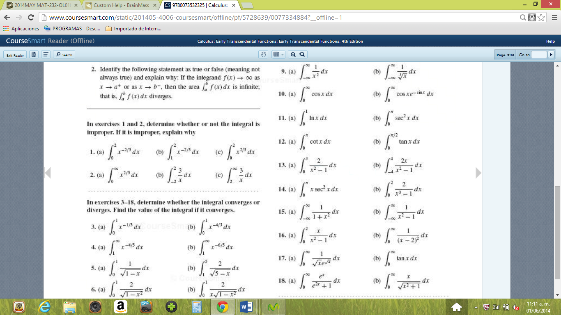

16. Find the indicated limit

$$\lim_{x→∞}{\frac{e^{x}}{x^{4}}}$$