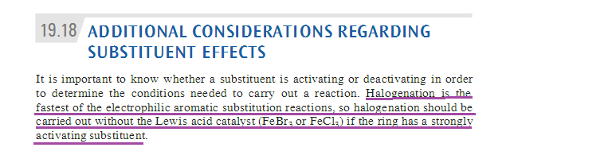
Why is halogenation the fastest one?
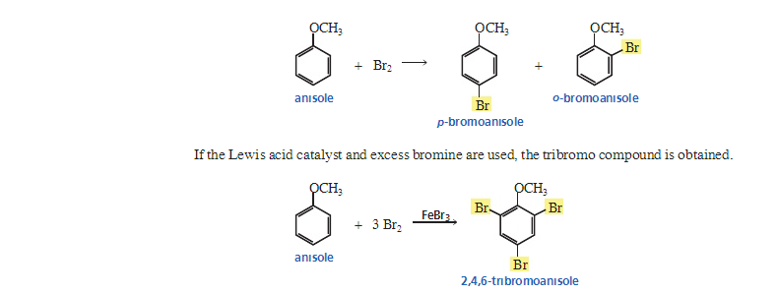
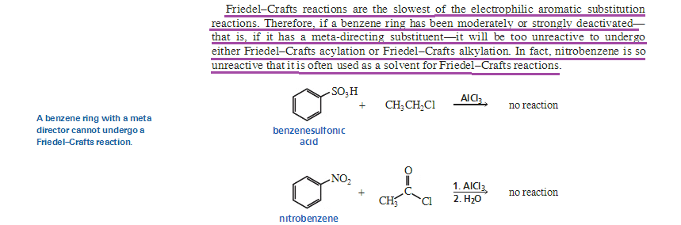
Why is friedel crafts reactions the slowest? And why is it so slow that it can not undergo meta substitution electrophilic reactions?

