**OVERVIEW**

Petlife Corporation (The Company) is a registered US Veterinary Pharmaceutical company, incorporated in 2012 in the state of Delaware as a subsidiary of Medolife International, Inc.  The company is headquartered in Beverly Hills, California with offices in New York City and maintains offices and its productions facilities in the Dominican Republic.  The parent company, Medolife specializes in the research, development, sales and support of advanced drugs and scientifically proven Nutraceuticals for human cancer and autoimmune system related disease; Medolife is preparing to start clinical trials for FDA approval as a drug.  Medolife has the exclusive patent license (United States patent # 8,097,284 B2) of the bioactive peptide and polarization technology. This is the base for a novel pharmacologically active compound that is critical in numerous new generation essential drugs and nutraceuticals, as well as in Escozine for Pets.

The Parent company is Medolife Corp and its flagship product, Escozine ([www.medolife.com](http://www.medolife.com) & www.escozine.com), is registered and certified for oncological treatment by the Minister of Health in the Dominican Republic and has also received a NAFTA Free Trade certification. Escozine is registered and distributed in 5 countries (Dominican Republic, Vietnam, Native American Territories of the US and Canada, Russia, Belarus and Kazakhstan); Escozine is also sold through direct online marketing to over 40 countries.

Petlife’s primary product offering will be sold under the name of Escozine for Pets, and is accessible through the company’s website ([www.USPetlife.com](http://www.uspetlife.com)). Escozine for Pets will be registered and distributed globally; Escozine for Pets will also be sold through direct online marketing.

Petlife’s primary goal is to bring its scientifically proven, potentiated bioactive medication and Nutraceuticals to the world of veterinary oncology, with the ultimate goal of extending the life of pets with cancer and improving their quality of life. In the process of achieving these objectives, Petlife will transition into a world renowned, professionally respected veterinary pharmaceutical company that will create new industry standards as well as being profitable and innovative.

**“My mission** **is to develop a new generation of veterinary medications and nutraceuticals strong enough to have powerful, scientifically proven curative effects without causing any damaging side effects to feline or canine health”**

**Dr. Arthur Grant Mikaelian**

**Founder of Petlife**

1. **Detailed product definition**

Escozine for Pets is a natural product that contains serum derived from the Caribbean blue scorpion. The technical structure of the Petlife’s nutraceutical is outlined in detail in Medolife’s patent # 8,097,284 B2 (see included patent summary).  The company’s Blue scorpion serum has demonstrated human clinical success during an eight-year, open-label human clinical study, which enrolled 8,302 cancer patients representing a wide spectrum of disease types and levels of severity.  The Escozine® serum showed an 89.5% success rate in the quality of life of those in the study. Thousands of stage four cancer patients who were only given months to live are still alive today years after first taking Blue scorpion serum. Petlife’s clinical observations have demonstrated similar success in both dogs and cats. Petlife will file for a new unique patent for Escozine for Pets that will be based on Medolife’s existing Escozine patent.

ESCOZINEFOR PETS is an innovative polarized, potentiated bio-active peptide extracted from the Blue Caribbean Scorpion (Rhopalurus Princeps) which contains amino acids, proteins and minerals. One of the main components of ESCOZINEFOR PETS, Chlorotoxin (CTX), is a 36 amino acid peptide, has a high positive charge at pH 7 andblocks small‐conductance chloride channels. It also binds preferentially to cancerous or any abnormal cells, leaving the normal cells intact.

ESCOZINEFOR PETS inhibits blood vessels by the process of angiogenesis in solid tumors. Chlorotoxin blocks trans-membrane fluxes of chlorine and regulates the adjusting of cell growth, cell division, metastasis and induces apoptosis that leads to tumor cells death. The regulating of activity of the potassium (K+) 3-4 kDa, sodium (N+) 6-8 kDa and chloride (CL+) voltgate ionic channels of the tumor cells leads to growth arrest and causes cell death (apoptosis); additionally, calcium‐dependent potassium channels inhibit growth of other cancer cells.

The unique polarization technique escalates the highly positive charges in the extracellular membrane of main compounds in ESCOZINEFOR PETS, which function as a transportation mechanism. Intensifying the binding preferences to malignant cells and increasing the delivery of ESCOZINEFOR PETS specifically to cancer cells by 58%, the polarization amplifies the effectiveness of ESCOZINEFOR PETS dramatically compared to a non-polarized compound.



**ESCOZINE FOR PETS will very soon become one of the main alternative or complementary options in the conventional veterinary cancer treatment protocol.**

**Two-Version Product Strategy**

Petlife’s strategy is to bring the below two products to market within 18 months. The nutraceutical will drive early revenue for Petlife while also creating brand awareness for the drug version that will follow.

1. **ESCOZINE FOR PETS – NUTRACEUTICAL**

This nutraceutical (natural) version will be marketed and sold within 4 months of acquiring and funding the new public vehicle for the Company’s public launch.

1. 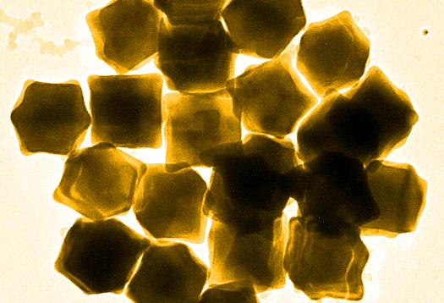**ESCOZINE FOR PETS GNP-1**

This drug version will be Escozine for Pets combined with gold nanoparticles which will enhance the effectiveness and increase the targeting capability of the product. The FDA registration process for this product will take nine months

1. **Market analysis**

Clients who have pets with cancer typically have few if any options for enhancing or extending their pet’s life; needless to say, these individuals are almost completely price-insensitive, and are highly motivated to make immediate purchases of medicines that promise to extend and improve their lives. From the Company's perspective, this equates to an effectively endless market of clients who are likely to take immediate action on purchasing Petlife's products, once they have been presented with an effective marketing message and a convincing case for why Petlife's Escozine for Pets can potentially extend and improve their lives. Given the parent company Medolife's current sales volume, which it has generated with virtually no sales or marketing budget, we believe that a concerted and well-funded marketing program is likely to immediately yield extremely strong sales and financial results; furthermore, given the size of the market, we believe that it should be able to grow sales at very high rates for many years into the future. Veterinary oncology is in its infancy and no major players, so far, have dominated this market.

Veterinarians are very receptive to new effective treatments in veterinarian oncology which gives them increased financial success. Human oncology is driven by safety and malpractice prevention rather than successful treatment which do not mean more financial success.

Unlike human oncology, veterinarian oncology does not rely on insurance; veterinarian insurance covers only approximately 15% of any treatment cost.

1. **SECTOR MARKET SIZE**

The annual global market for the various health related applications of Escozine for Pets is $22 Billion.

Source: Wall Street Journal

**United States Potential Market**

* 164 million owned dogs and cats in the United States
* There are approximately 86.4 million owned cats in the United States
* There are approximately 78.2 million owned dogs in the United States
  + 30% of dogs get cancer
  + 50% of dogs over the age of 10 get cancer
  + 50% of cats get cancer
  + 43,200,000 cats have cancer
  + 23,460,000 dogs have cancer

*Data Source: The Humane Society of the United States*

1. **GLOBAL MARKET**

The global market for veterinary oncology is growing at a rapid rate. The below map from 2009 shows the top 10 dog populations globally and Petlife will target these market areas for sales of both its nutraceutical and drug versions.

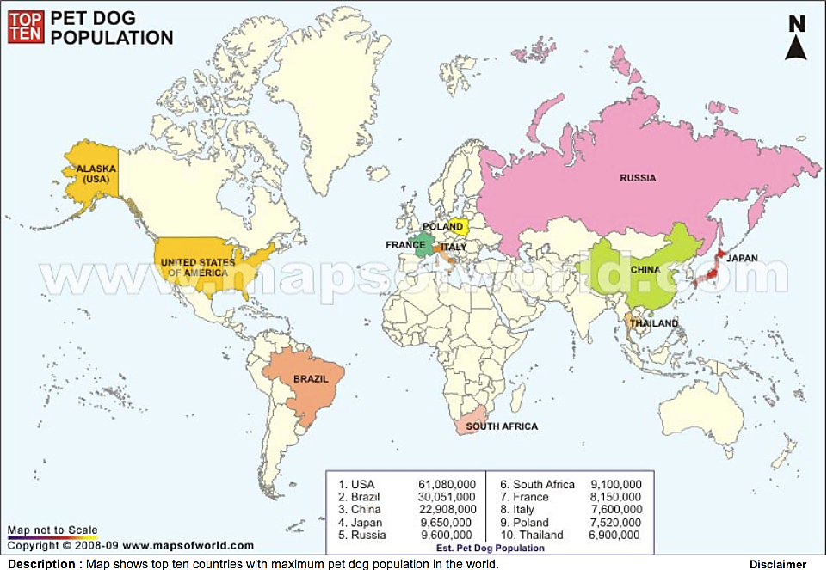

1. **COMPETITION**

To our knowledge, the Company has no directly competing products at this time, other than the inferior and un- patented human oncology products produced and sold in Cuba under the names Vidatox, Escozul, and Biotox; these would first need research and development to produce a derivative veterinary product. While based on the venom of the same Blue Scorpion (Rhopalurus Junceus), the sale of Escozul has ceased due to supply and Vidatox is diluted 100 times from Medolife’s therapeutic dose. These products are not likely to impact Escozine for Pets sales and will remain relegated to a relatively small distribution footprint targeted at human oncology. However, these product names are already searched for thousands of times online each month, further buttressing our belief that with ample marketing and capital the Company will rapidly ramp sales and earnings. *Please see White Paper entitled “****The History of Escozine for Pets.****”*

The FDA approved the first drug to treat cancer in dogs in 2009. Palladia (toceranib phosphate), is the first drug developed specifically for the treatment of cancer in dogs.

All cancer drugs now used in veterinary medicine originally were developed for use in humans and are not approved for use in animals. Cancer treatments used in animals are used in an “extra-label” manner as allowed by the Animal Medicinal Drug Use Clarification Act of 1994. The Company will register Escozine for Pets with the FDA for specific use with both dogs and cats and will therefore provide vets with an effective product targeted specifically to veterinary oncology.

1. **Financial impact**
   1. **Sales Projections**

The chart below illustrates the 5 year financial projections for Petlife, assuming that the various product introductions, revenues and cost projections occur according to the assumptions included in the detailed Commercial Model.  This information includes the costs of all FDA filing and testing, the addition of critical staff, expansion of the patent and intellectual property activities, the commercialization of at least 2 products (Escozine for Pets & Pet treats), plus the additional disease research and development.

**SALES PROJECTIONS – 5 YEARS**

The detailed projections of Medolife’s sales and resulting product requirements are contained in the Economic Summary sections of Medolife’s Detailed Commercialization model (Please refer to the Petlife section of the **Medolife Financial Model**).

* 1. **Revenue Projections**

The detailed information contained in the revenue projections for Petlife’s commercial activities can be found in **Medolife’s Financial Model**.

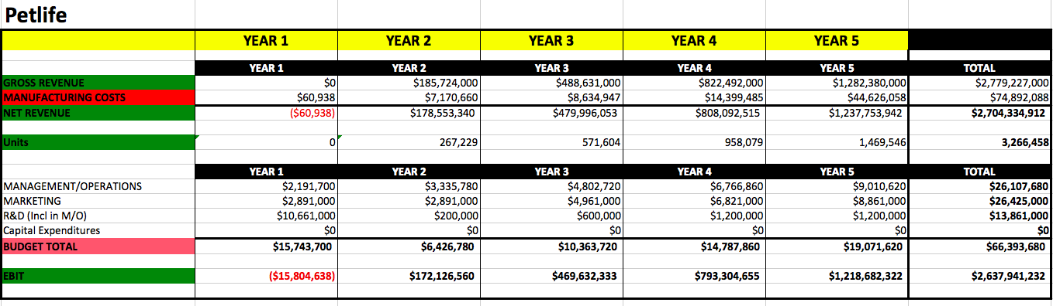

1. **Capital Requirements**

The exact capital requirements are illustrated in the above chart.The detailed commercial activities and cash flow for Petlife are contained in the Medolife Commercialization Model sections illustrated as Petlife.

*Please refer to the “Petlife” Tab of* ***Medolife Financial Model***



1. **PUBLIC MARKETS BUSINESS EXPANSION STRATEGY**

The parent company, Medolife™ will remain a private company.

We anticipate taking Petlife Corporation (Pet Oncology) public in the U.S. in the 1st quarter of 2014. Petlife will take advantage of the short drug registration period (approximately 9 months) and large market demand in the sector. The uniqueness and effectiveness of the product will drive significant revenue. The company illustrated below, VCA Antech, is indicative of the growth in the veterinary sector.

**VCA Antech Inc**

VCA Antech, Inc. operates as an animal healthcare company in the United States and Canada.

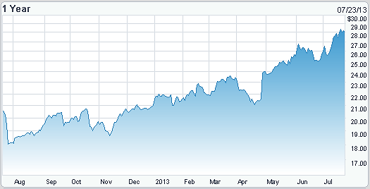

**NASDAQ: WOOF Recent Price: $30.00**

Medolife will quickly pursue the required testing and modifications necessary to deliver a Veterinarian related oncology product for use on animals and / or pets.  The company will initially become a “publicly traded” company in 2014 in both in the US and UK. (See **Petlife Public Markets Strategy**).

1. **Development / Commercialization Activities**

Medolife has clearly has identified a number of activities that it will complete within two years in order to achieve its commercialization objectives.  Medolife’s commercialization strategy of ESCOZINE FOR PETS and the company’s related products and technologies include:

* 1. **Expand Management Team** – The company’s top priority is to scale the management team to support the growing list of medical and health care activities as well as support the global sales, and service of its Escozine product.  Initially Medolife will address the immediate day-to-day staffing requirements for certain activities by engaging a combination of top quality, 3rd party service professionals, consultants, part-time and full-time employees. The specific details of the various staffing additions are contained in certain sections of the model as described below. The information contained in Year 1 of the Oncology section of the Commercialization Model identifies the additional management team and their projected annual salaries that will be added to support the company’s on-going activities.
  2. **FDA Activities** – The chart below illustrates the various phases and activities associated with the FDA drug certification process.  A priority of Medolife’s commercialization activities is the completion of these FDA activities as quickly and efficiently as possible.   The actual budgets, timelines and involved personnel are identified in detail for each product in the appropriate section of Medolife’s Detailed Commercialization model. The Commercialization Model (Please refer to the Petlife section of the **Medolife Financial Model**) contains a separate detailed listing of the personnel that will be added for the support of all FDA activities.  The model includes the timing and salary associated with the addition of each technical professional.

**FLOWCHART OF ACTIVITIES FOR FDA REGISTRATION**

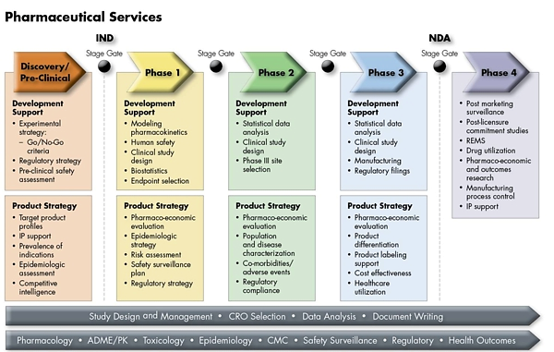

* 1. **Production Capacity / Quality –** Medolife has prepared a detailed profile of its existing scorpion reservation, the production process and the venom capacity for additional product production.  This information is contained in the separate attached document titled **“Summary of Scorpion Reservation and Venom Production”**.  The details in this document identify the activities and costs associated with each drop of venom as well as the details associated with the expansion of the company’s Escozine for Pets production capacity. **The Scorpion Reservation and Venom Production Profile** contains the detailed information related to the staffing associated with the scorpion reservation and related milking, and product production.  As demand increases staffing will expand in accordance with the drop-by-drop analysis contained in the report. The company has an alliance with Instituto Butantan in Sao Paolo, Brazil, who are specialists in the breeding and maintenance of scorpion populations. For more details please refer to “maintenance of Scorpions” document contained in the **Scorpion Reservation and Venom Production Profile.**

Petlife will also be working with Venomics (a French Government research group of companies in 5 European Union countries) and Venomtech (Specialists in Venom technology) in France, to ensure the latest research is utilized to ensure the most effective results from Petlife’s products.

Petlife will also be utilizing the results and benefits from other venom based research and approved products; for example the FDA approved scorpion antidote, Anascorp.

* 1. **Global Licensing** –The company intends to establish qualified distribution arrangement in strategic countries as quickly as possible. The procedural activities associated with the introduction of Escozine® for Pets as an accepted nutraceutical and drug in a foreign country can be quite technically demanding (see details in the Commercialization Model). Petlife will apply a portion of its capital to assemble a dedicated team of skilled professionals capable of managing the required details and on-going procedural activities associated with the introduction of the company’s product in foreign markets.   The company is still in the process of prioritizing which countries it will focus on first in the expansion of its global sales network. Achieving the desired expansion of the company’s international licensing campaign will require the addition of a staff that includes international legal experts, processing personnel and operationally focused digital support systems.
  2. **Expansion of Patent Protection –** Petlife’s initial patent will address certain activities associated with the “polarization” of the solution in order to enhance the delivery to the specific areas of the dogs and cats where the cancer is located.  Additional patents will be prepared that more aggressively address the detailed structure of the complex proteins and peptides contained in the Scorpion venom.  The objective is to define and protect a “synthetic formula” for the Escozine for Pets version of the applied compound. The parent company, Medolife has already engaged a group of intellectual property professionals (Hankin Patent Law) that are specifically skilled in the bio-pharmaceutical areas associated with the Escozine for Pets product.
  3. **Expansion of Escozine® for Pets Oncology Products**
     1. **Cancer Preventative**

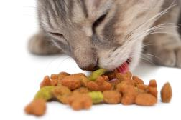Petlife will develop four dedicated cancer preventative products. These products will have the effect of prolonging pets’ lives when taken consistently. This will drive significant sales for Petlife as clients adopt these types of products as part of their pets normal daily diets.

* + - 1. **Dog Treats**
      2. **Cat Treats**
      3. **Dog Food**
      4. **Cat Food**
    1. **Cancer Specific Products**

Escozine for Pets has a universal effect on different cancer types; with inexpensive modifications Petlife can create cancer Specific products that can significantly increase sales. The following are the top veterinary cancer types that Petlife will target.

1. Lymphoma or Lymphosarcoma
2. Hemangiosarcoma
3. Osteosarcoma
4. Mast Cell Tumor
5. Melanoma
6. Squamous Cell Carcinoma
7. Mammary Carcinoma
8. Apocrine Gland Carcinoma (Anal Sac)
9. Transitional Cell Carcinoma
10. Soft Tissue Sarcoma
11. Lymphoma
12. Squamous carcinoma
13. Fibrosarcoma
14. Lung tumors
15. Brain tumors
16. Nasal tumors
17. Liver tumors
    * 1. **Products For Different Intake Protocols**

When surgery is hard to perform, oral use is an effective tool which clients can use this in their home that makes it easy to use; this will drive increased sales. Similarly the patch can be used at home and positioned in the area of the tumor for effective, targeted treatment; this will also increase sales of Escozine for Pets. The injectable version can be used by vets to directly inject the product into the tumor for effective, targeted high dose treatments. This will increase sales with vets who will have an effective in clinic, targeted product that clients will have to bring their pets into the clinic for treatment.

1. Oral
2. Patch
3. Injectable

* 1. **Expansion of Escozine® for Pets Applications –** Petlife, through the work of its analytical scientists has identified a diversity of diseases that it believes will respond positively from treatment with Escozine for Pets type drugs.   The diseases below illustrate those areas of potential expansion beyond the current focus on veterinary oncology related illnesses. The expansion of the application of Petlife’s products and technical knowledge into other health related areas will require the addition of specially skilled research scientists and pharmacological experts. The details associated with these staff additions are contained in the Year 1 projections of the Commercialization Model; Petlife will initially develop the new Petlife products with the use of Medolife’s research and development teams.  Petlife will expand its market share and increase its revenue streams by treating other diseases.

Petlife will develop products for pets in the following areas:

* + 1. **ARTHRITIS**

Arthritis (or osteoarthritis) is a slowly progressive, degenerative disease of the joints for which there is no cure. However, Escozine for Pets can help to prevent, delay, and manage arthritis in dogs or cats. Arthritis affects 1 in 5 dogs over the age of 7(Arthritis Foundation) and over 90% of geriatric cats have arthritis; currently 12 million cats have arthritis (PetMeds).

* + 1. **HEPATITIS**

As with humans, Hepatitis in dogs and cats affects the liver. This contagious disease includes symptoms such as fever, vomiting and diarrhea accompanied by abdominal pain. Furthermore, Hepatitis may lead to kidney damage. About 12% of dogs get Hepatitis (US National Library of Medicine). With cats, the number is around 40%.

* + 1. **LYME DISEASE**

Lyme disease is dangerous bacterial disease that can cause irreversible damage to a dog's health; cats also get Lyme disease, although it is not as common. About 5% of dogs contract Lyme Disease and with cats it is not a prevalent disease.

* 1. C:\Program Files (x86)\Microsoft Office\MEDIA\CAGCAT10\j0222015.wmf**Marketing / Sales strategy –** While the Company has not yet finalized a relationship with a traditional marketing and/or traditional PR firm, we believe that it will easily be able to hire competent marketing and PR organizations to promote itself and its products, once it has secured the funding necessary to make such investments. Such partners will improve the Company's brand and brand awareness in key target markets, both in terms of client awareness and in terms of veterinary healthcare practitioners, veterinary clinics, pet stores, and distributor mindshare. Although much slower than online marketing, we expect traditional marketing to be an important component of the Company's eventual growth and long-term success.

In addition to traditional branding and marketing, the Company is actively seeking distributors for its international sales operations. The strategy is to first, initially target the largest key markets such as the United States, Europe and Russia over the coming few months. These distribution relationships are extremely important to the Company, as they allow them to leverage single relationships to reach thousands of veterinary clinics, hospitals, and vets in the nations in which each distributor operates. As Escozine for Pets becomes available in an increasing number of clinics and stores, this will allow the Company to reap the benefits of its planned "traditional" branding and marketing initiatives.

The Company is in discussions with a top-tier marketing organization that specializes in driving sales through pay-per-click (PPC), organic search, and affiliate marketing initiatives.

The Company will integrate three marketing strategies that have the potential to accomplish rapidly increasing online sales for Medolife. Our online marketing initiatives are as follows:

* + 1. **DOSEP Campaign:** DOSEP (Direct Organic Search Engine Optimization) is a groundbreaking online awareness campaign and technology that will push Medolife’s web presence to the top of Google organic search results for targeted search keywords determined by Medolife management. By working with a top tier online marketing firm, 68.4% of all sales via the Internet go to the product that has one of the top three Google rankings in its category.
    2. **Multi-Touch Facebook Campaign:** The Marketing Company will executive a targeted multi-touch Facebook advertising campaign that will generate major social awareness (and resulting online sales) of Vet Oncology products. The marketing messages will appear directly in the Facebook newsfeeds of specific demographic groups who additionally have expressed personal or professional interest in cancer treatment, based on research and targeting of the specific interests contained in their Facebook profiles.

This combination of geographic- and interest-targeted ads, in addition to producing direct online sales, will also generate viral social media traffic, as each targeted prospect’s Facebook Friends will be automatically exposed to each newsfeed post about Medolife’s products—resulting in additional online sales. From Facebook, targeted prospects will be directed to a video ad that will then direct them to the e-commerce site for both products.

* + 1. **Scientifically-Optimized Banner Ad Campaign:** The third and exponentially powerful Absolute Force marketing strategy—with the capability to deliver the balance of $100 million in sales for each product within one year—is a scientifically-tested, optimized and ongoing banner ad campaign. The Marketing Company will conduct research for optimal placement, and perform continuous split testing of ads to quickly determine “winners” and then further refine campaigns to determine the optimal combination of performance metrics to justify increasing ad budget spend for top-performing banner campaigns.

Once the high-performance suite of top-converting banner ads has been market-proven, The Marketing Company will execute an ongoing series of strategic banner ad media buys to grow revenue exponentially on a daily basis—at an absolute minimum cost per banner ad impression.

The triple strategic marketing campaigns will repeatedly “local-launch” Petlife into specific metro markets while concurrently building Petlife’s overall brand and marketing presence globally. Repeating the trifecta marketing campaign in each additional targeted metro market will not only localize and establish the Medolife brand and products, each event will also catalyze Petlife’s local and nationwide Google search rankings via DOSEP, Multi-Touch Facebook and Scientifically-Optimized Banner Ads, producing both short- and long-term online sales growth, and firmly establish Petlife as the recognized market leader.

Petlife believes that each of these campaigns will be effective, based on our research and based on historical results obtained by other online product marketing efforts.  Furthermore, the online marketing's inherently short feedback cycle (often measured in hours rather than in calendar quarters or years), provides immediate feedback which allows the Company to quickly eliminate and/or reallocate marketing spend that is not producing sufficiently positive sales. Based on these factors, we are comfortable that the Company will be able to realize the sales and earnings contained in our financial model.

It should be noted that the company’s fund raising efforts reflect the timing and costs associated with achieving the critical goals described above in a timely and professional fashion.

Five additional detailed documents are attached to this Commercialization Summary.  Those documents include **“Petlife Public Markets Strategy**”, **“Investor Fact Sheet** ”, “**Patent # 8,097,284 B2 Description**” (Continuation of the patent will be applied for veterinary use), and “**Medolife Scorpion Reservation and Venom Production Profile V.3**”.  These documents contain extensive details on the company, its operations, the veterinary oncology market and existing competition.  Rather than reproduce that information in this Commercialization Strategy, relevant facts contained in those documents will be appropriately referenced throughout this discussion.