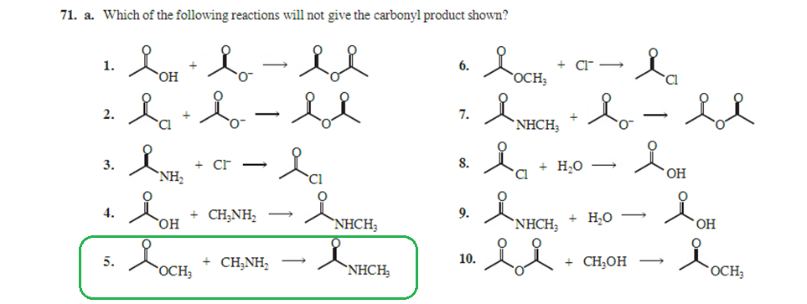
Number 5 in 71 will occour even though both ester and amide is less reactive then aldehyd and ketones. At the same time in this chapter 17.3 they say that formation of tertiary structures from aldehydes and ketones can be formed from their lack of reactivity? Is this because proton can not be added to aldehyde or ketone group? Why does 4 occour but not 5?
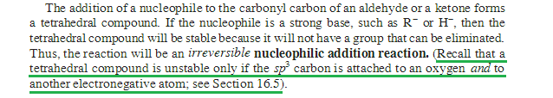
H and C’s are not very electronegative but why can not the added nuclephile be electronegative and then you have O-group and a electronegative attachment on the sp³ carbon? Why does O and an e negative carbon in the first place create an unstable sp³ carbon?

