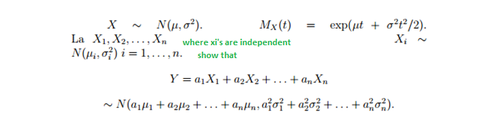

$$E\left(e^{\left(a_{1}X_{1}+a_{2}X_{2}+…a_{n}X_{n}\right)t}\right)$$
$$=E\left(e^{a_{1}X_{1}t}\right)E\left(e^{a_{2}X_{2}t}\right)…E\left(e^{a_{n}X_{n}t}\right)$$

$$e^{a_{1}X_{1}t}={\left(e^{X_{1}t}\right)}^{a_{1}} moment generating function$$
$$=E\left({\left(e^{X_{1}t}\right)}^{a_{1}}\right)E\left({\left(e^{X_{2}t}\right)}^{a_{2}}\right)…E\left({\left(e^{X_{n}t}\right)}^{a_{n}}\right)$$
$$={\left(E\left(e^{X_{1}t}\right)\right)}^{a_{1}}{\left(E\left(e^{X_{2}t}\right)\right)}^{a_{2}}…{\left(E\left(e^{X_{n}t}\right)\right)}^{a_{n}}$$
$$={\left(e^{μt+\frac{σ^{2}t^{2}}{2}}\right)}^{a_{1}}{\left(e^{μt+\frac{σ^{2}t^{2}}{2}}\right)}^{a_{2}}…{\left(e^{μt+\frac{σ^{2}t^{2}}{2}}\right)}^{a_{n}}$$
$$={\left(e^{μt+\frac{σ^{2}t^{2}}{2}}\right)}^{a_{1}+a_{2}+…+a_{n}}={\left(e^{μ\left(a_{1}+a_{2}+…+a_{n}\right)t+\frac{\left(a_{1}+a_{2}+…+a_{n}\right)σ^{2}t^{2}}{2}}\right)}^{a_{1}+a_{2}+…+a_{n}}$$
This is wrong since it should have variance

And hence
$$=e^{μ\left(a_{1}+a_{2}+…+a_{n}\right)t+\frac{\left({a_{1}}^{2}+{a_{2}}^{2}+…+{a_{n}}^{2}\right)σ^{2}t^{2}}{2}}$$

The only thing that I could see that is wrong is that
$$E\left({\left(e^{X_{1}t}\right)}^{a_{1}}\right)≠{\left(E\left(e^{X_{1}t}\right)\right)}^{a_{1}}$$
I would like to be pointed out what is wrong with my attempt and be given a new derivation that is justified as correct through all the steps.

